Total Supplier Manager (TSM) Registration Steps (Individual)

Note: Please consult with your legal counsel or visit https://www.irs.gov/
for all tax related inquiries, including, but not limited to guidance on form completions.
Wayne State University (WSU) can not provide counsel to third parties for tax related inquires.
The Self Registration forms are intended to be utilized for buisness entities who have already
communicated with WSU’s Department contact to procure goods and services.

After reviewing the Welcome information, enter the entity’s email address in the text box, and click “Next”.
(Please note that users will need access to that email box to complete the registration process)
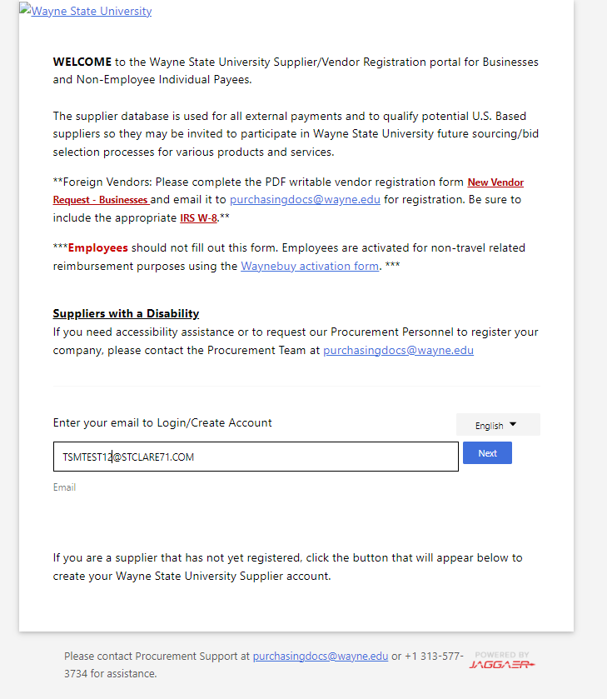

Click “Create Account”
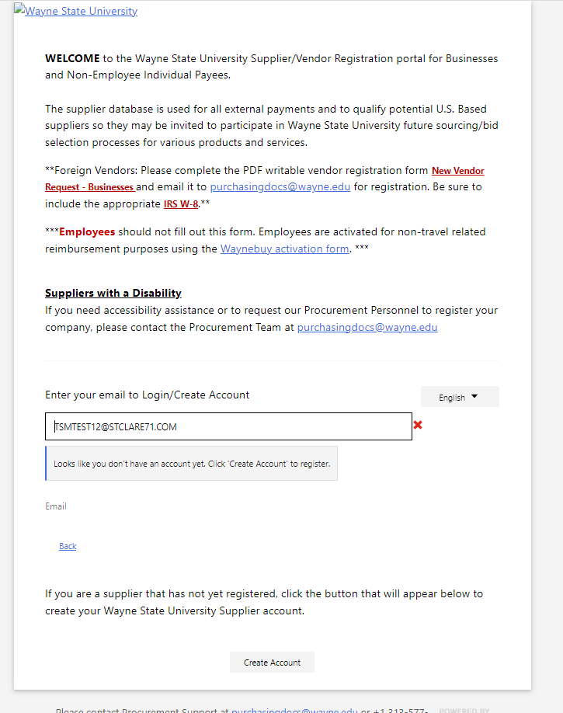

Select your entity type.
(Note: Selecting “I represent a company” requires the entity to conduct business utilizing an EIN number.
Selecting “I am, or represent a person providing goods or services” requires the entity to conduct business utilizing a social security number.
The registration form differs, depending on the option that is selected.)
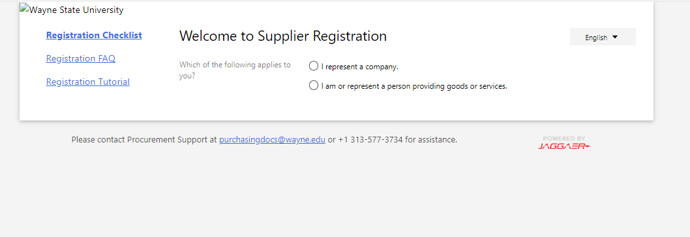

Review the Registration Checklist.
Click “Continue With Registration” after selecting your entity type.
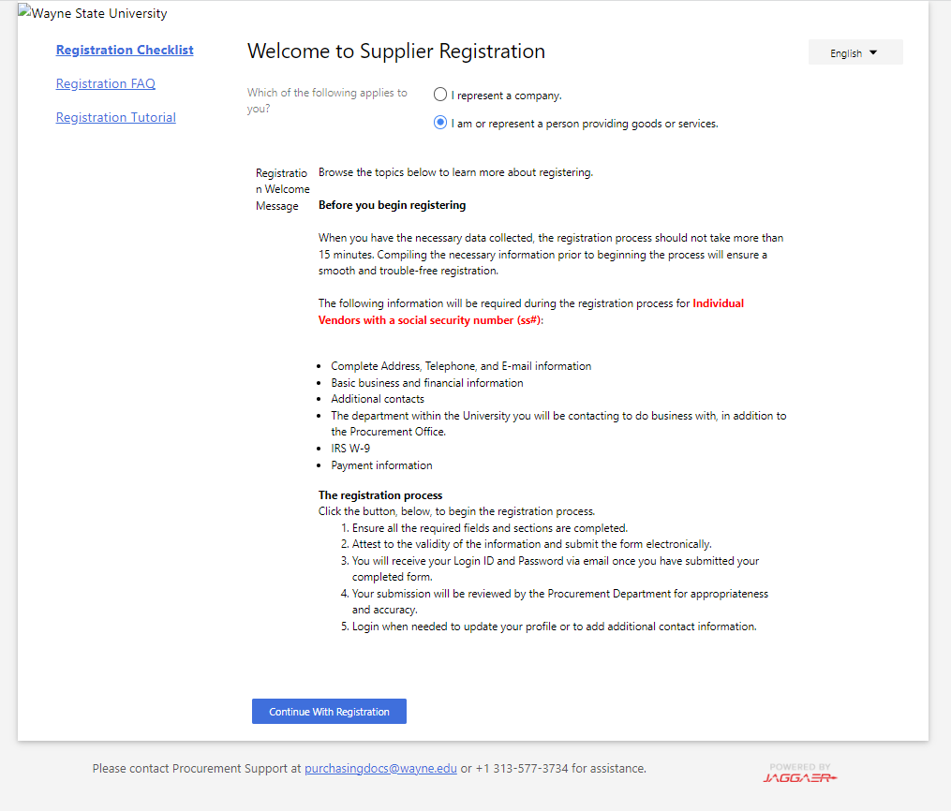

On the following screen, complete all of the fields that are applicable.
Be sure to select “Social Security Number” in the “Tax Id Number Type” Drop down box (fields marked with an asterisk are required).
Towards the end of the page, check the boxes after reviewing the “Terms and Conditions” and the “hCaptcha”.
Click “Create Account”.

Please note that all companies may not have a DUNS number.
Minimum length of the password should be 8 characters. Maximum length 100 characters. Capitalization and special characters are not required.
If accessibility assistance is needed, please check the corresponding box and contact Procurement Support at 313-577-3734, or via email at purchasingdocs@wayne.edu. (Please refer to the example provided below)
Assistance can also be provided via Jaggaer Support at 1-800-233-1121 option 2.
Wayne State University does not manage passwords. Please Contact Jaggaer Support to reset credentials

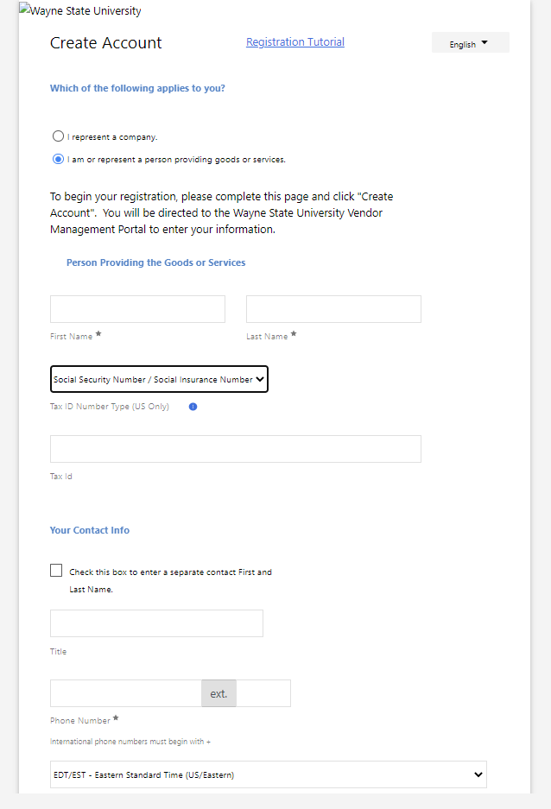
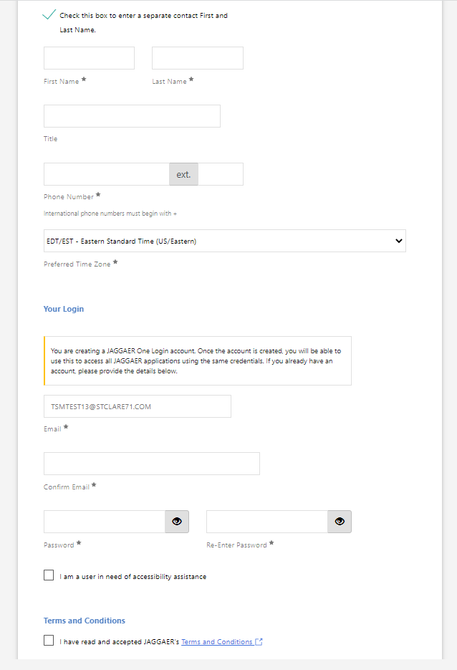

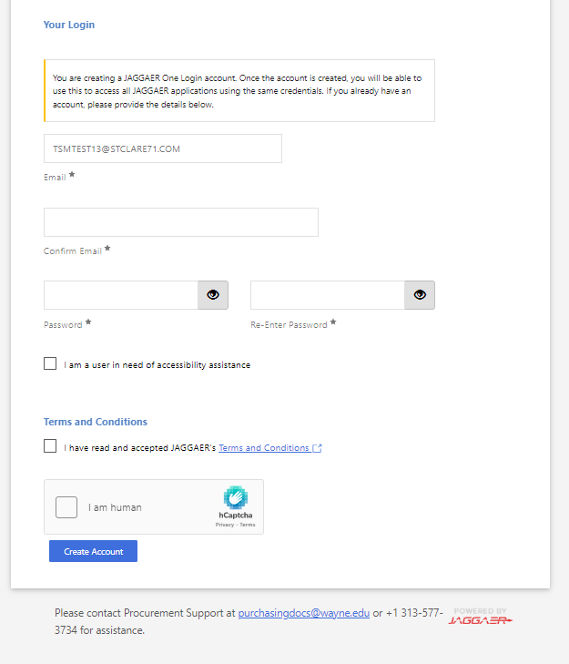
Once the applicable fields are entered and “Create Account” is selected, users will receive an email to complete the registration process.

It can take several hours to receive the email due to varying factors. Please also look in the junk or deleted email folder if the email cannot be located in your inbox.
If the email is not received in a timely manner, please contact Jaggaer Support at 1-800-233-1121 option 2.

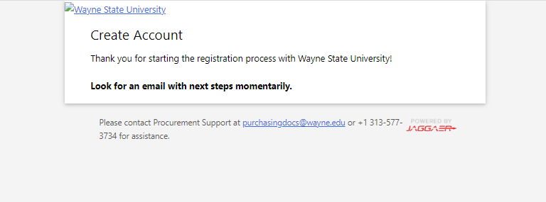

When the Email has been located in the email box, click the “Complete Registration Now” Link.
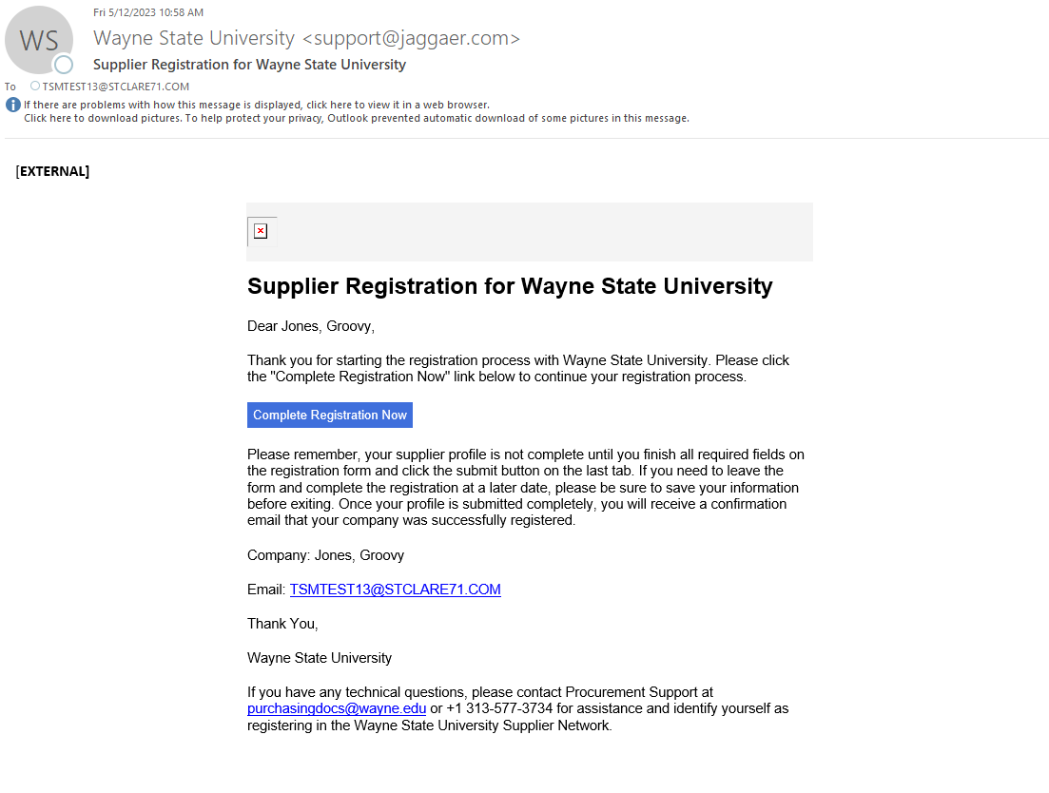

Once routed back into the Browser, click “Submit”.

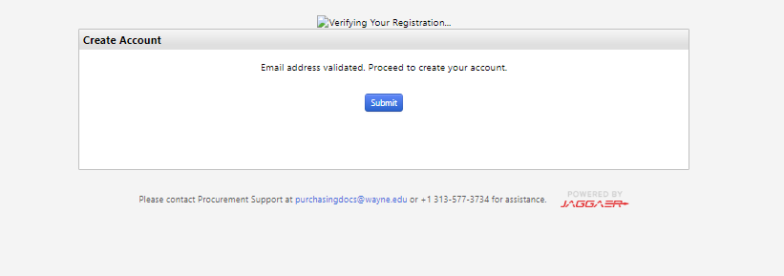

When the email address has been validated, users will be routed back to log in with their newly created credentials to complete their profile.

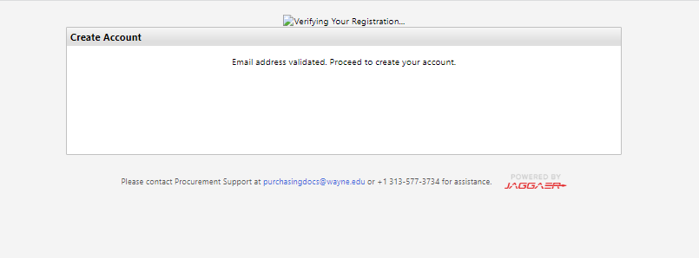

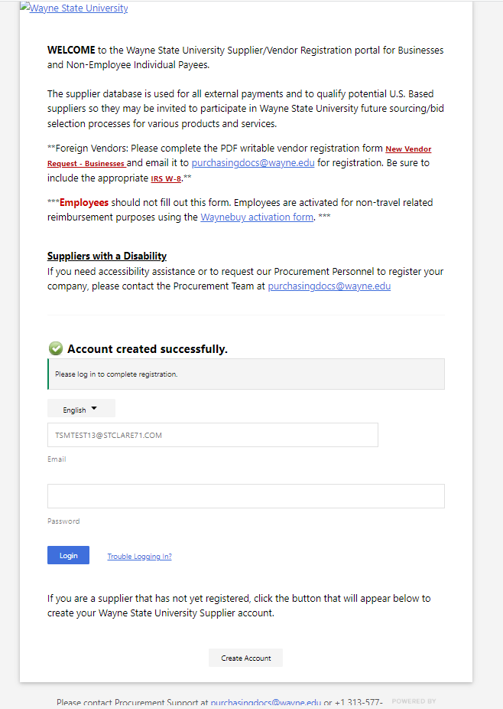
After successfully logging in, users are routed to the Welcome Page of their profile. Please complete all of the applicable sections.
Please ensure that the “First and Last Name” are correct, as we perform a TIN match on the name that is provided.
The blue “Next” button can be used to navigate through the pages. Updates made on each page/section can be saved by clicking “Save Changes”.

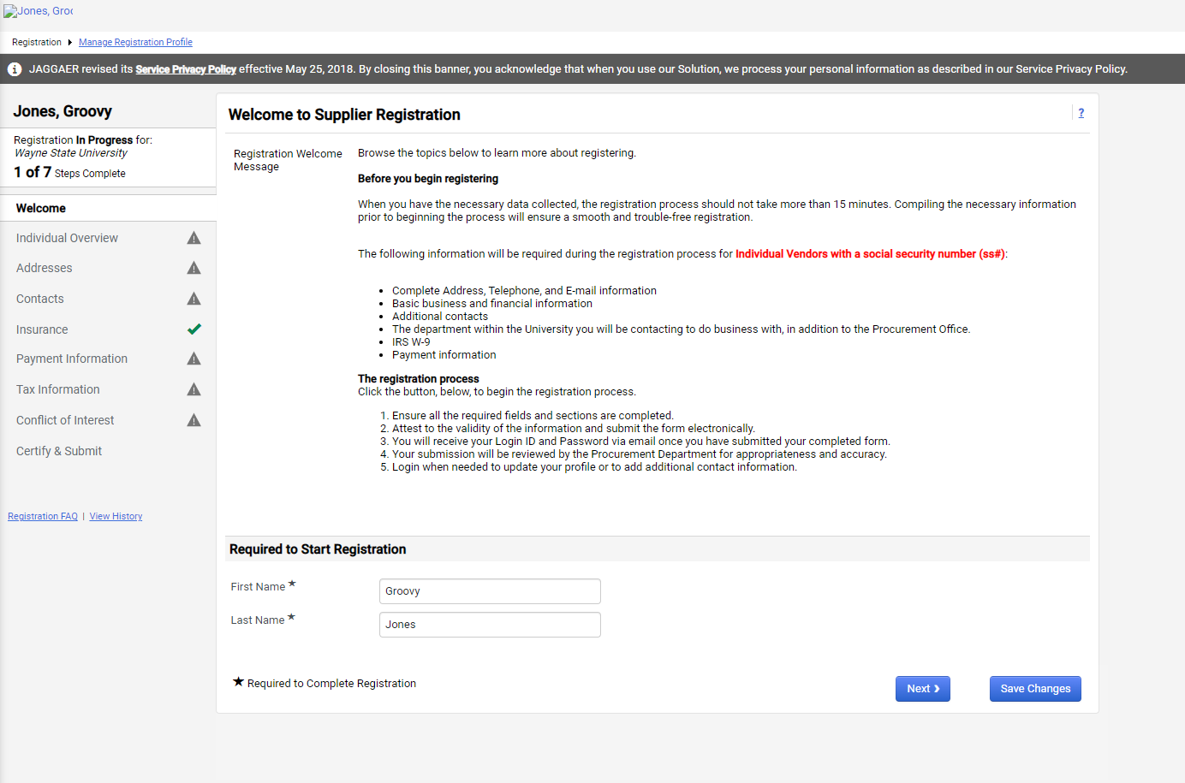

Before proceeding, review the icons in each section.
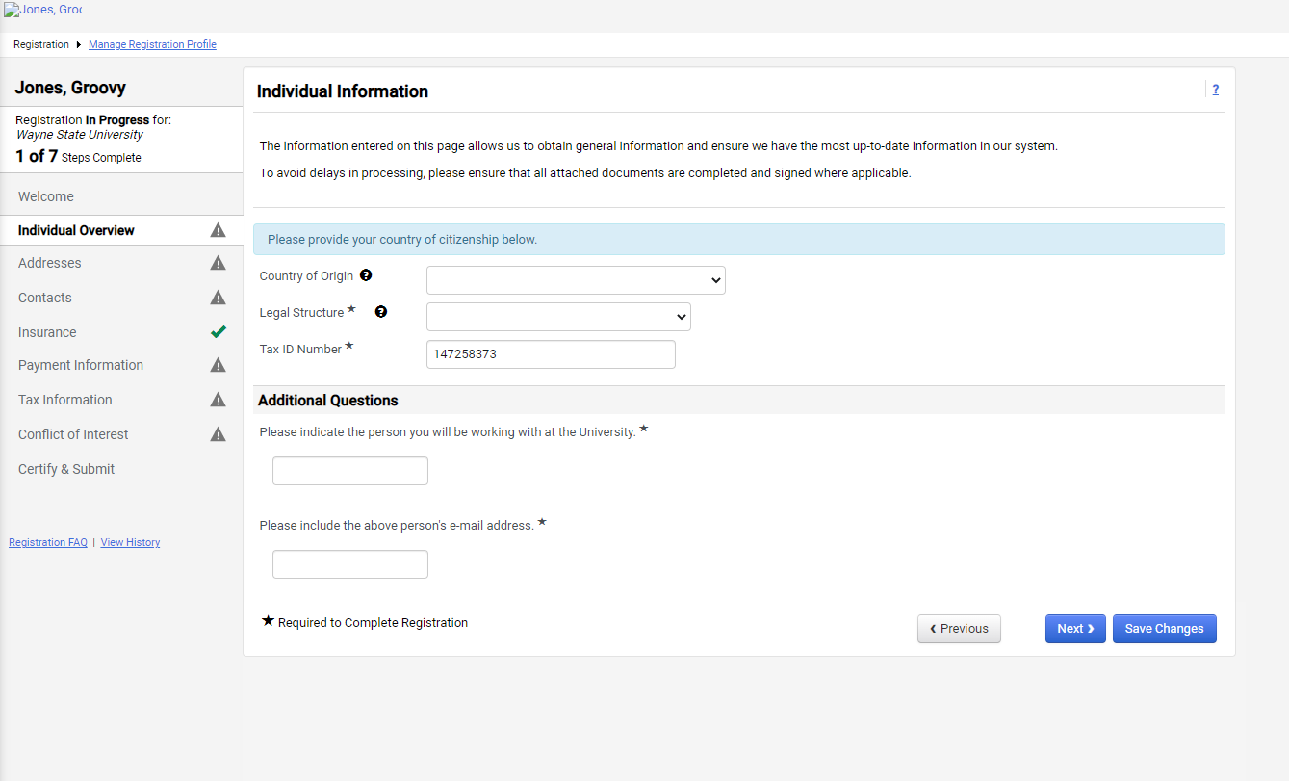

Assistance with definitions and instructions can be accessed by clicking on the question mark icon.
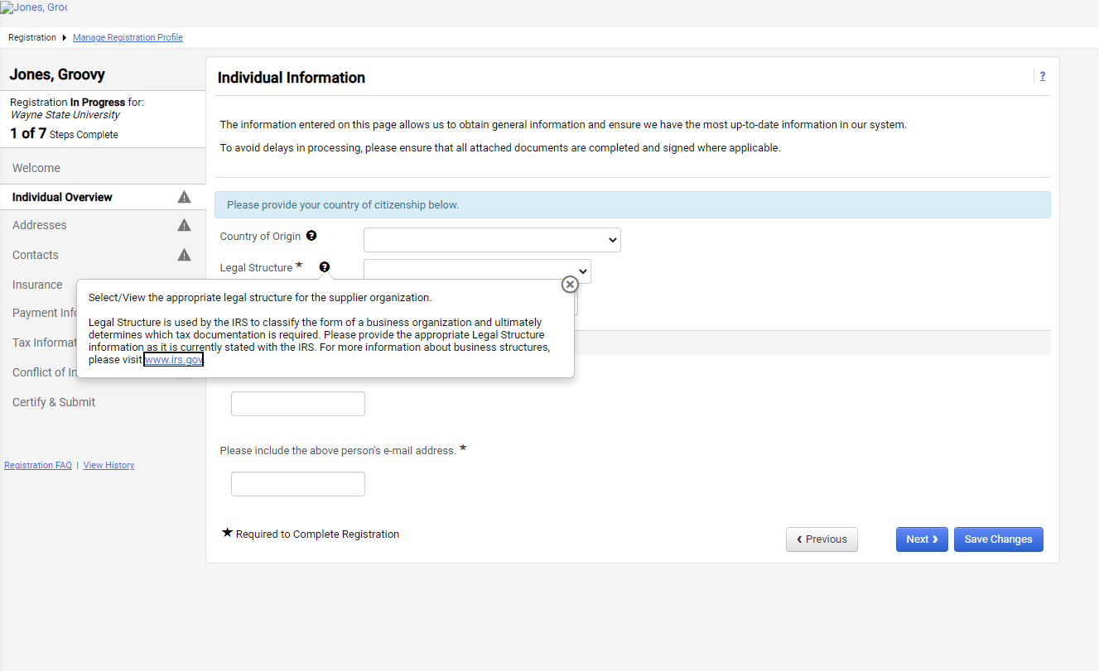

The Registration FAQ hyperlink can be accessed to retrieve information on Frequently Asked Questions
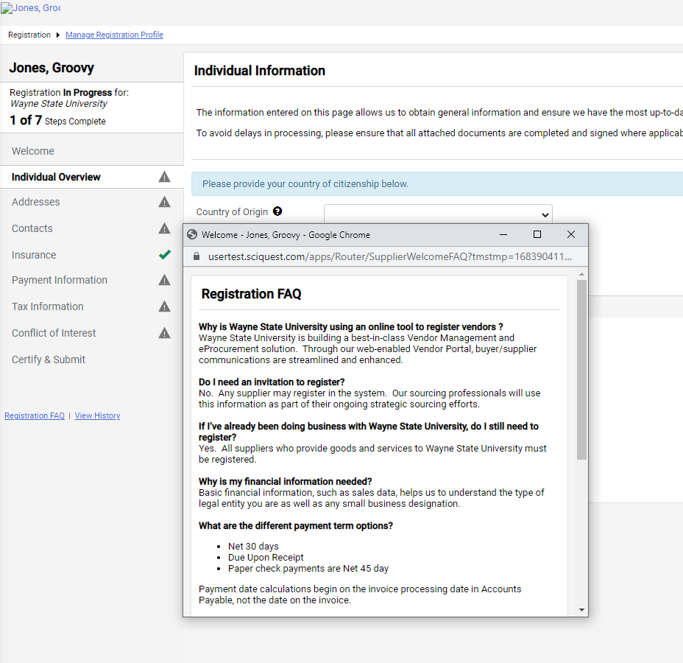

Click the question mark icon (Help) in the upper right of the page to access contact information for support.
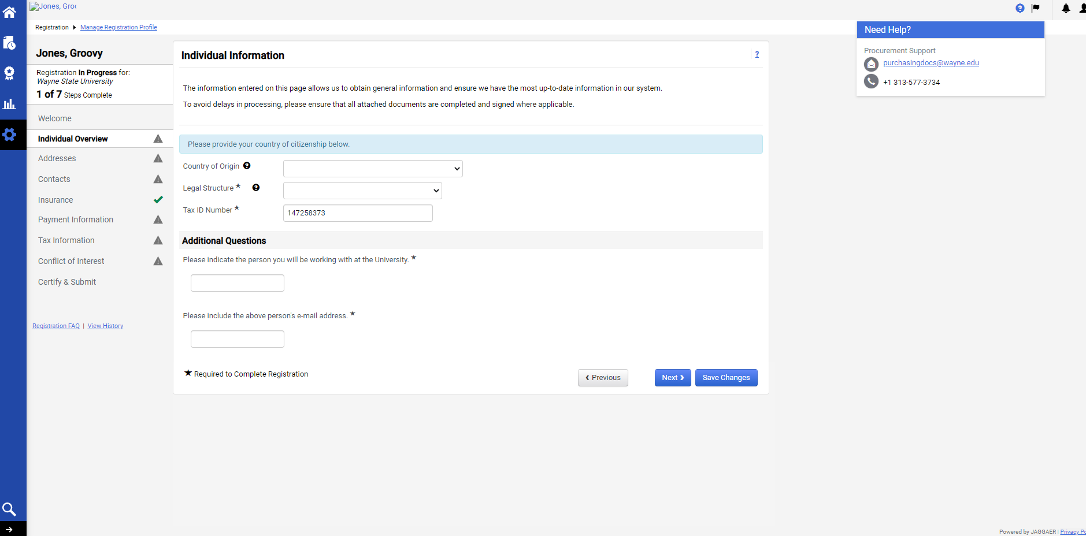

Click the flag icon (Action Items) to access any items that require action. If there is an action item, click the link within the box to be routed to the area where the action is needed.
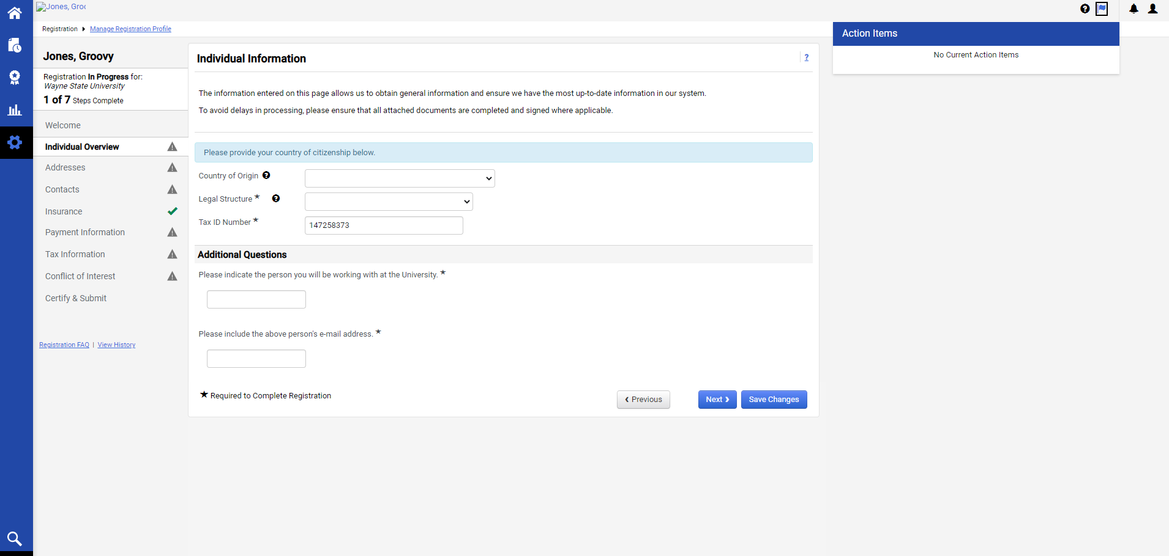

Click the bell icon (notifications) in the upper right of the page to access notifications pertaining to activity on your profile.
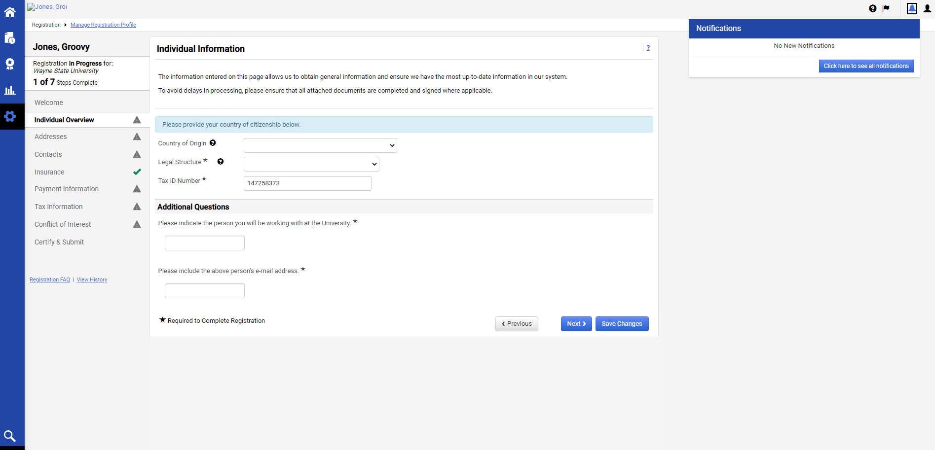

The person icon (profile) in the upper right of the screen can be used to log out and change the account password, if the current password is known. If it is not known, contact Jaggaer Support at 1-800-233-1121 option 2.
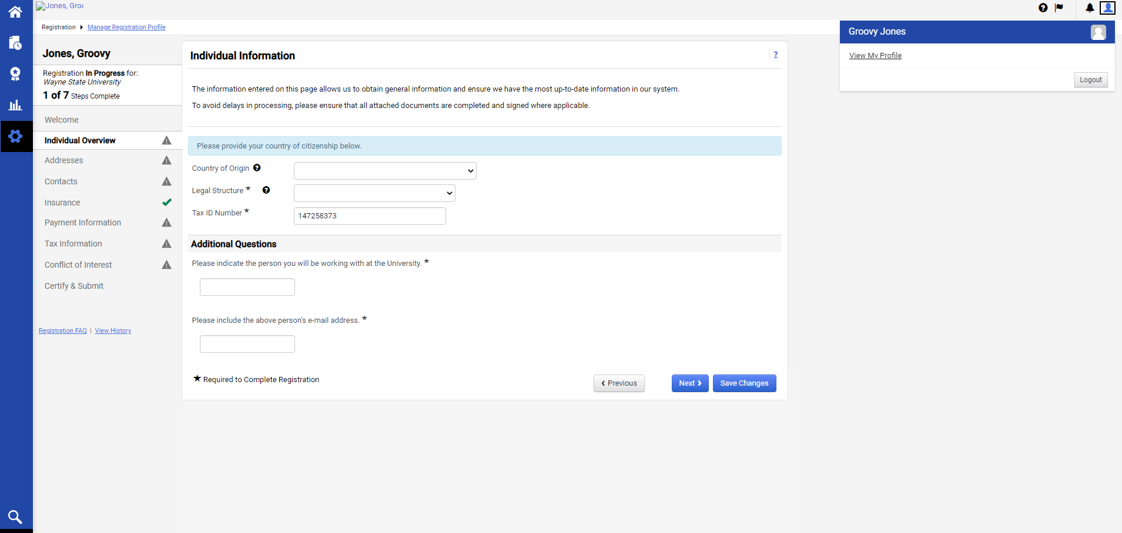

To change the password, Click “Update Security Settings”, click “Change Password”, update your credentials, click the blue box for “Change Password”, and click Close.
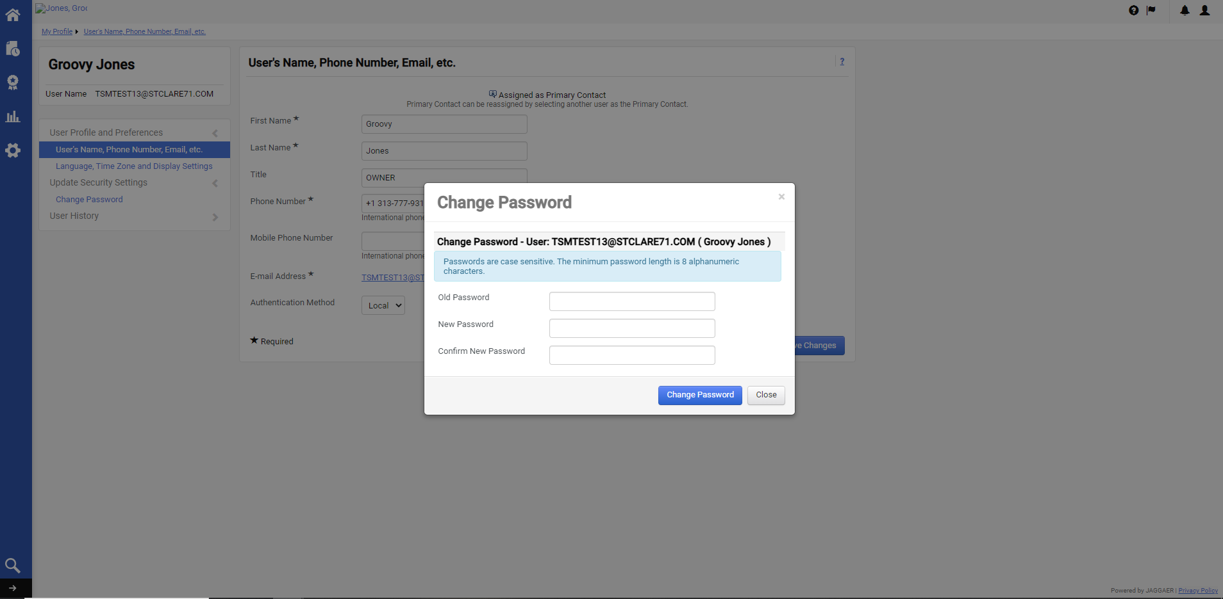

The triangle icon represents a section where the required fields have not been fully completed and saved.
The green check mark icon represents a section where all of the required fields have been completed and saved.
The View History Hyperlink allows the profile owner to review activity that has occurred on the account.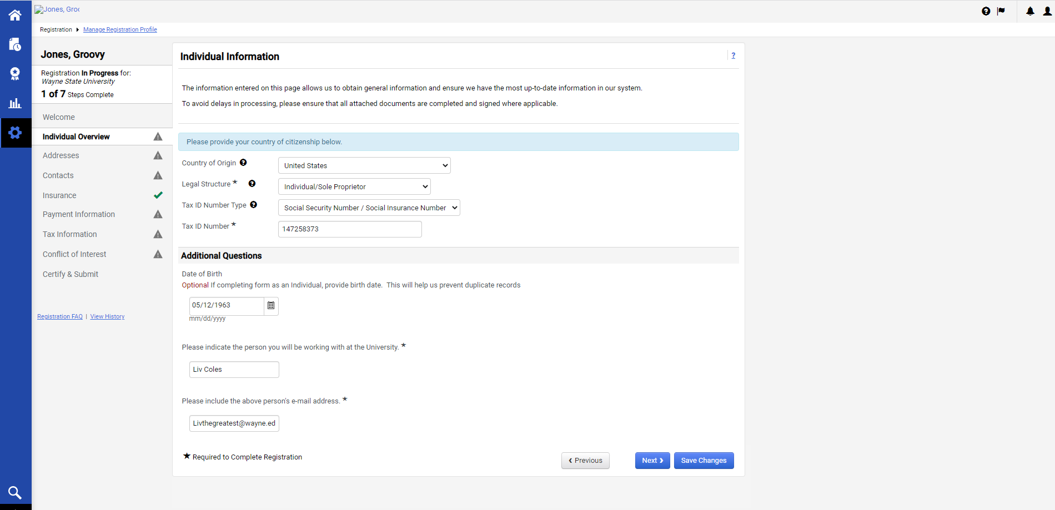

After familiarizing yourself with this page and completing the applicable sections, click “Next” to navigate to the next section.

Please provide the mailing address(s) to send purchase orders and payments.
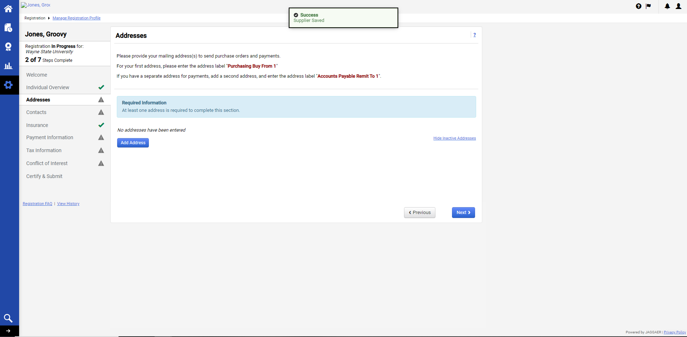
Click the blue “Add Address” Box, complete the applicable fields in the box that appears, and click “Next”.
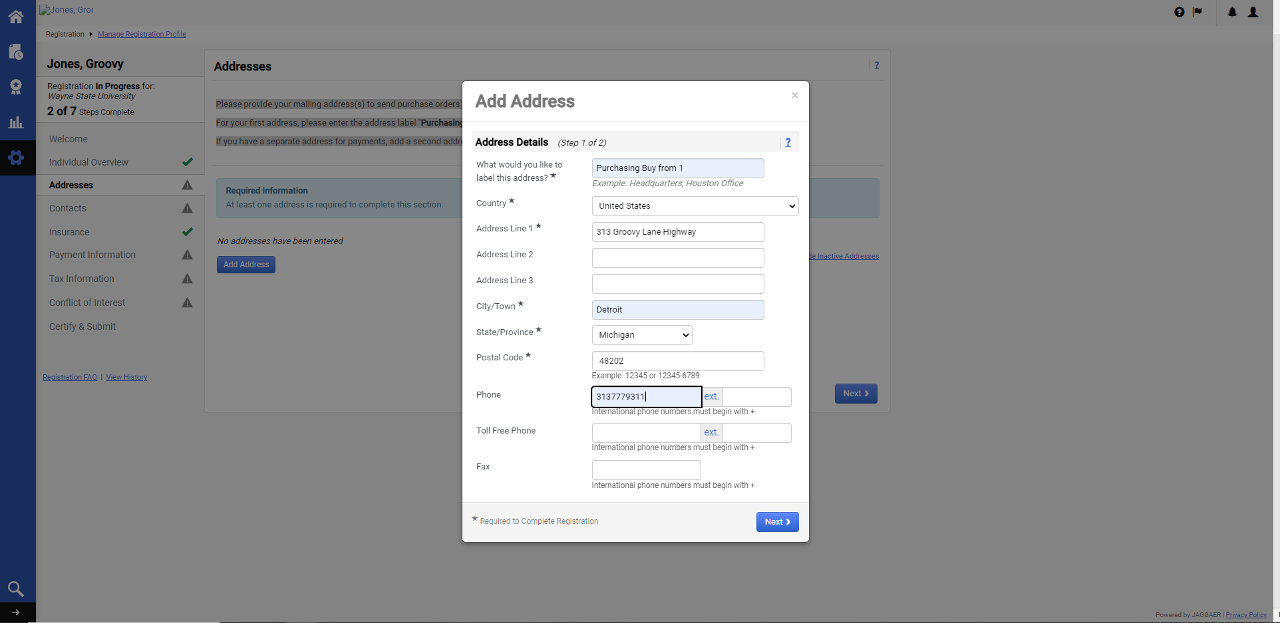
Note that additional addresses can be included by clicking back into the Address section, and clicking the blue “Add Address” box. The current address information can be updated by either clicking the hyperlink under the Address Label, or by clicking the “Edit” button in the drop-down menu. Addresses can also be made inactive from this menu.
If an address is inactive, it will not show on the screen, but can be retrieved by clicking the “Show Inactive Addresses” hyperlink.
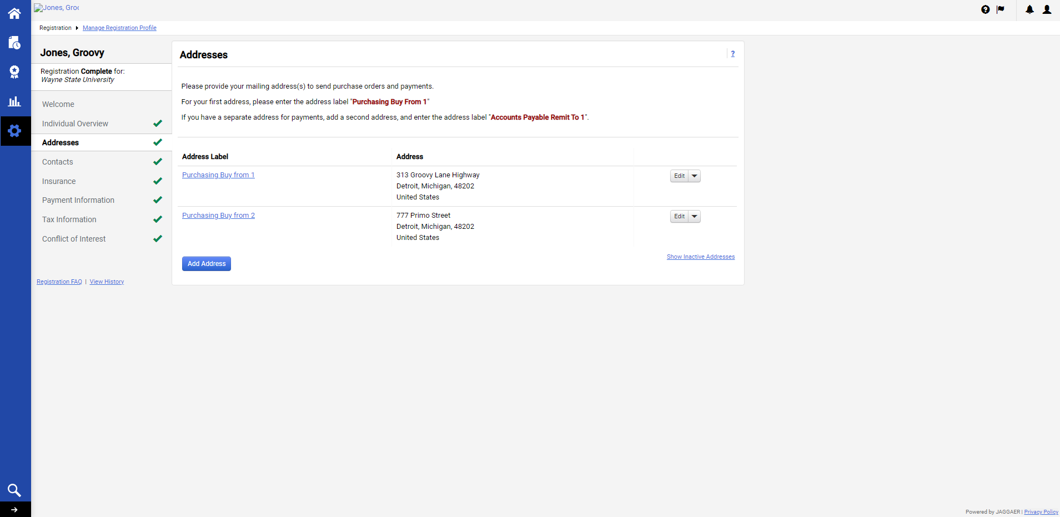
Be sure that the Address Label uses the format provided in the Address instructions, but use the next consecutive number available on the end. Click “Save Changes”.

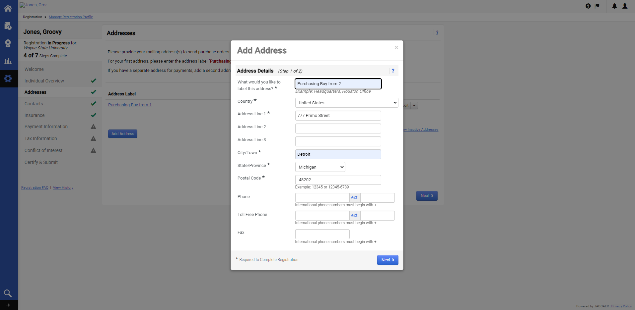
If the address does not need to be associated to a contact, click the radio dial for “Not Applicable” and click “Save Changes”.
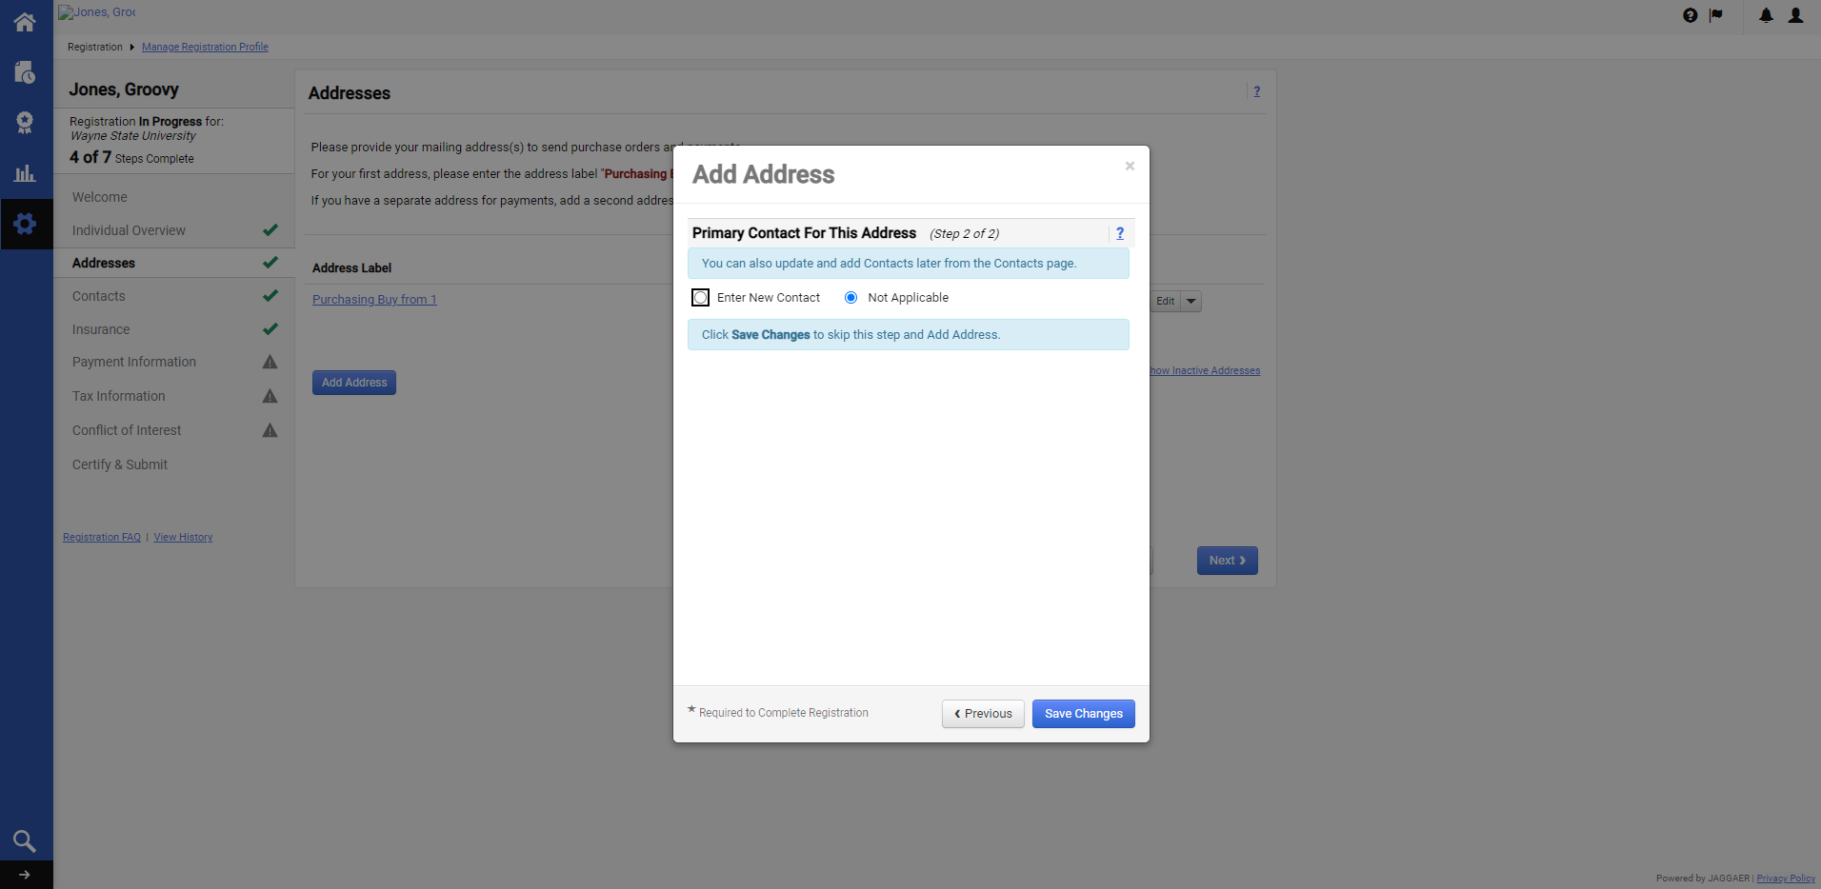

If multiple addresses exist, one can be assigned as “Primary” after it’s created, by clicking the “Edit” drop-down box, or the hyperlink under the Address Label.

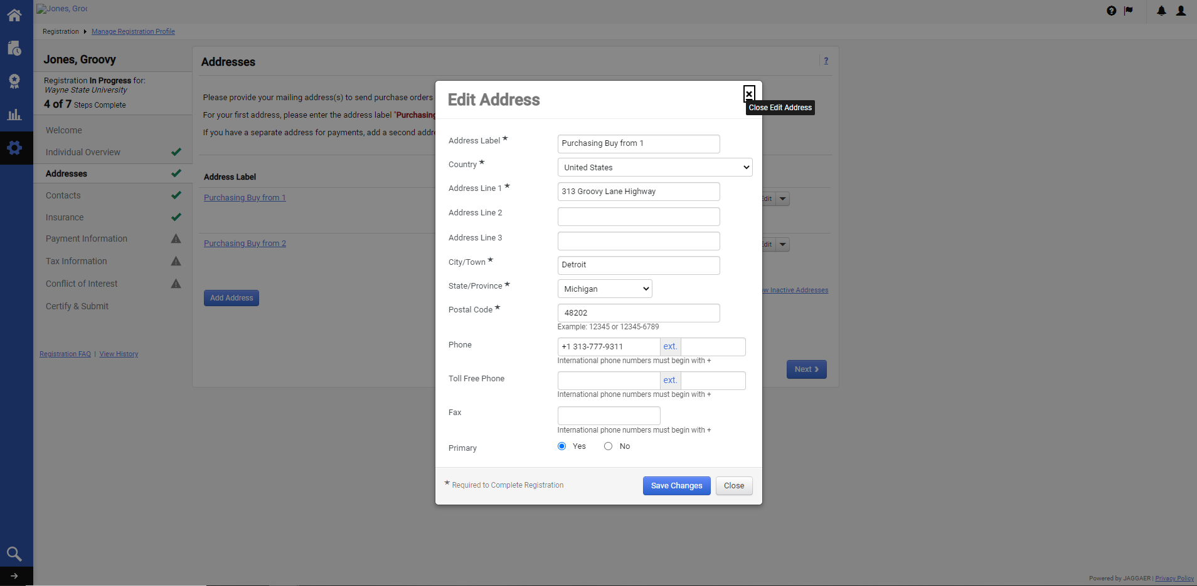

Addresses can also be inactivated via the drop-down menu
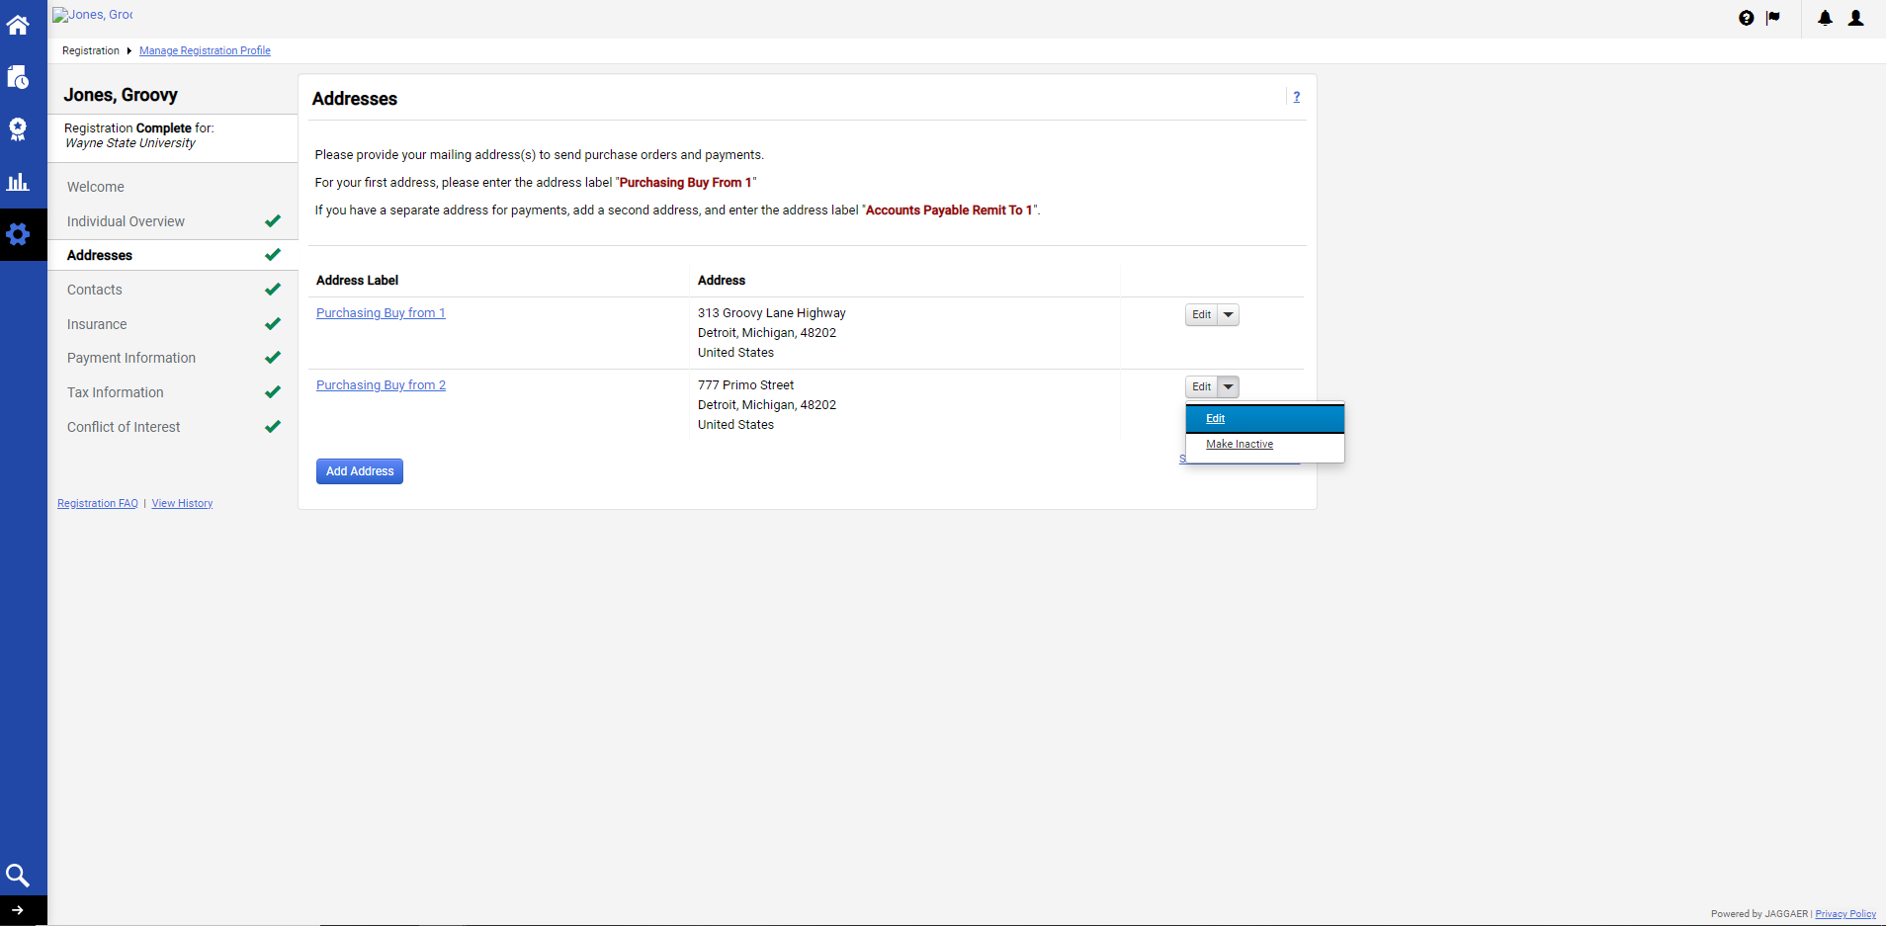

After clicking “Make Inactive”, notice that the address is now light gray.
If an address is inactive, it will not show on the screen after the user has navigated away from the section, but can be retrieved by clicking the “Show Inactive Addresses” hyperlink.
Addresses can be made active by clicking “Show Inactive Address”, and click “Make Active” in the “Edit” drop-down menu.
Click “Next”.
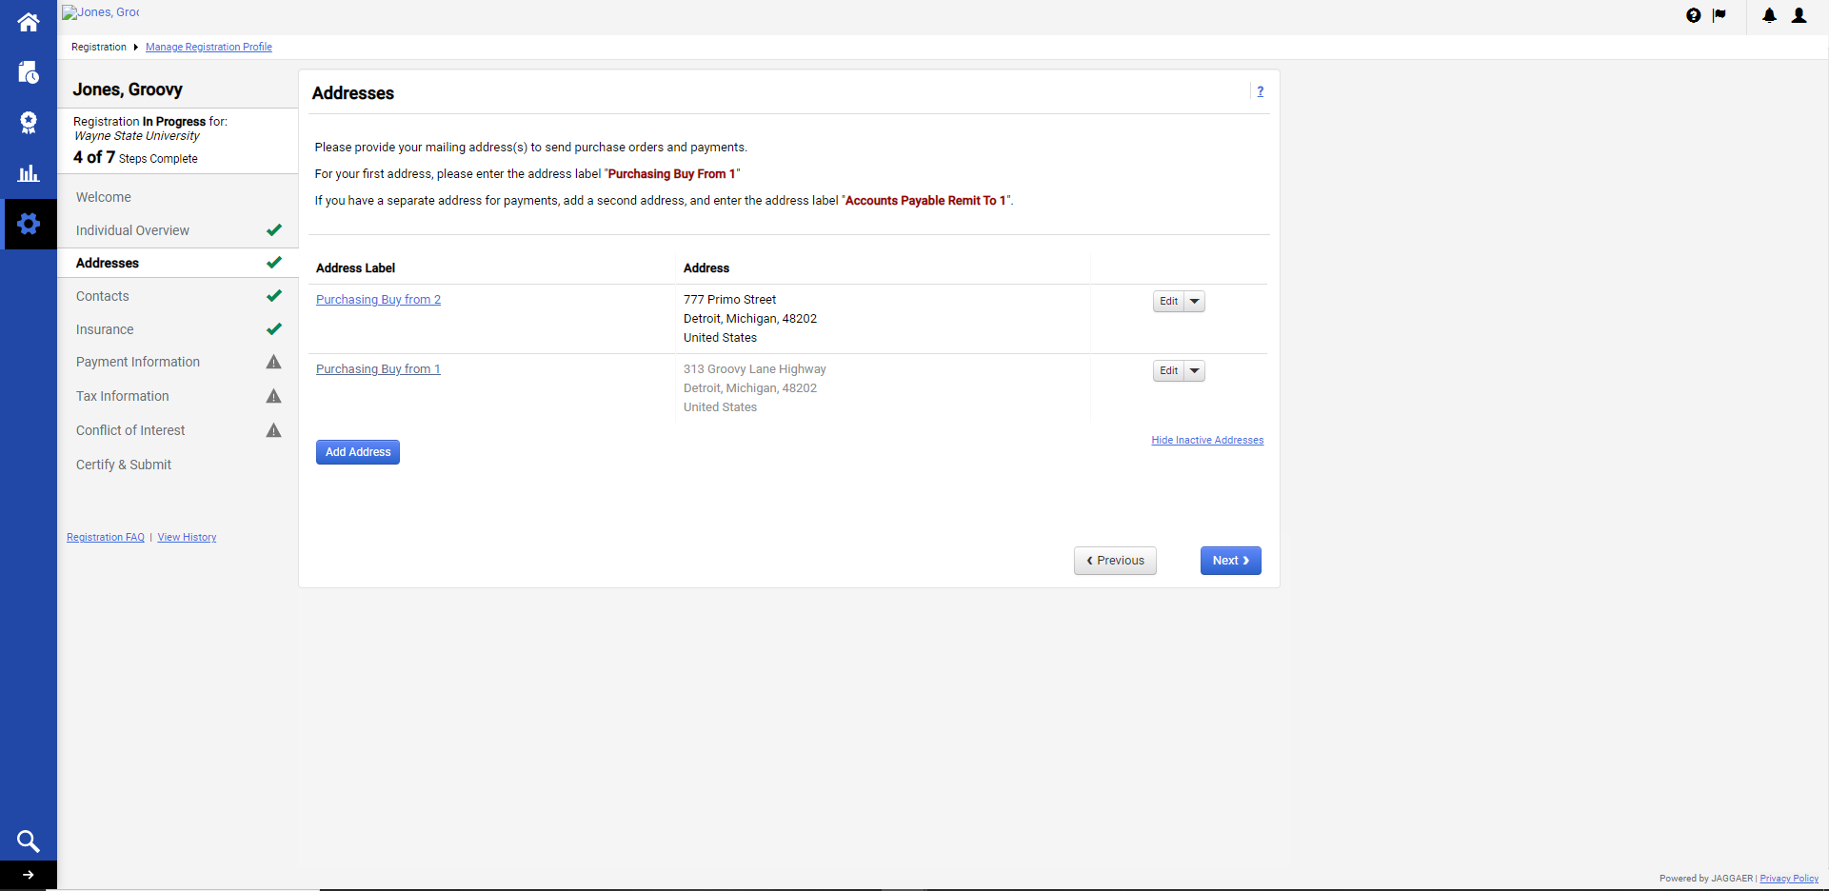

Review/update the information that carried over from the address, and add the contact label in the format provided in the address instructions. Click “Save Changes”.
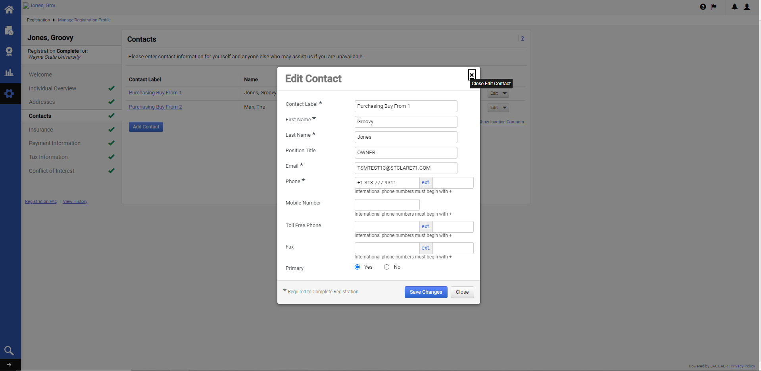
Note that more contacts can be added by clicking the blue “Add Contact” box. The current contact information can be updated by either clicking the hyperlink under the Contact Label, or by clicking the “Edit” button in the drop-down menu. Contacts can also be associated to addresses and made inactive from this menu.
If a contact is inactive, it will not show on the screen, but can be retrieved by clicking the “Show Inactive Contact” hyperlink.

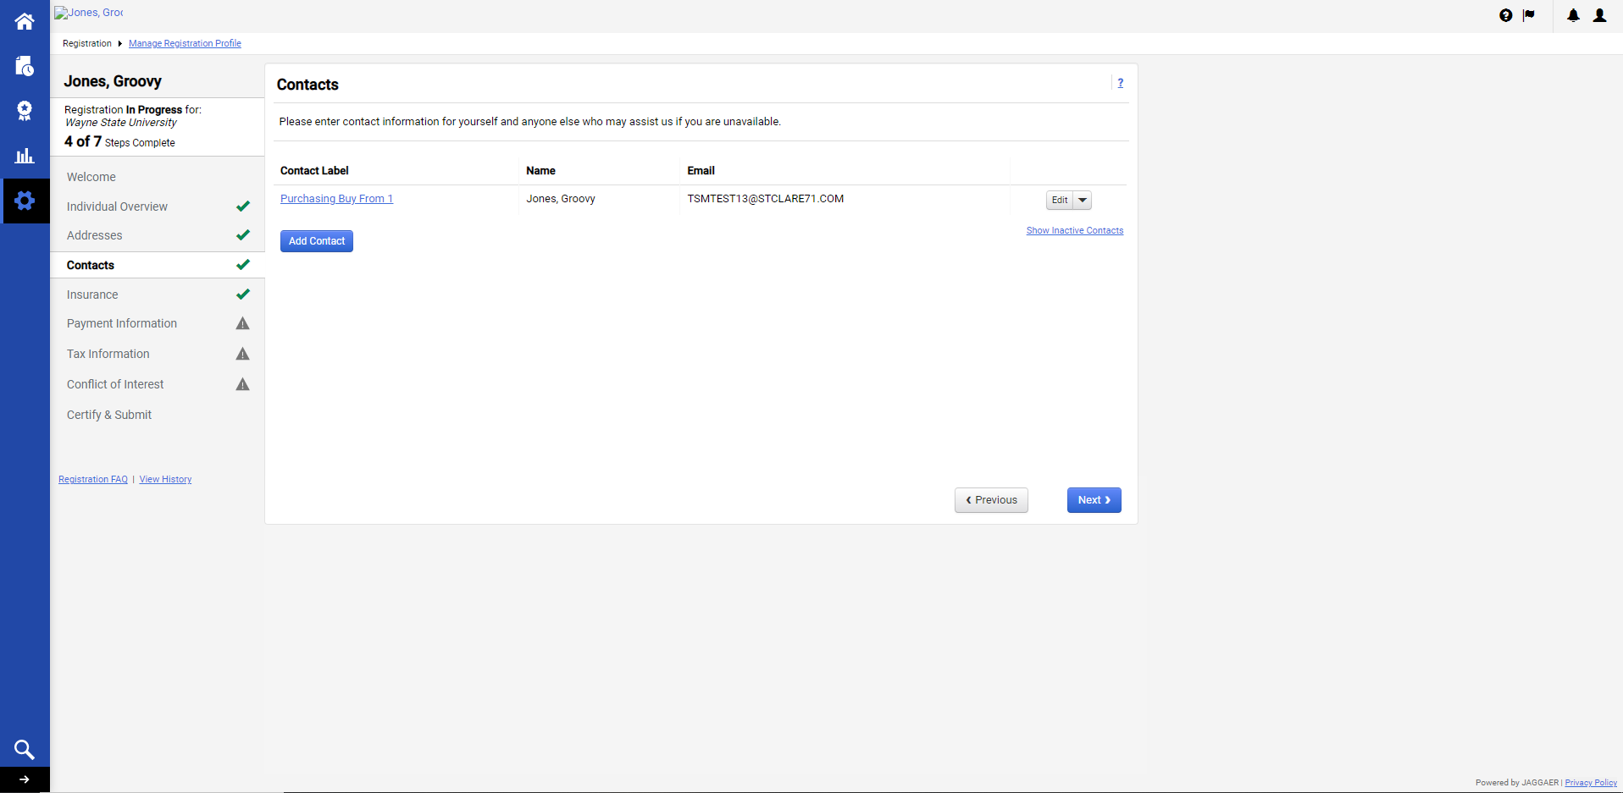

If applicable, click “Add Contact” to include additional contacts. Be sure that the Contact Label uses the format provided in the Address instructions, but use the next consecutive number available on the end. Click “Save Changes”.
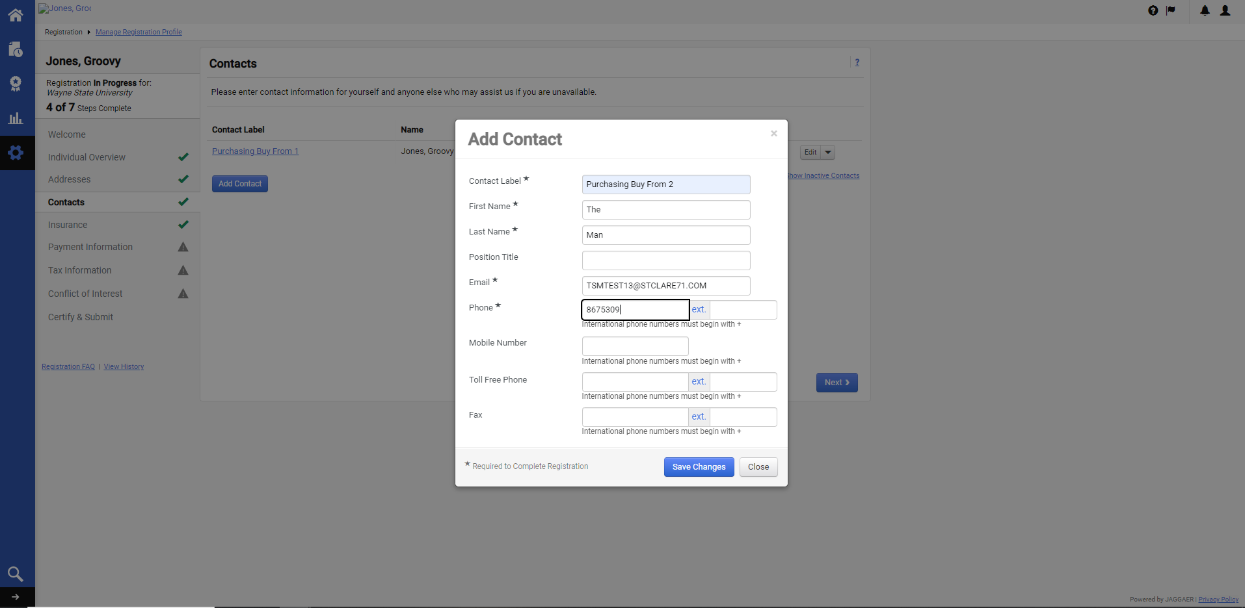

Depending on the number of address that are on file, contacts can be associated to different addresses by clicking Edit in the drop-down menu, and selecting “Manage Associated Addresses”.
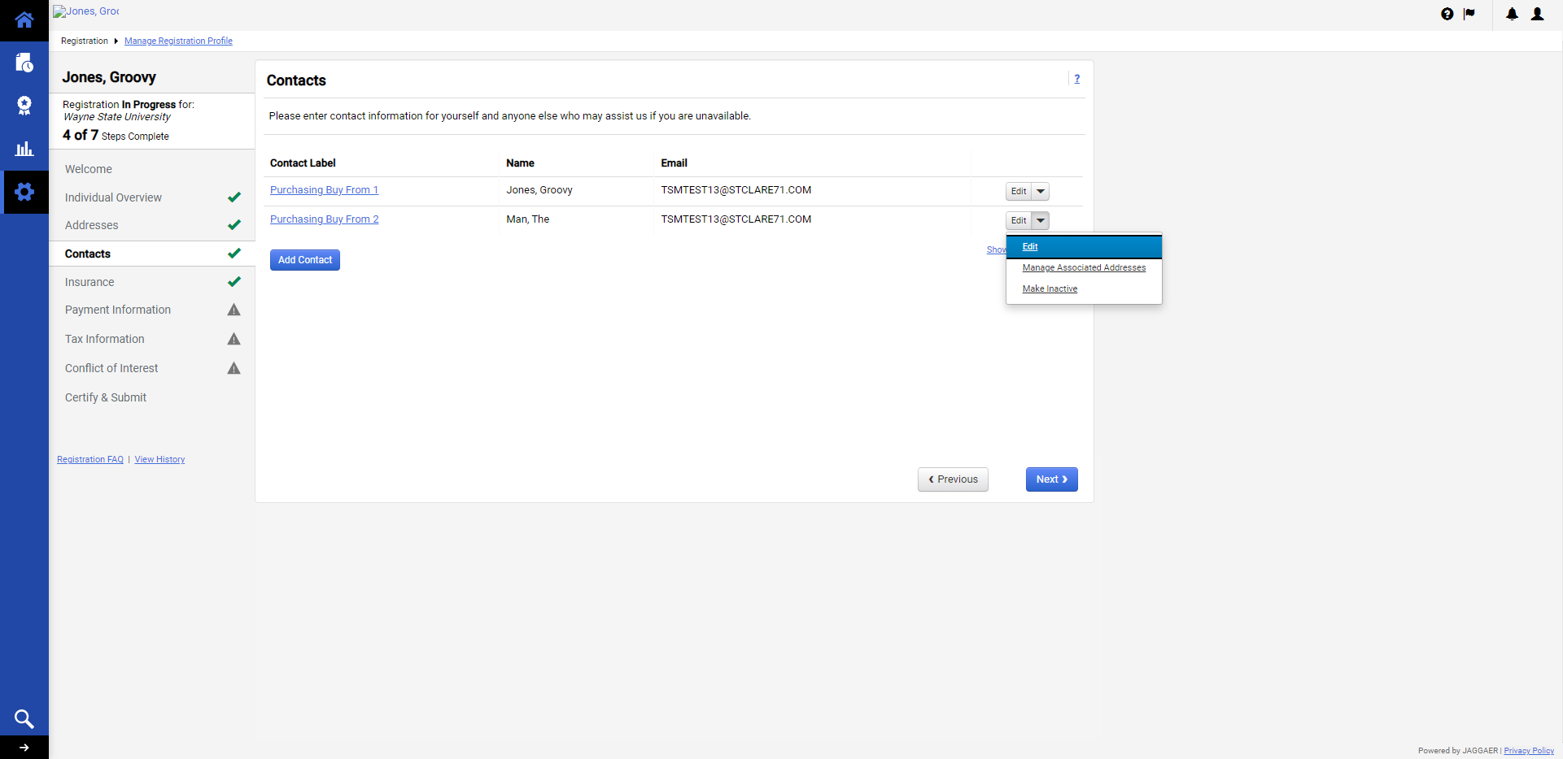
Click “Edit” to associate the contact to an address that is active.
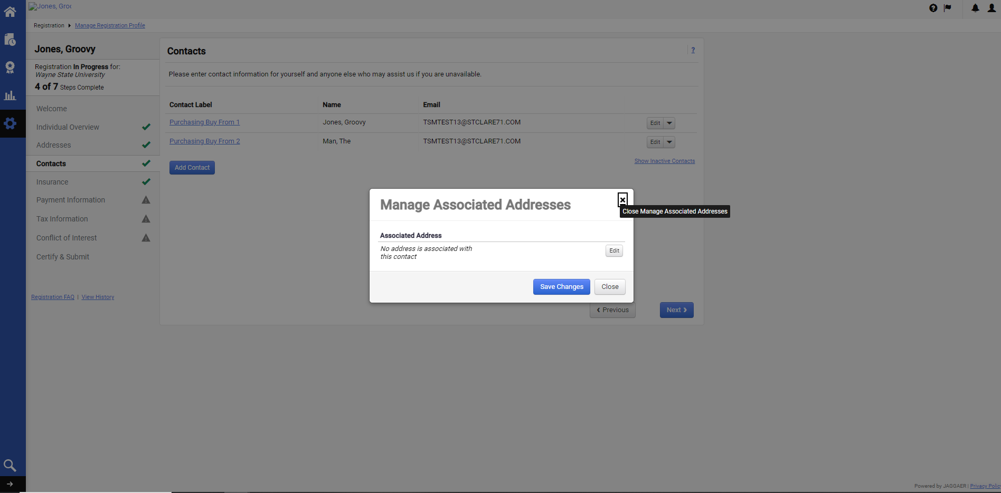
Select the address that the contact is to be associated, and click “Save”.

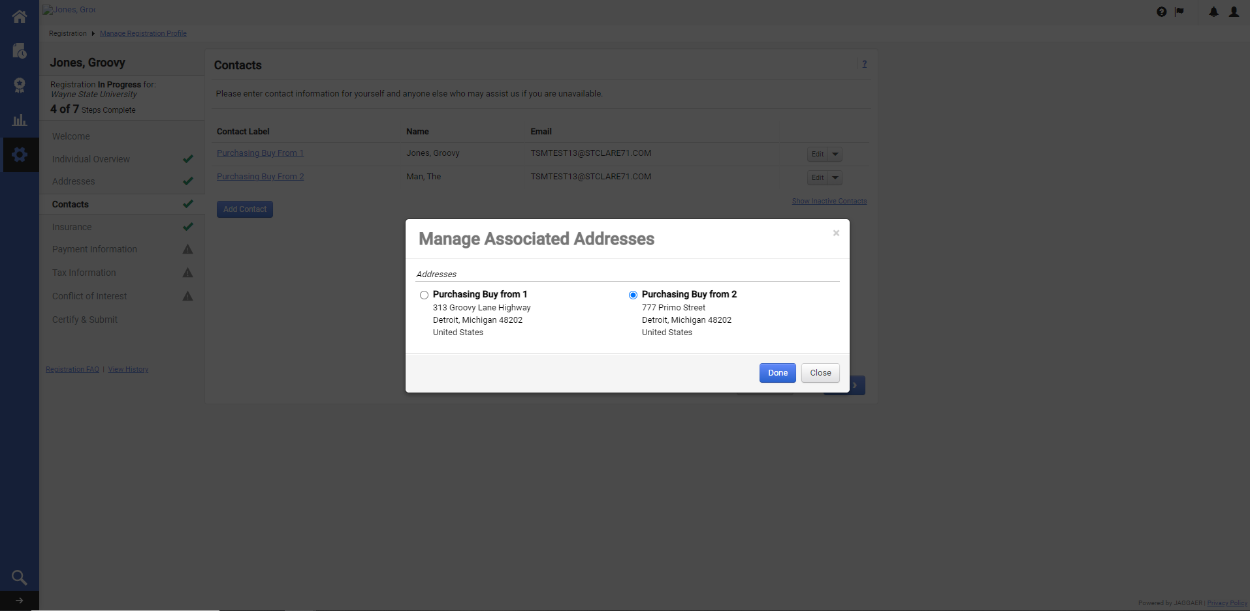

Click Next to Navigate to the Next section
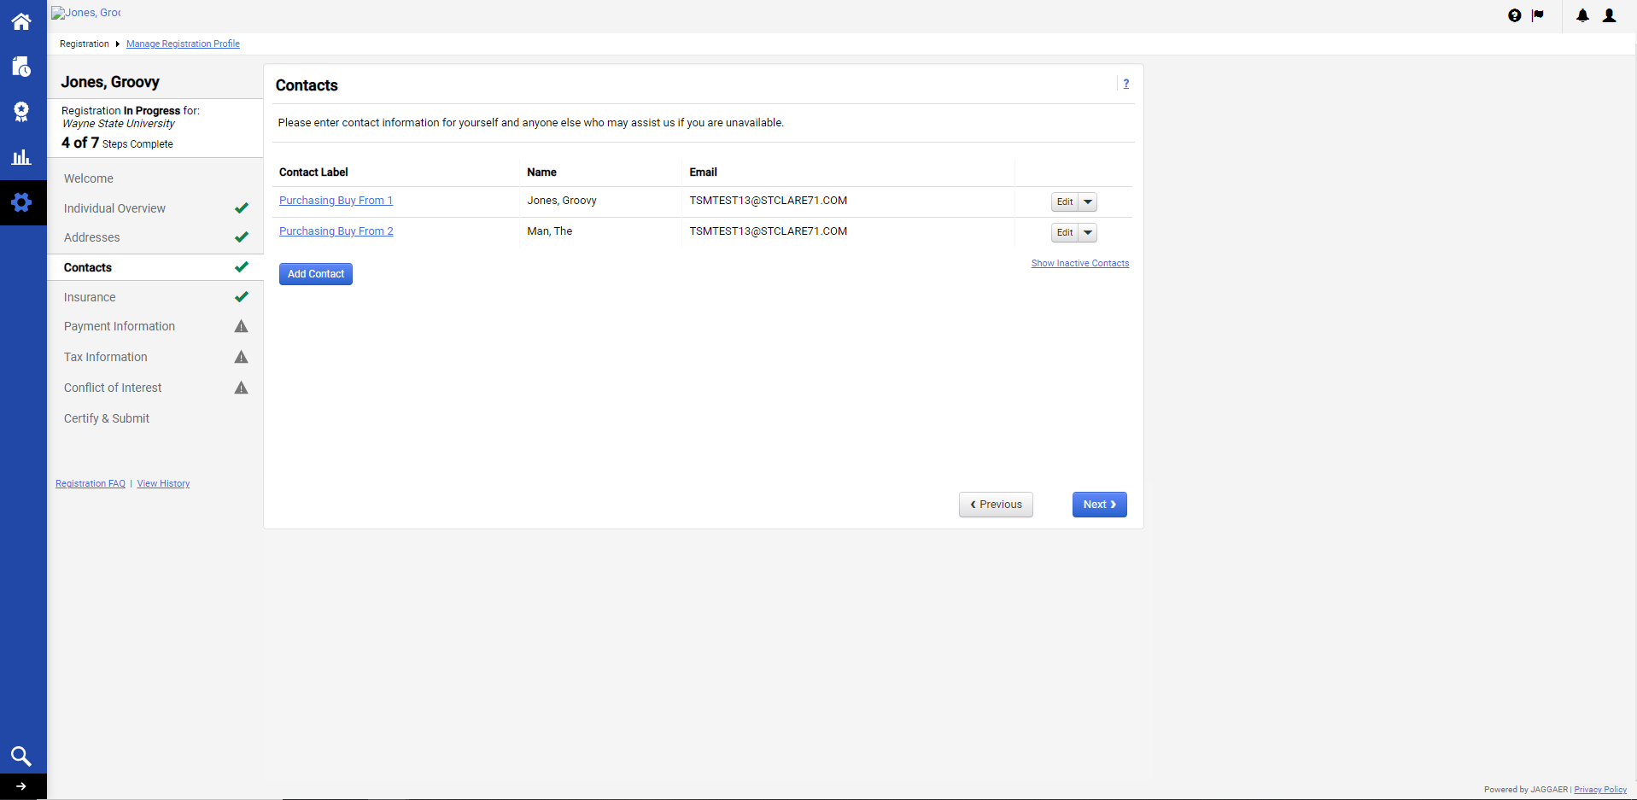

(Note that if additional addresses or contacts were not previously added, clicking next will skip over the Insurance section, and navigate to the Payment Information page.)

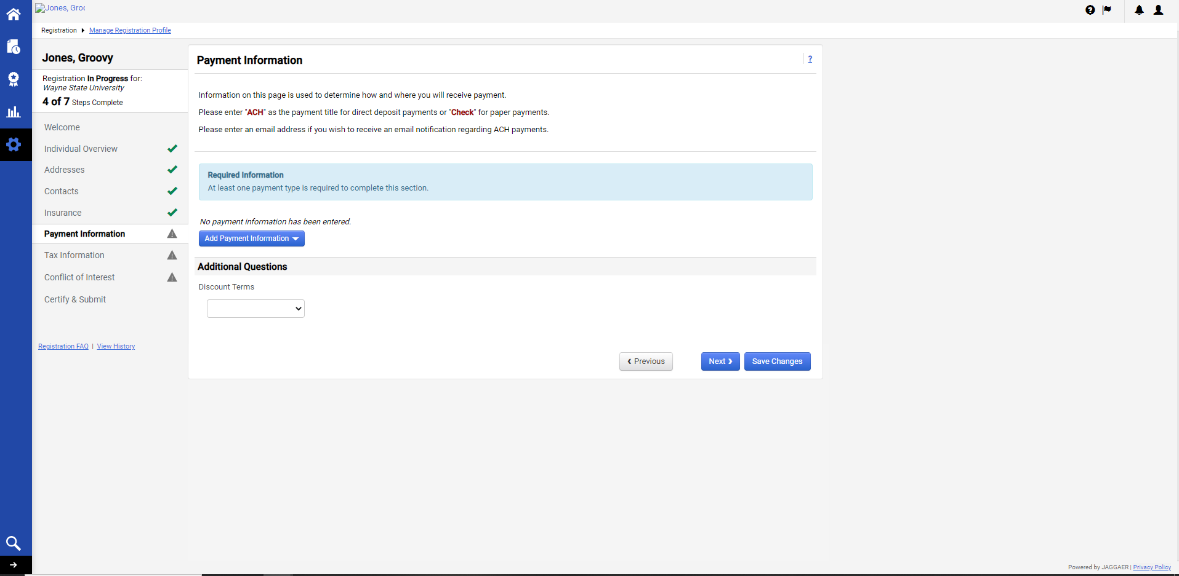

If insurance is needed, please review and update this section.
(Wayne State University requires our Suppliers to maintain appropriate insurance coverage. This includes Individuals and sole proprietorships when performing work on campus or providing professional services.)
(If not needed, proceed to the Payment Information section.)

Click the blue “Add Insurance” drop-down box.
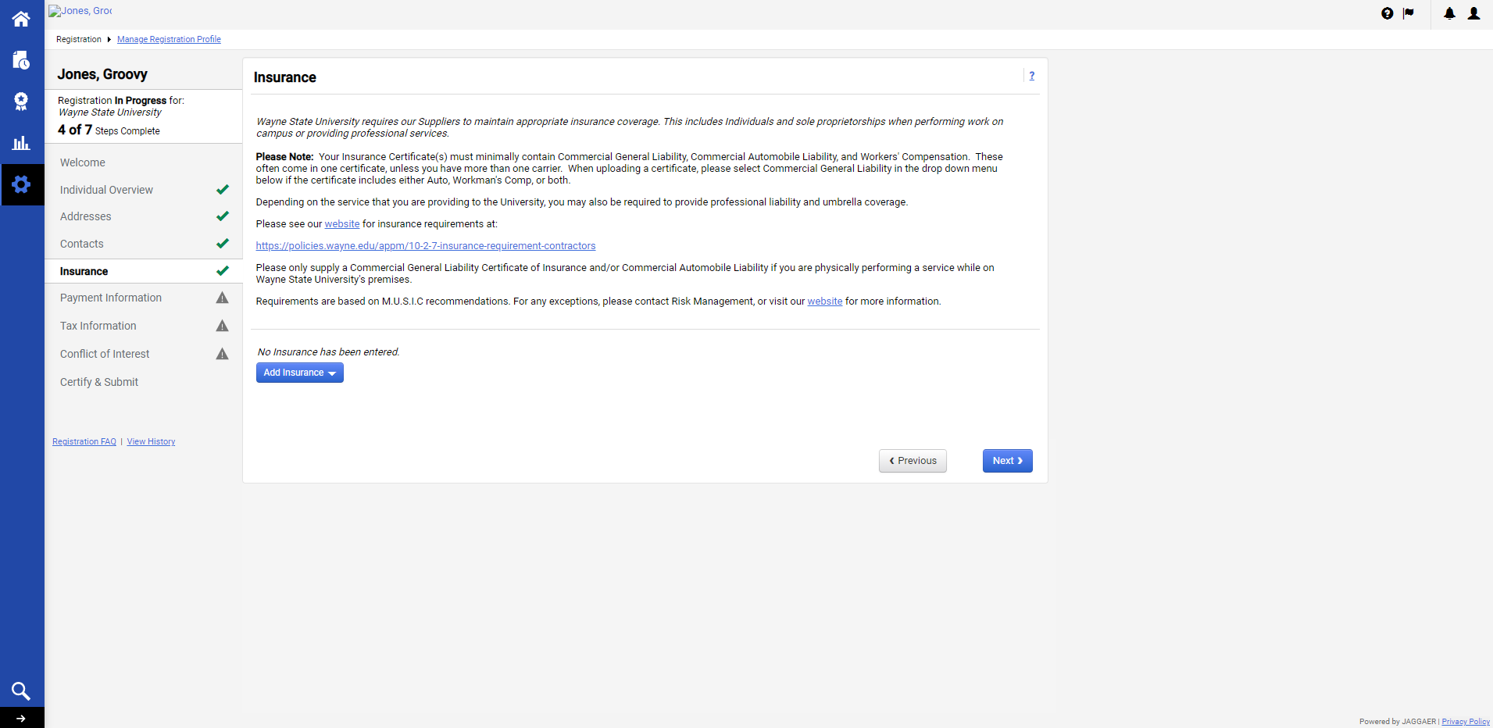
Select the appropriate level of insurance that will be needed to perform work on WSU’s campus or if providing professional services.
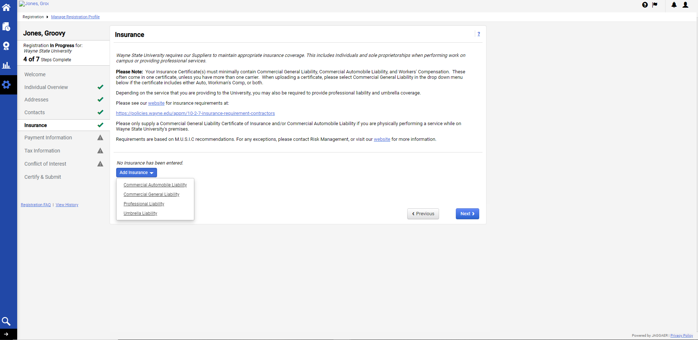

Complete the appropriate fields
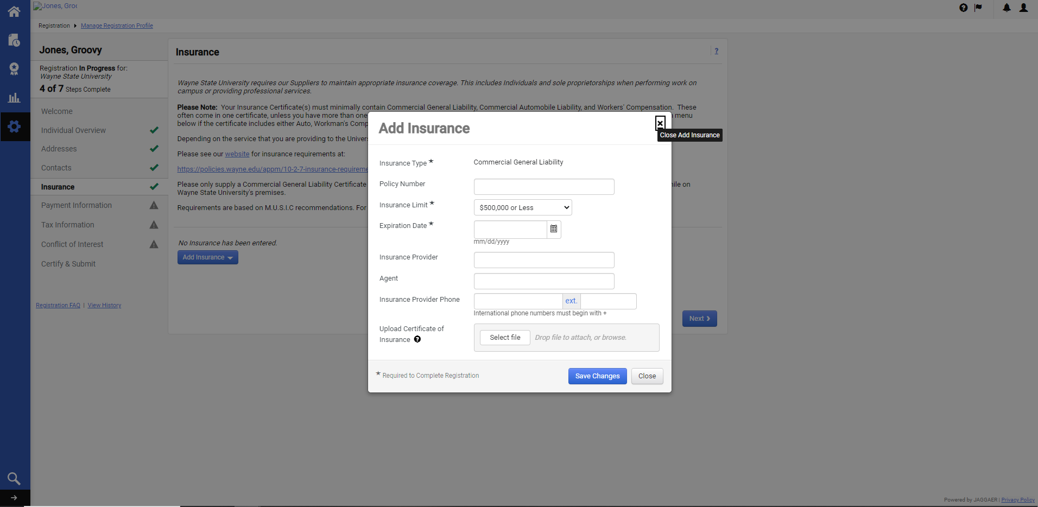
Be sure to upload the appropriate documents and click “Save Changes”.
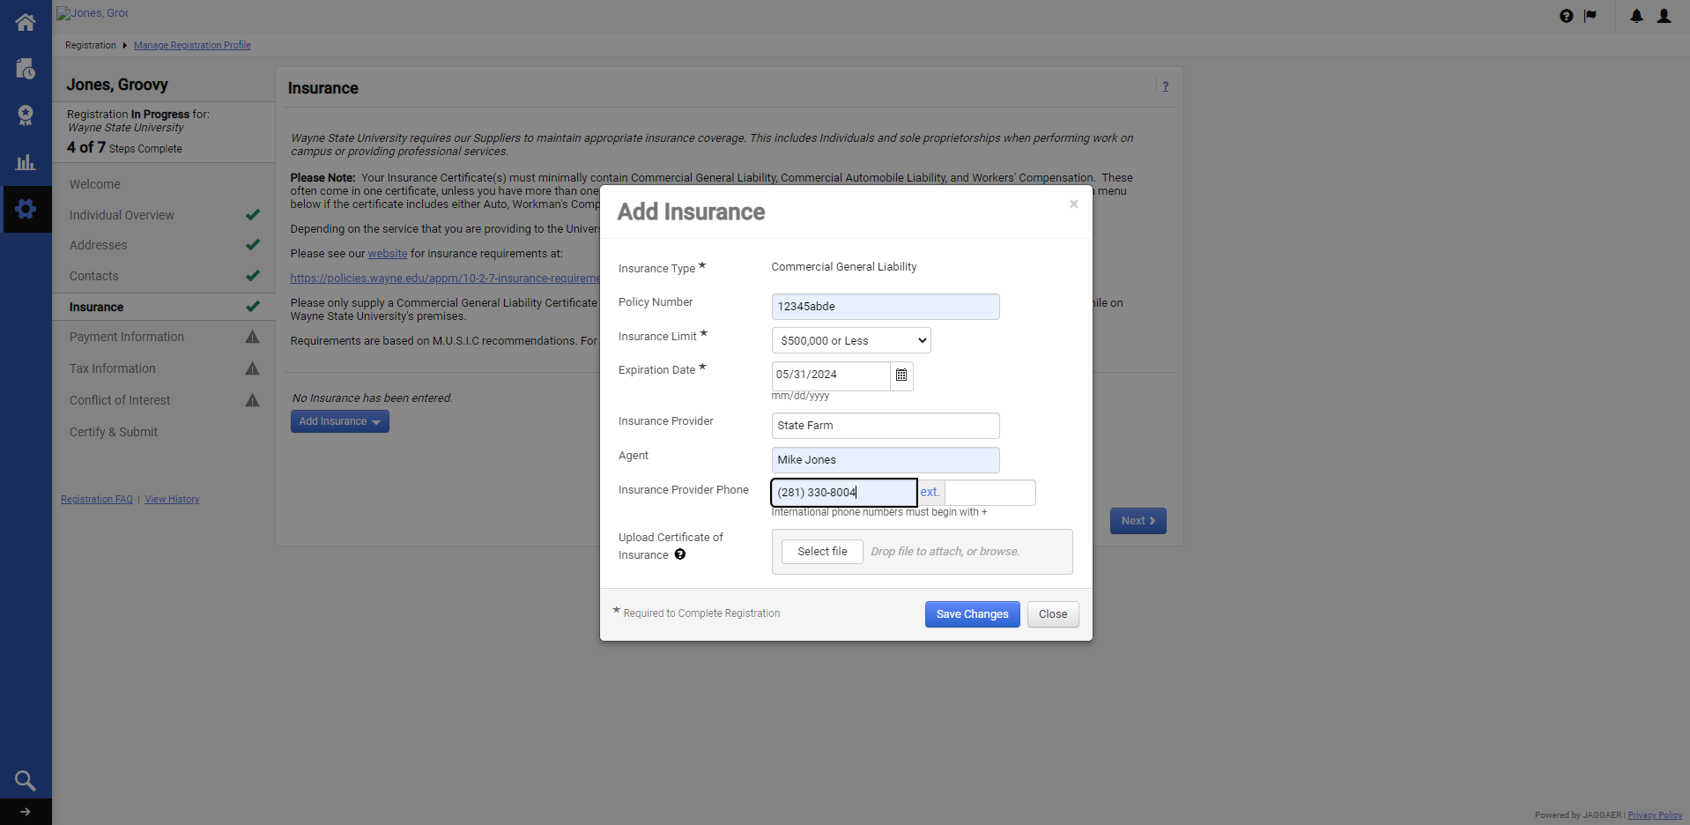

Click “Next” to navigate to the Payment Information section, or click the “Edit” drop-down box to make changes.
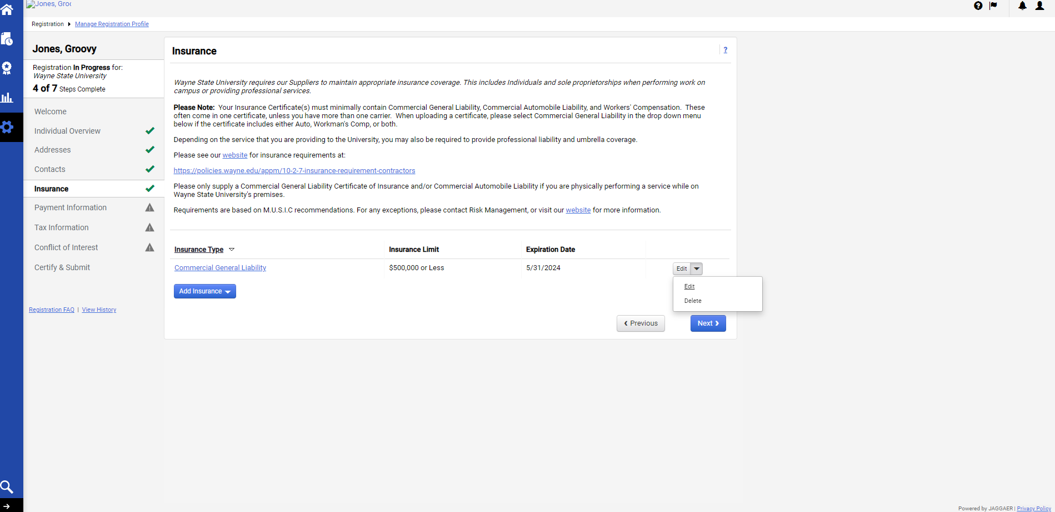

Information on the Payment Information page is used to determine how and where you will receive payment.
Please enter "ACH" as the payment title for direct deposit payments or "Check" for paper payments.
Please enter an email address if you wish to receive an email notification regarding ACH payments.

Click the blue “Add Payment Information” box to select the payment type.
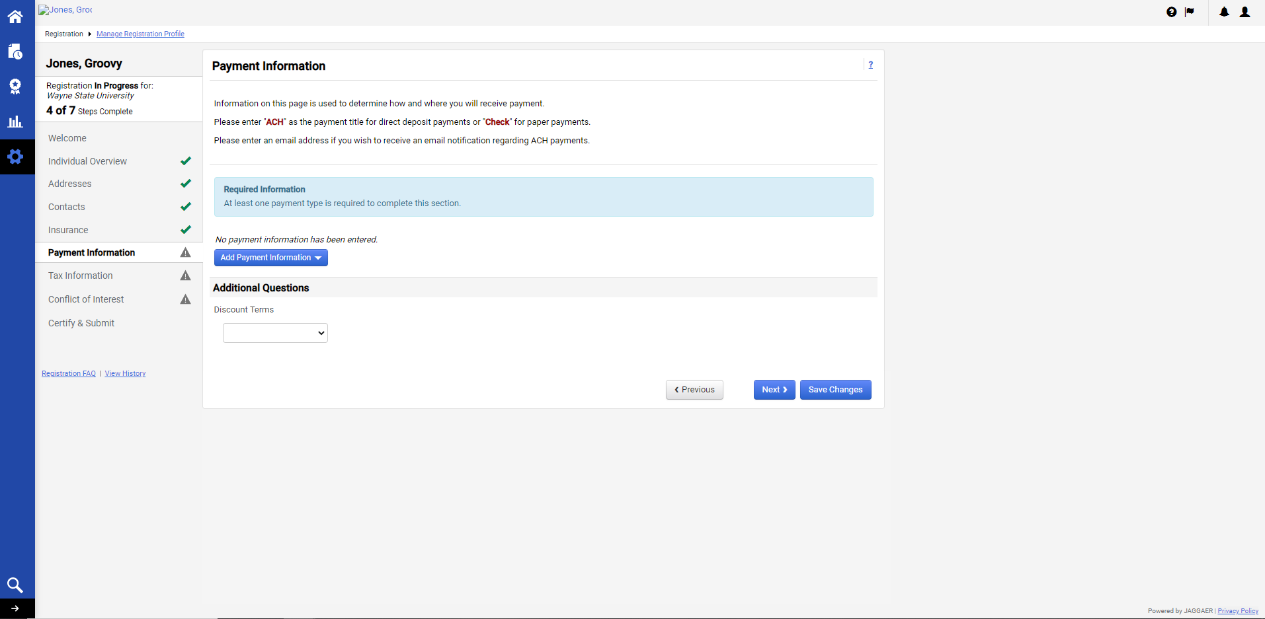
Select “Direct Deposit ACH” or “Check” as the preferred payment method.
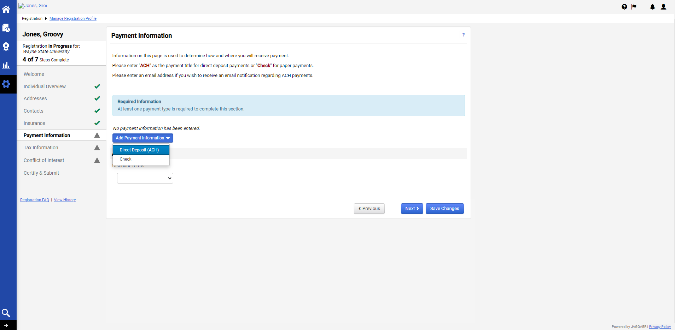

Complete the fields and click “Save Changes” when complete.
(Please be sure to type the appropropriate Payment Title as either, “ACH” or “Check”, depending on the option that was selected)
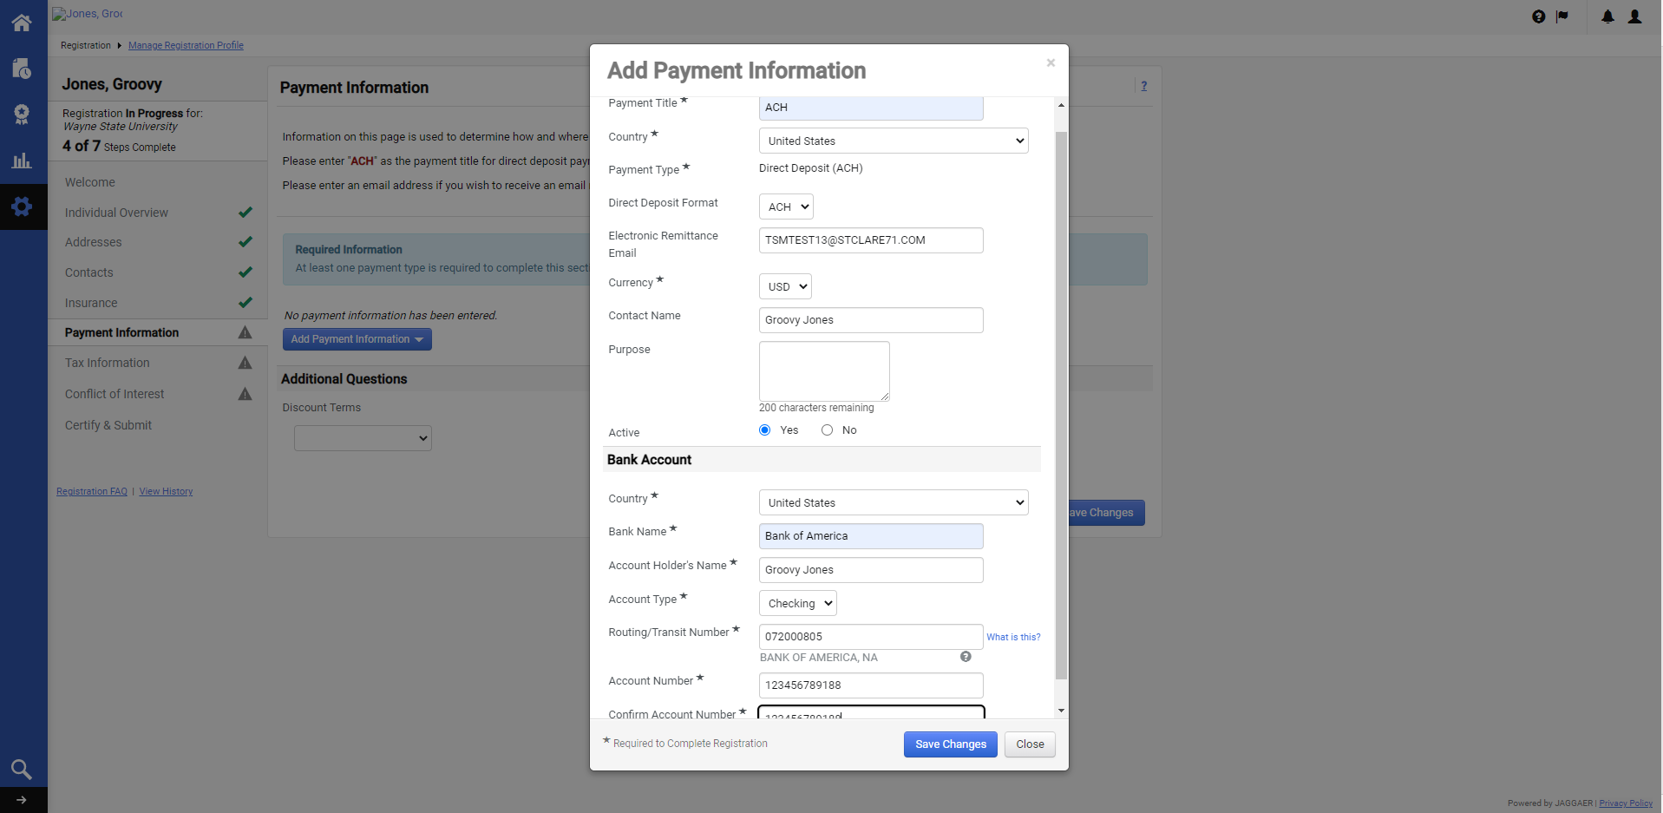
or
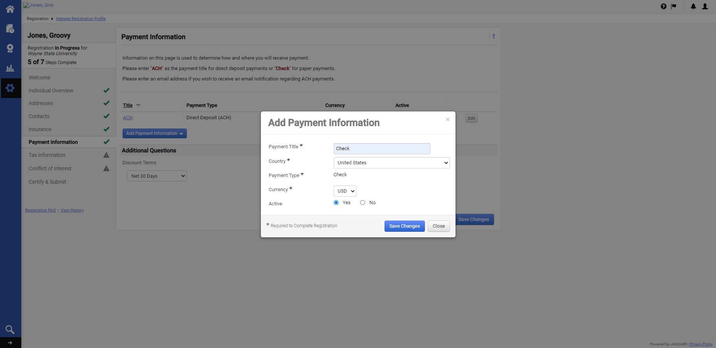

Changes can be made by clicking the “Edit” drop-down box.
Select “Net 30 Days” as the Discount Term.
Click “Save Changes” or “Next”.
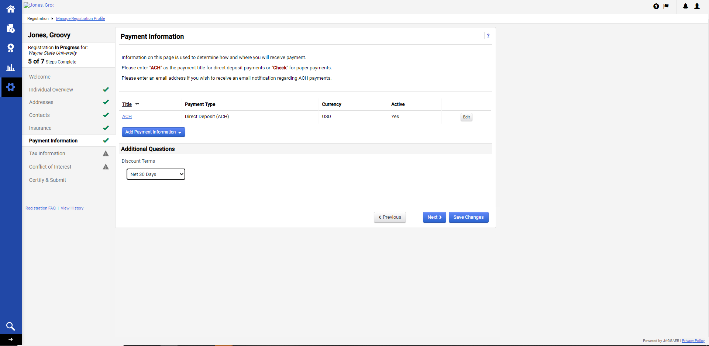

Tax information is required for IRS TIN matching and any IRS reporting.
Click the blue “Add Tax Document” box and select “W9”.
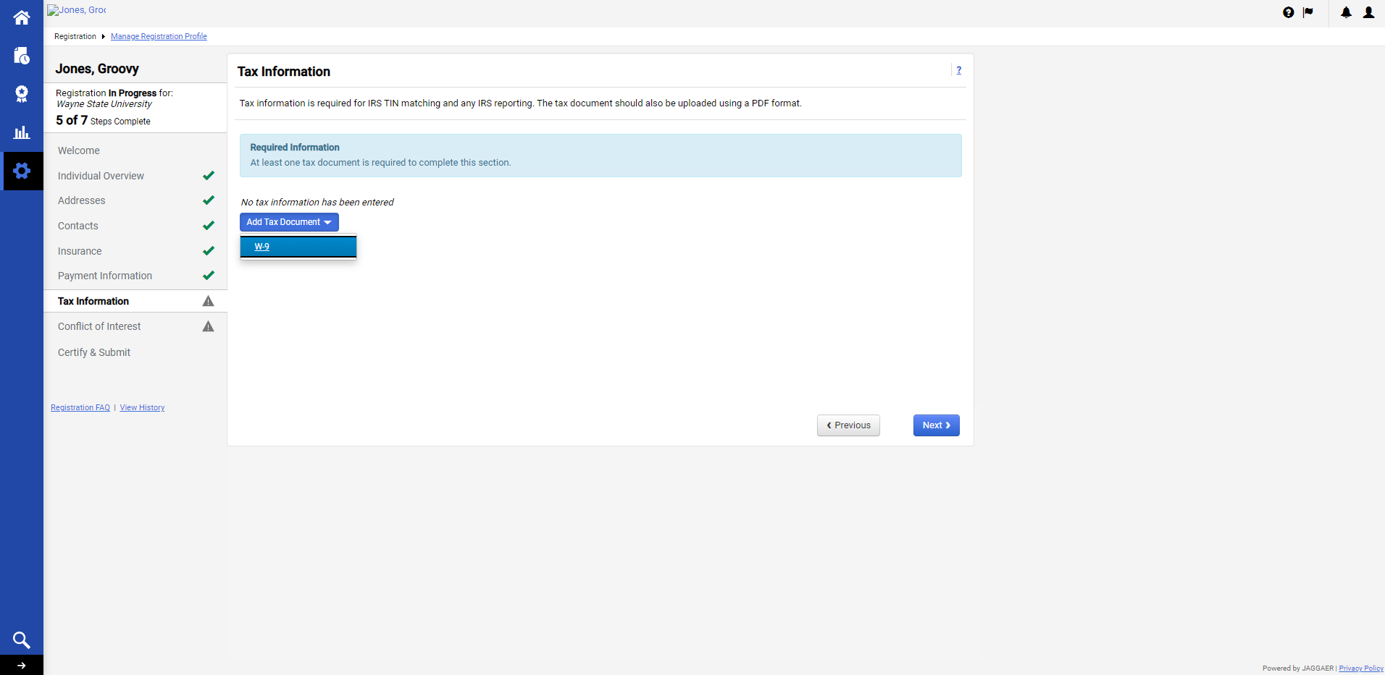
Complete the fields, upload the entity’s W9 with the appropriate signature, and click “Save Changes”.
The hyperlink provided generates a prepopulated template of the W9. (W9’s are also available on the IRS’s website)
When utilizing the template, be sure to complete all of the applicable fields, and include a signature.
WSU is unable to process request without the applicable signed documents.
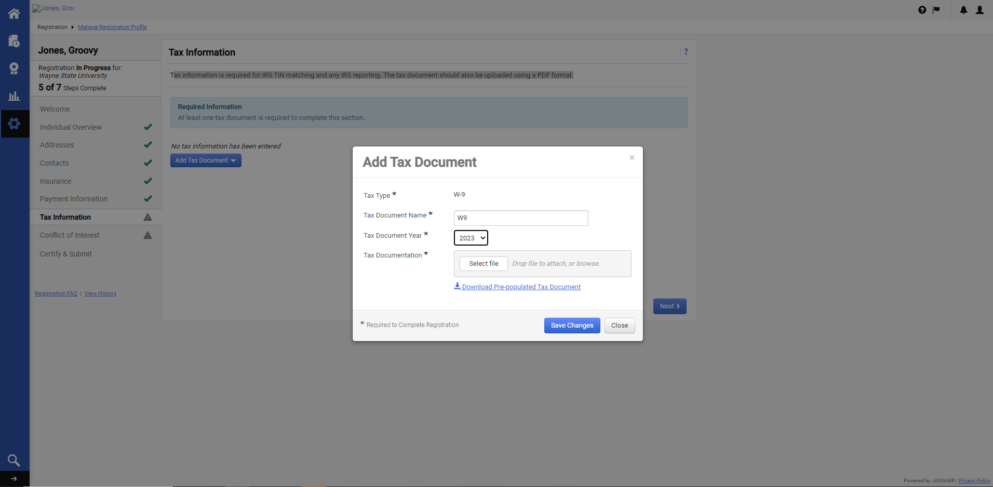
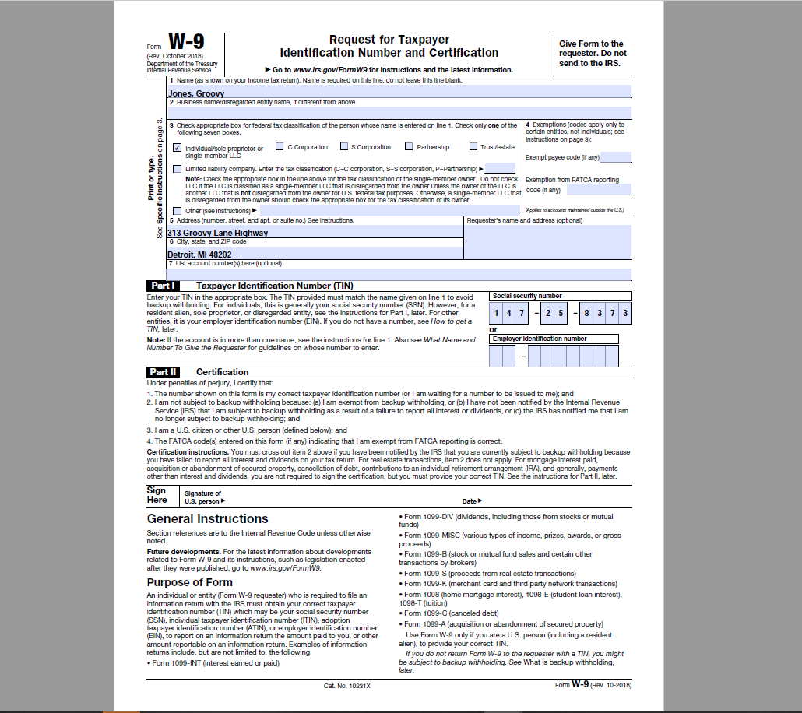

Click the “Edit” drop-down box if changes are needed. Click “Next”.
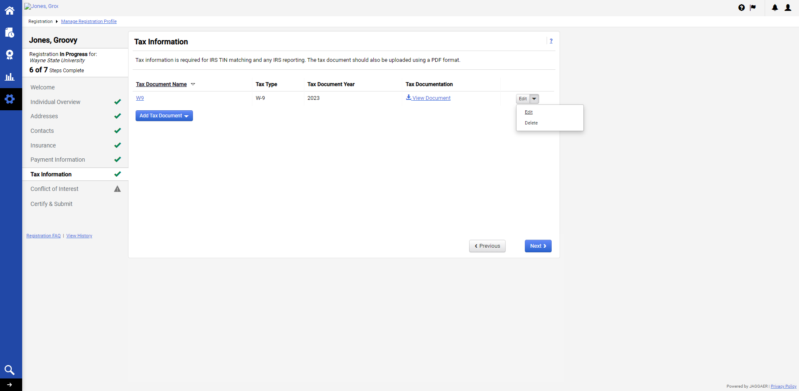

Review/answer the questions in the Conflict of Interest section and click “Next” or “Save Changes”.
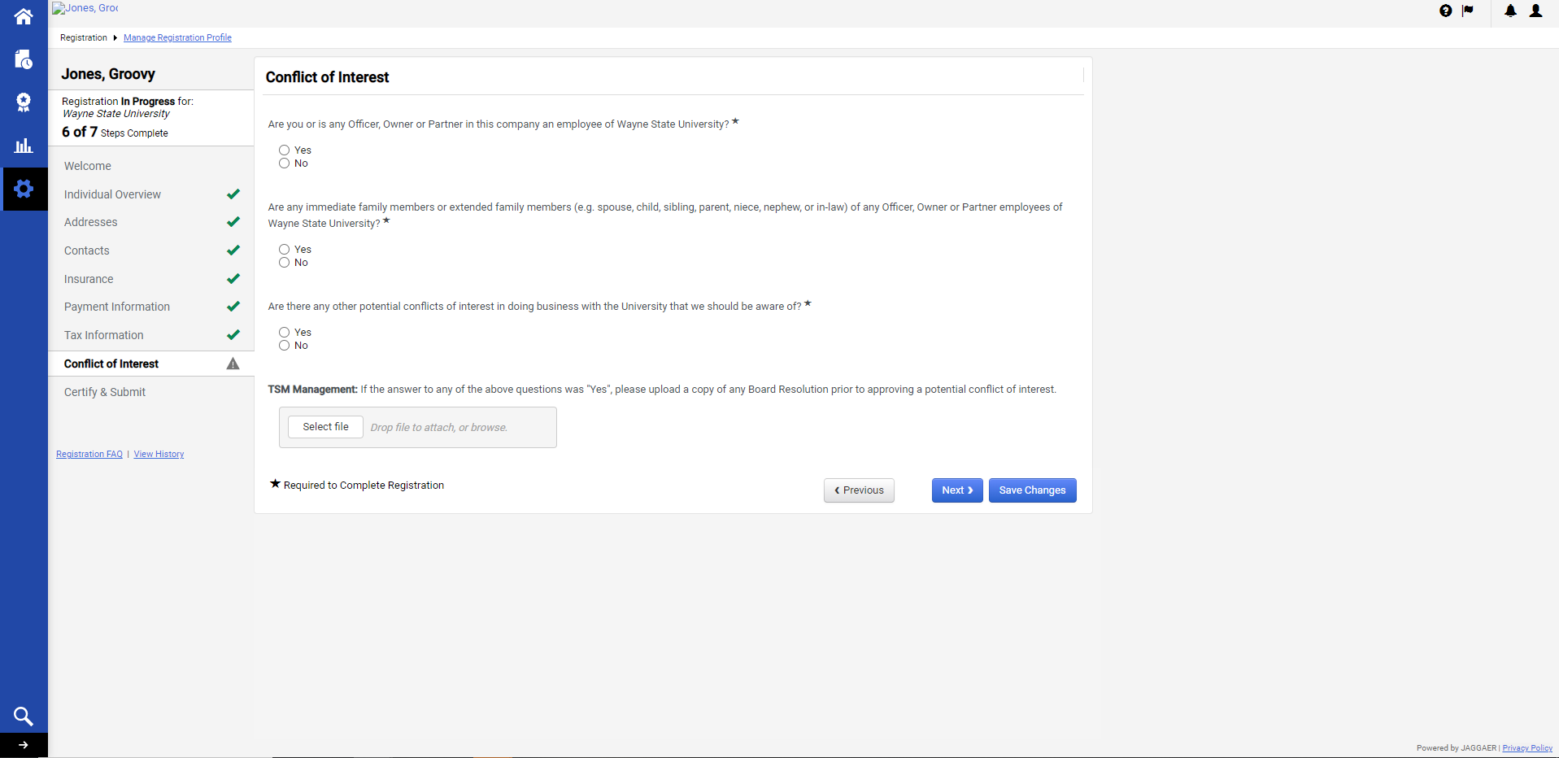

Review and complete the fields. Check the Certification box, and click “Submit” to certify that all of the information provided is true and accurate.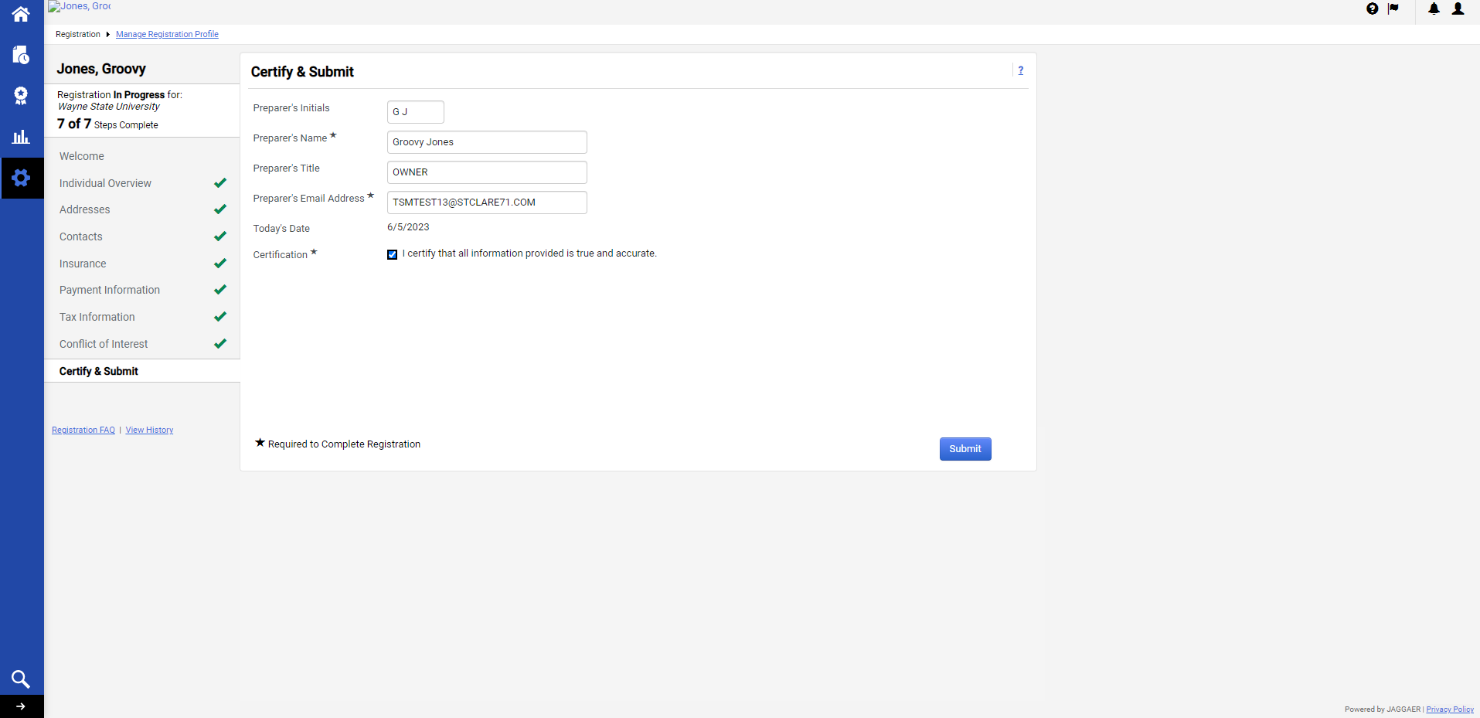

Congratulations! Registration has been completed. Click the hyperlinks to navigate to the Home Page, back to the Registration Profile, or log out by clicking the Profile icon in the upper right.

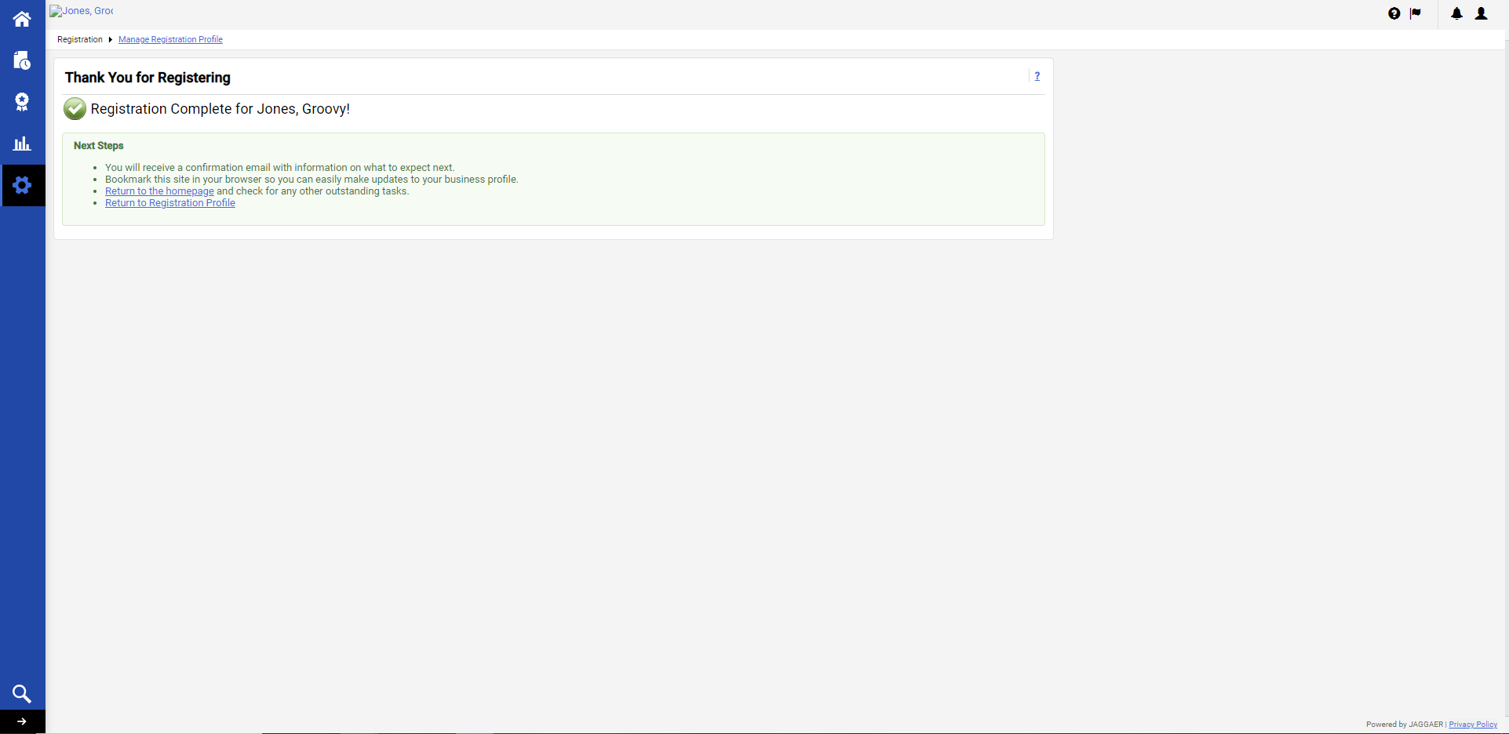

An initial Registration Email will be sent with a link to the Customer Portal.

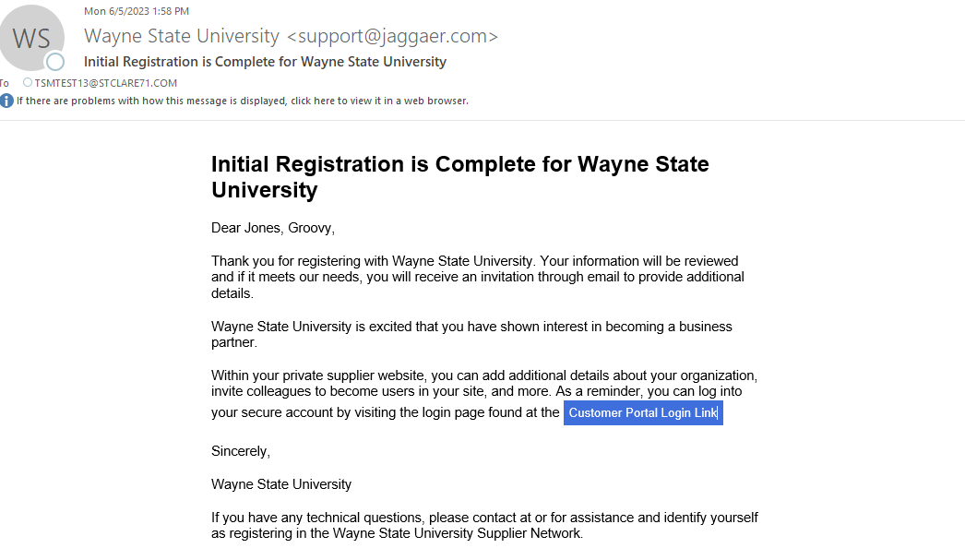

Wayne State University’s vendor team will review the registration for processing.
Please allow up to five (5) Business days to process the registration.
Once approved, an email will be sent to the email address provided within the profile, of both the vendor and the department contact, that the setup is complete.
Be sure to also look for any action items or notifications via the icons on the Customer Portal.
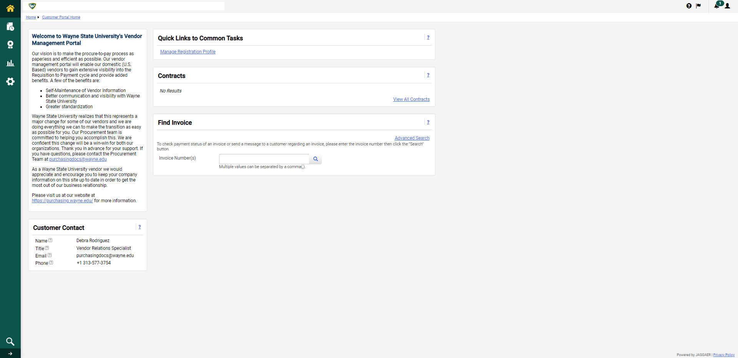

Any changes that are made to the profile after the final approval is subject to review by the WSU vendor team.

