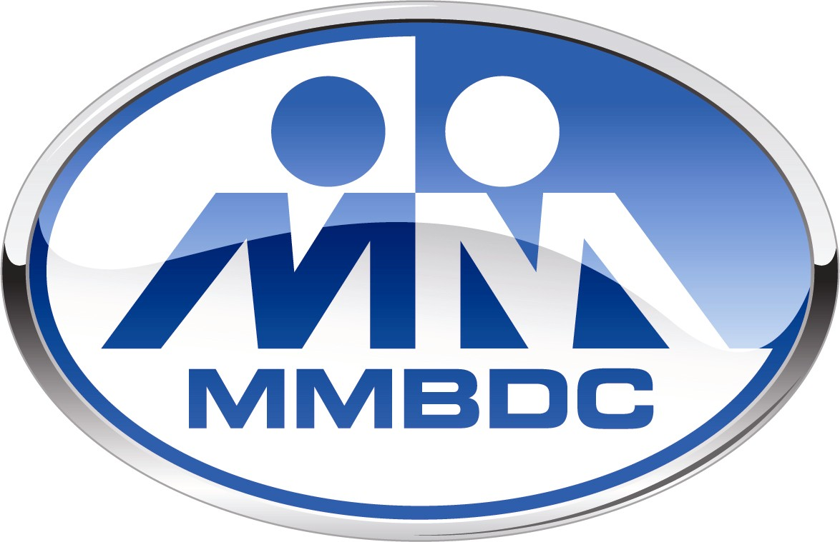

**MICHIGAN MINORITY SUPPLIER DEVELOPMENT COUNCIL**

**PROJECT ONE (OPERATION NETWORK ENHANCEMENT)**

The Project ONE program is designed to enhance business relationships between minority businesses and corporations through business education training and knowledge sharing. It provides minority businesses with mentorship from dedicated corporate leaders, along with access to internal corporate customer meetings and bid opportunities.

The Project ONE program began in 1998 and continues to spark strategic business relationships between majority-owned corporations and minority businesses. Corporations have benefited from Project ONE’s focus on long-term growth and lasting partnerships, while also meeting and in some cases exceeding supplier diversity objectives in the process.

**MISSION STATEMENT**

Project ONE mission is to enhance successful business relationships between Minority Business Enterprises (MBEs) and Corporate Members through the implementation of “Business Modules.” The purpose is to grow minority business enterprises which have the capacity to compete for corporate contracts.

**GOALS**

* To assist corporations which seek to strengthen/launch their minority supplier development programs
* Implement NMSDC minority procurement and minority supplier mentoring best practices
* Establish “business modules” that will significantly increase procurement from Minority MBEs by corporations utilizing a collaborative mentoring process
* Enhance the existing corporate membership programs of MMSDC/MMSDC by increasing the number and expectations of corporations.
* Increase corporate/MBE participation and financial support of MMSDC/MMSDC major Networking Programs

**MODULE**

* MMSDC business module is small working group which consist of 5-6 Corporate Members and 10-12 Minority Business Enterprises (MBEs) selected by the corporate members based on projected target opportunities. This will be kept on a 2-1 ratio (MBEs to Corporate) per module.
* Each business module shall is lead by a corporate member called the “module leader” and their company name would be designated as the module name, i.e. the “Company Name” Project ONE Module.
* The module leader will select or recruits 7-9 additional corporations who have meet the qualifications as outline by MMSDC to establish the nucleus, and specific goals of the Module (Exhibit I).
* The module leader will report metrics, status and issues to MMSDC on a quarterly basis on appropriate forms.
* Corporate and MBEs are required to participate in a module for 24 months, at the end of that period, the module graduate both corporate members and MBEs. Corporate members will be encourage to establish new modules and serve as leader
* A multiple commodity focus is encouraged in the module.
* Each module is expected to meet at least quarterly.
* Attendance should be taken at all meetings.
* Rules for attendance (70% per year) should be established; Knowledgeable alternates are acceptable.

**OBJECTIVES**

The Module is expected to meet formally on a monthly basis at minimum and have four primary objectives:

* To increase and report the amount of MBE purchases from the corporations, MBE to MBE sales, increase sales of the MBEs, and non-financial/mentoring activity within the Module ;
* To assist each other (Corporate and MBE module members) in improving their minority supplier develop processes (i.e., mentoring, commodity plans, joint venture formation, via NMSDC Best Practices.) and,
* To increase participation in all “key” programs and signature events of the MMSDC (e.g., Membership Drives, MMPC-Trade Fairs, Golf Tournament, Awards program, etc.).
* To assist corporate recruitment and increase corporate membership in MMSDC.

**BENEFITS**

* Provides opportunity for corporations to benchmark successful minority supplier development strategies among corporate peers.
* Provides increased business opportunities for both Corporate and MBE members through learning from each other’s competitive strengths.
* Has a greater impact on improving the economic environment of the community by reinforcing the concept of buying among and between Corporate and MBE companies.
* Closer aligns the sales methods of minority organizations with the procurement processes of Corporate module members
* Improves competitive market position by helping corporations satisfy the expectations of an increasingly diverse customer base.

**METRICS**

* Number of corporations and MBEs which participate.
* Dollar value of goods and services purchased from MBEs by Corporate module members.
* Sales dollars of MBEs within the Module.
* Annual increase of dollar value of goods and services purchased from MBEs by Corporate members within the module.
* Annual increase of sales dollars of MBEs within the Module.
* Referral activity within Module or between Modules
* The module leader will track activities of corporate module members.

**CORPORATE EXPECTIONS**

* Corporate Membership –Local or National
* Project ONE 2.1 Corporate Application
* MMPC & Opportunity Fair: booth or higher sponsorship
* MBE sourcing business opportunity leads (listed in corporate project one application)
* Report annual purchasing activity report and quarterly MBE spend to MMSDC
* Report module MBE spend to module leader
* Participate in corporate supplier diversity assessments and core curriculum sessions
* Maintain 70% module attendance with module