|  |  |  |
| --- | --- | --- |
| wsu-primary-horz-color-600-10-2017-small  **Division of Finance and Business Operations** |  | **Business Services**  **5700 Cass Avenue, suite 4200**  **Detroit, Michigan 48202**  **(313) 577-3734** |

June 05, 2023

**Subject: Notification of changes to the vendor creation process**

We have made changes to the process, documentation and administration related to vendor creation and vendor record management as a result of an ongoing review designed to both expedite setting up new vendors and having a more secure process for vendor sensitive documents. These changes will strengthen the overall control environment, and will be effective June 05, 2023.

**Procedure and Documentation**

There are essentially five ways a Vendor is added or updated in WayneBuy:

1. Employee Payment
2. Regular New Vendor (individual or company)
3. Activation of an Inactive Individual Vendor
4. Activation of an Inactive Company Vendor
5. New International Vendor

Each of these methods has a tile in WayneBuy to facilitate the process. However, the tile for most common method, creation of a new Supplier or Payee vendor, is really only an informational tile providing information that can be sent by email to your supplier.

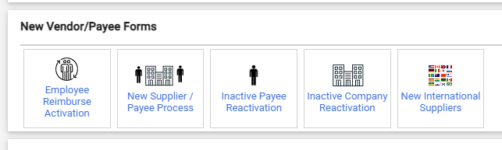

Below is a discussion of each scenario and when it applies:

**Employee Payment**

Since University employees are not eligible to be suppliers to Wayne State, the only purpose for setting up an employee is for reimbursement of personal funds for some purchase made on behalf of the University. Employees are not retained the WayneBuy system as active suppliers. To temporarily activate an employee, complete the Employee Reimburse Activation form. All that is required is to provide the:

* Employee Name,
* Employee Access ID
* Mailing Address for any payment

Employees who prefer direct deposit for accounts payable purposes should update their personal information in Academica. This is a separate process from the direct deposit information for payroll purposes. Both payroll and accounts payable information can be updated by navigating to Academica / Employee Resources / Employee Self Service / Direct Deposit / Update Direct Deposit. The Student & Accounts Payable Direct Deposit is a section beneath the Pay Distribution section.

**Regular New Vendor**

Before determining that a Vendor is or will be a new Vendor for the University, it’s important to first verify they are not in WayneBuy, either as an active or inactive supplier. To do this, use the “Suppliers” icon in the left margin of the WayneBuy home page, and navigate to Suppliers / Manage Suppliers / Search for a Supplier

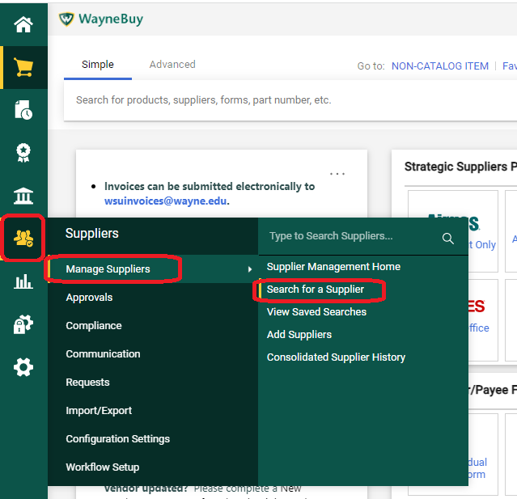

In the pop-up field, enter appropriate information to search for your supplier. The result will be any active or inactive suppliers with a matching name, along with their Vendor number, such as the search below for Jet’s Pizza:

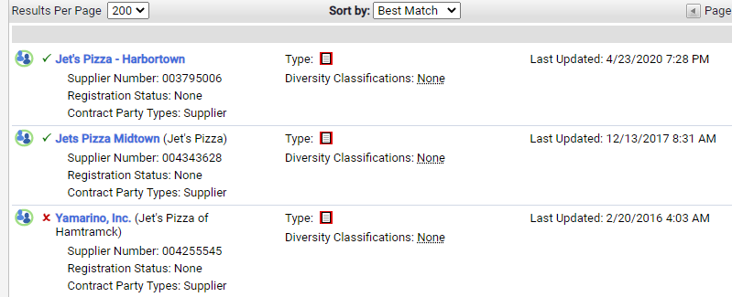

If you have a potential match, you can click on the Vendor to see additional details, including addresses and contacts. If the Vendor does exist, but is inactive, do not follow the Regular New Vendor process, but instead use the Reactivation process for either individuals or companies described in the section following this one.

Once you’ve ascertained that you do need a new supplier added to WayneBuy, you can either copy and email your supplier the summary supplier information found in the New Supplier / Payee Process tile, or copy and email the more detailed description found on Procurement’s website / Forms page:

[New Vendor Request - Business and non-Employee Individuals](https://procurement.wayne.edu/new-vendor)

Both the tile and the website provide your vendor with an overview of our process, and a link they can use to begin a self-registration. Once they have completed all the fields on the individual pages, the request comes to Business Services, where it is assigned to a member of the Vendor Management team, is validated, and if appropriate, approved. In the self-registration form, the Vendor is asked who at the University should be notified when they are approved, and this information is used to alert you when the Vendor is available for Requisitioning purposes.

The Vendor is required to upload their W9, and any insurance or other appropriate certificates. In this revised process, you should not ask for nor accept any PDF documents of this nature. Normal approval processing time is 3 to 5 days.

**Activation of an Inactive Individual or an Inactive Company Vendor**

If the search for a Vendor results in a match with an inactive vendor, flagged with a red “X” like Yamarino, Inc. below, complete one of the two Reactivation forms, depending on whether your Vendor is an individual or company.

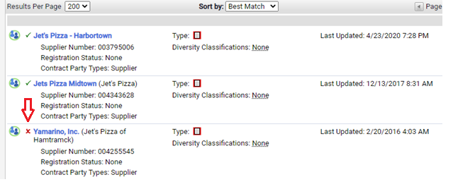

There are only 3 required fields, your Vendor’s name, Vendor’s Supplier Number, and your department’s internal contact & email. If you have your Vendor’s contact information, that will help insure we send a request to the correct person or default email.

A reactivation works similar to a New Vendor, but with a reactivation, the Vendor Management team goes into the existing record and invites the supplier from within WayneBuy to update their information. This prevents the creation of duplicate record. Upon receipt of the updates, the Vendor Management team will review the information, and if appropriate, will approve it. If the Vendor has included the Requesting Department contact information we provide at the time we send the invite, you’ll be notified by email on the supplier has been updated and activated.

**International Vendors**

Due to the lack of a US based taxpayer ID, International Vendors are not eligible for the self-registration / self-maintenance process in WayneBuy. Thus, International Vendors must be set up in the same manner as the older PDF process. The Department sends the International Vendor the appropriate of 1 of the following 2 forms:

* [International New Vendor Request - Businesses](https://procurement.wayne.edu/docs/vendor-form-businesses-writable.pdf)
* [International New Payee or Vendor Request - Individuals](https://procurement.wayne.edu/docs/vendor-form-individuals-writable.pdf)

The supplier completes the PDF writable form and returns it to the Requesting Department, along with the appropriate [**IRS W-8 Forms**(foreign)](https://procurement.wayne.edu/irs-tax-forms). Once received, the Requesting Department completes the New International Suppliers form, and attaches both the New Vendor Request and the W8. The Requesting Department is notified when a Vendor number has been established.

**Administration**

An important aspect of an effective vendor maintenance program is a timely deactivation process. A vendor record that is inactive for a specified period is deactivated automatically. The criteria established in 2017 is as follows:

* ***Business/Company***: Vendor record will be deactivated once there has been no Vendor update for 6 months and no PO/Payment activity for 36 months.
* ***Non-Employee Individual***: Vendor record will be deactivated once there has been no Vendor update for 6 months and no PO/Payment activity for 12 months.
* ***Employee***: Vendor record will be deactivated once there has been no Vendor update for 30 days and no PO/Payment activity for 30 days.

This process does not affect the employee record in Banner.

If you have any questions about these changes, please contact us at [purchasingdocs@wayne.edu](mailto:purchasingdocs@wayne.edu) or 313-577-3734.