  Division of Finance and Business Operations |  | Purchasing Department  5700 Cass Avenue, suite 4200  Detroit, Michigan 48202  (313) 577-3734  FAX (313) 577-3747

Departments now have the ability to view Approval Queue’s to determine who has the ability to approve Banner transactions for the various activities in the system, including:

1. Requisitions
2. Amendments
3. Journal Vouchers.

Fiscal Operations Technical Support Department creates and maintains the naming convention of all Approval Queue ID’s and Approval Queue Descriptions for the University Community.

In order to set up an approval queue, one must visit the Purchasing website at www.purchasing.wayne.edu. Under the Forms link, download the RAPP Approval Queue Request Form. The form should be used both to set up new approval queues and to modify existing approval queues. When completing the queue request, please use the WSU issued email ID in the Wayne State University ID field. Each queue level must be assigned a different amount and each level should be greater than the previous level. Any queue limits set at zero will only allow the approver at that level to view the information without any final approval privileges.

The completed form should be signed, scanned and sent to Joseph Coleman in Fiscal Operations / Technical Support Services, at af8014@wayne.edu.

Once a new approval queue is set up or an existing queue is modified with additions or deletions, an email is sent back to the requestor advising on the status. As of October 1, 2011, all approval requests are imaged and uploaded to form FTMAPPQ.

As of October 19, all Banner / RAPP users have the ability to view approval queues across campus. The following is the step-by-step process to identify and view queues.

To review existing approval queues is a two to three step process, involving Banner forms
FTVAPPQ, FTMAPPQ and FOMAQRC:

FTVAPPQ - to search for a Queue ID

FTMAPPQ - to view users set up within a Queue ID

FOMAQRC – to view Org Codes within a Queue ID
FTVAPPQ – Approval Queue Validation:

The form opens with a display of ID, Description and Queue Limit
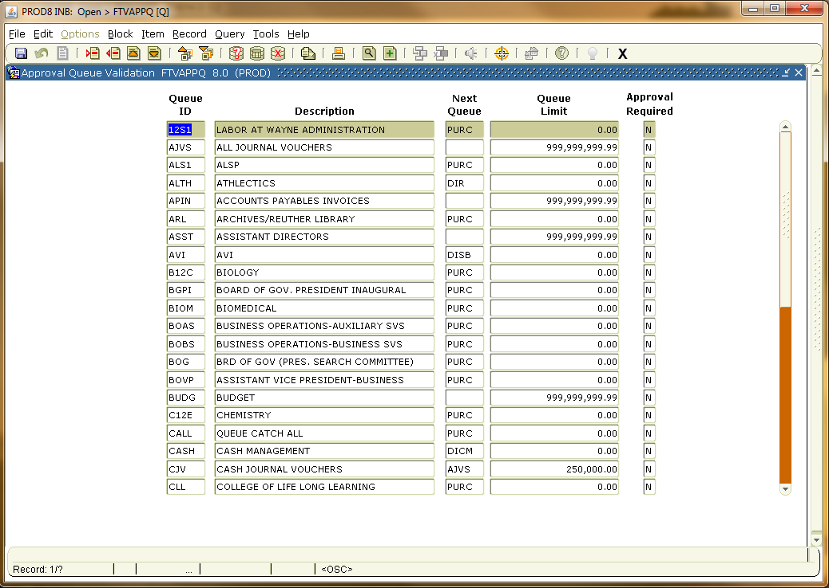
Press F7 to clear the Form
Tab to the Description Box and type in the first 3 letters of the department and a percent sign (wildcard). This form is case sensitive and will only find all caps. Searching for the Math department = MAT%.
Press F8
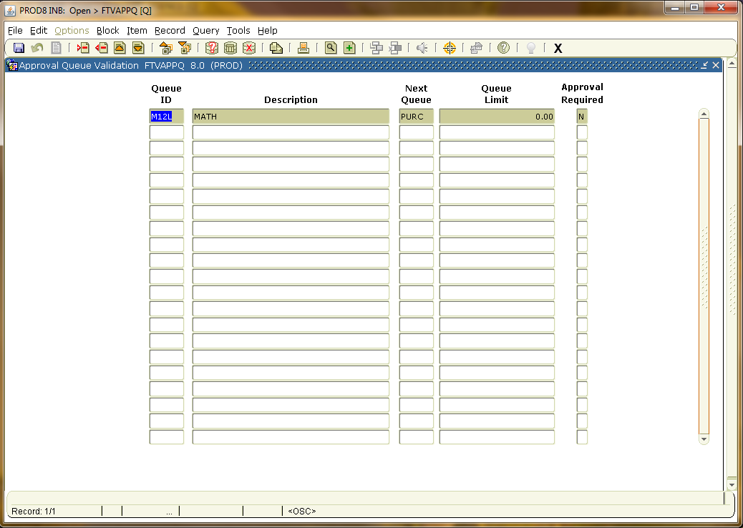
The Math Department approval queue ID is M12L

FTMAPPQ - Approval Queue Maintenance/Inquiry:
The Form opens blank with a queue limit displayed, Press F7 to clear the Form.
Type M12L in the Queue Id box
Press F8 to populate and control page down or next block to scroll through the users in the Queue.
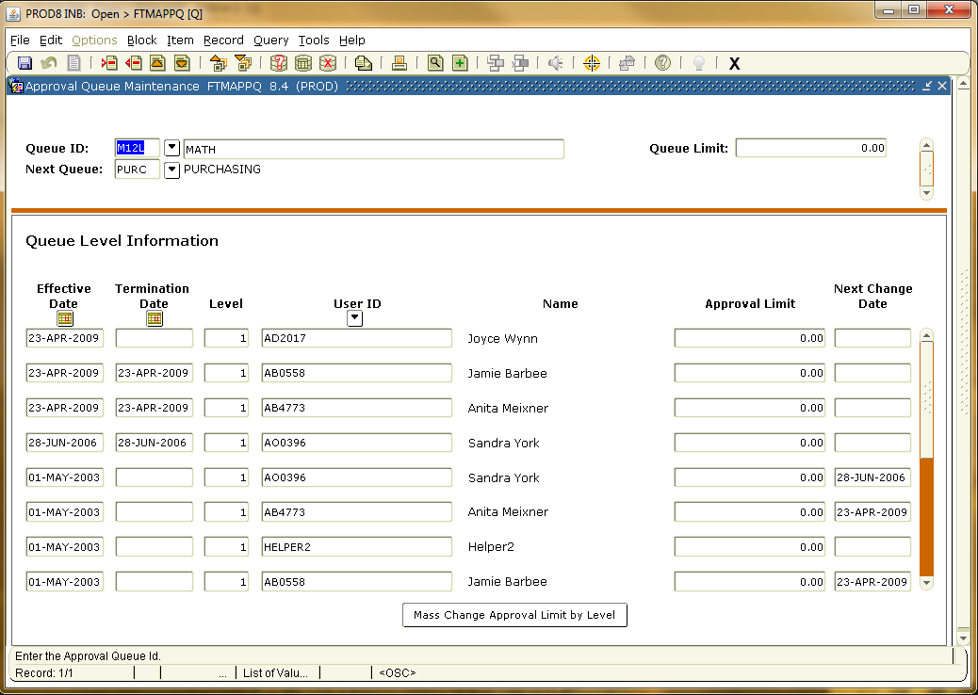
FOMAQRC - Approval Queue Routing Codes:
Type in M12L in the Queue ID box and Control Page down to see the ORG Codes associated with the Queue ID.
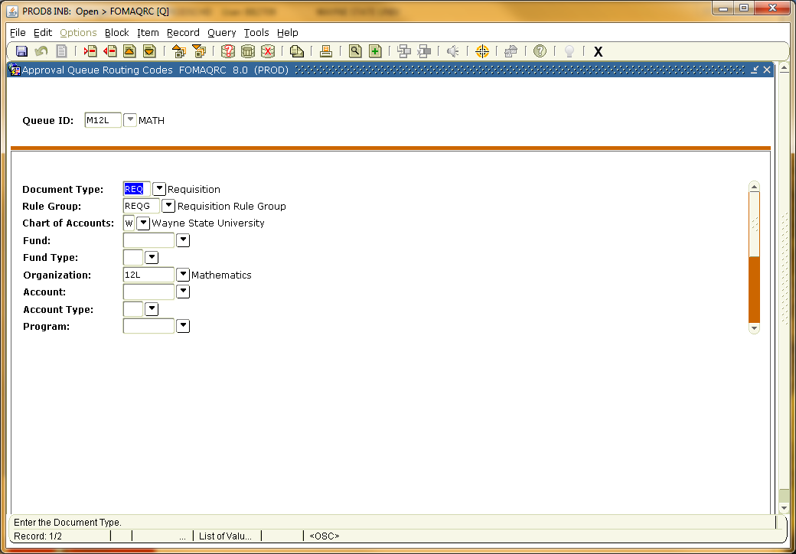 Use the scroll bar to see additional ORG codes / Rule Groups.

