**In This Guide**

|  |  |
| --- | --- |
| * Learn how to change the accounting date to charge a new Fiscal Year |  |

This guide provides the steps required to change the “Accounting Date” on a requisition in order to charge it to a new Fiscal Year.

**Procedure**

1. Once you have completed a Requisition and have added all items, select the  tab at the top of the Requisition window (shown below).
2. \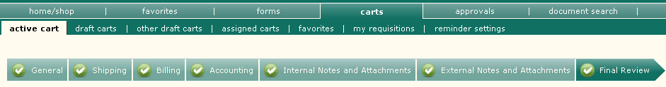



***You will need to be sure all other Accounting information is correct. Refer to the “How to Split an Account” job aid if further information is needed on this topic.***

1. The Accounting Date is initially blank, allowing it to default to the date the Requisition becomes a PO. Under “Billing”, select the  icon for Billing Options.

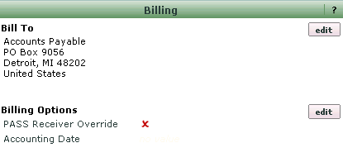

1. A pop-up window will appear with a blank for the Accounting Date. To charge a new Fiscal Year, simply enter “10/01/20xx” with the xx corresponding to the first date of the new fiscal year (i.e. FY 2013 starts on 10/01/2012). The pop up window can be used to select the date, or the date can be manually changed.  
     
   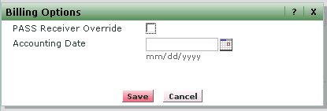
2. Once the date is changed, the Accounting Date will display, as shown below:

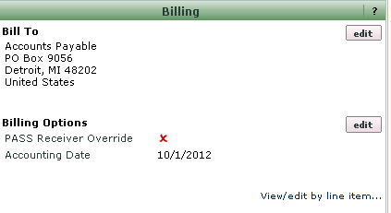.

1. If all other information on the Requisition is complete and correct, you can either submit the Requisition or assign the cart by clicking the appropriate button.

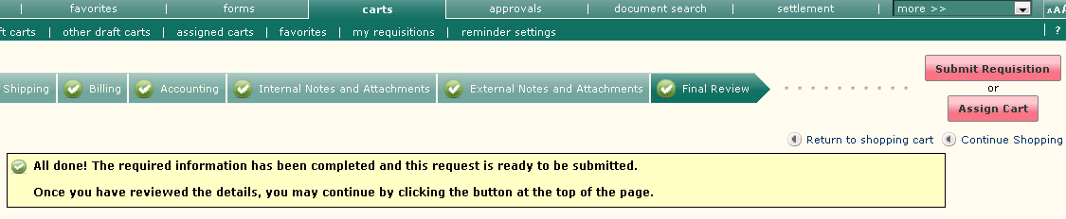  
  
  
*You have modified the Fiscal Year for this Requisition or Cart.*