**In This Guide**

|  |  |
| --- | --- |
| * View approval queues | * Review approval requests |
| * Review/add comments | * View past approvals |

**Procedure**

1. From the home screen, there are two ways to view documents in need of review. You 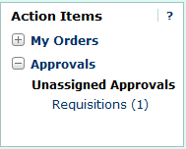can either select the **Requisitions** link within the **Approvals** section of the **Action Items** window (shown to the right), or select the **Requisition** tab under the **Approvals** window.
2. The **Requisition** tab under the **Approvals** window displays all documents awaiting your review/approval. As an approver, your approval queues are based on the organization specified on the transaction as shown in the following example:  
     
   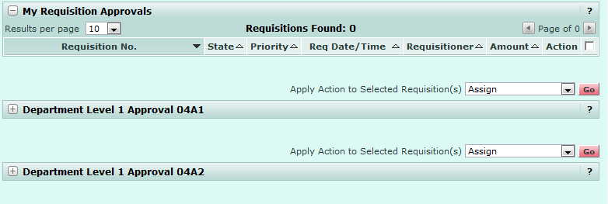

***When requisitions are routed to a queue for approval, they are in an “unassigned” state, as multiple approvers can be assigned to a single queue.***



1. To move a transaction to the “My Requisition Approvals” queue, where you are the only approver who can edit/approve the transaction, select the  link from one of your approval queues.  
     
   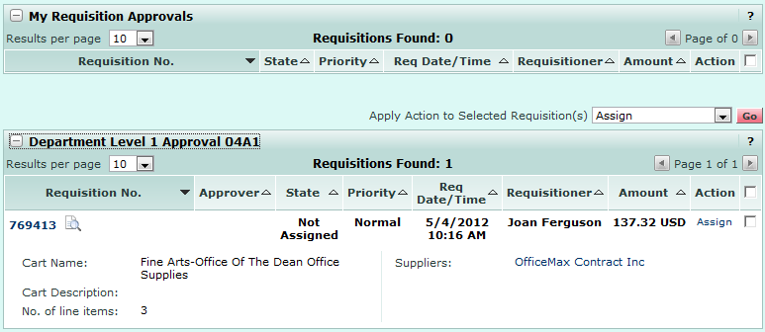
2. The transaction is moved to the “My Requisition Approvals” queue, preventing other approvers in the same queue from either approving the transaction or assigning it to their personal approval queue. Note, the transaction is still shown in the original queue, as well as “My Requisition Approvals”; however, the transaction is assigned to you and can not be edited by others on the approval queue.  
     
   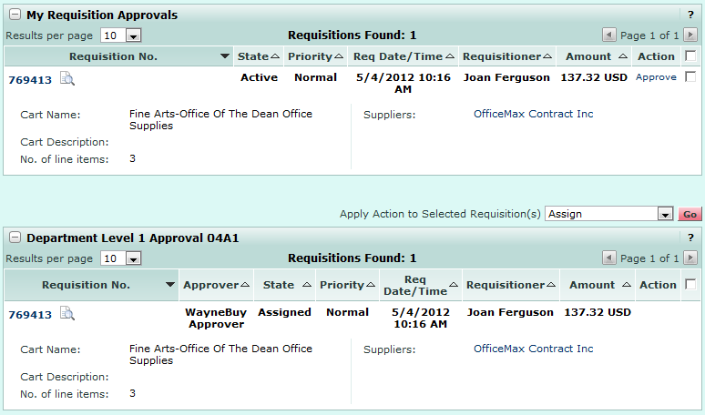
3. To view transaction details, select the **Transaction ID** link.  
     
   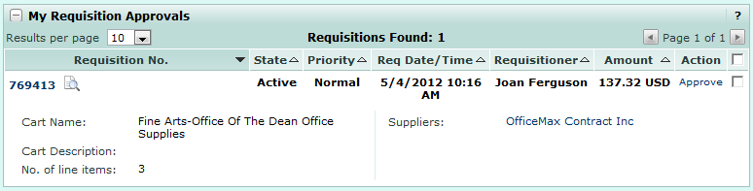
4. From within the transaction, you can review, and if necessary, edit, the transaction. Once you are through reviewing the transaction, select the option from the **Available Options** section and click .   
     
   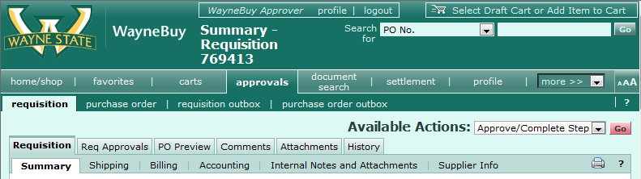
5. The transaction has been approved and you are returned to the **Approvals** window. The transaction has been removed from all queues requiring your approval, including the “My Requisition Approvals” queue as well as the queue associated with the index on the transaction.  
     
   
6. To view transactions you have previously reviewed, select the **Requisition Outbox** tab under the **Approvals** window.  
     
   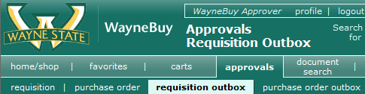
7. A list of requisitions you have approved/returned/rejected is shown and the date of the review action is displayed.  
     
   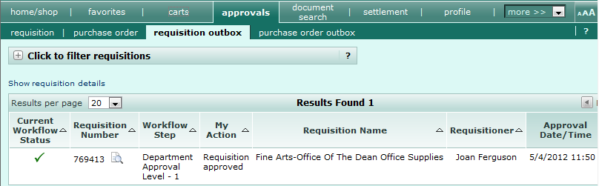

*You have successfully managed a draft cart.*