**In This Guide**

|  |  |
| --- | --- |
| * Proceed to Checkout * Enter Shipping Information | * Enter Accounting Information * Adding Attachments |

This guide provides the steps required to checkout and submit your order for approval and processing

**Procedure**

1. Click on the **Shopping Cart** icon found in the top right portion of WayneBuy   
     
   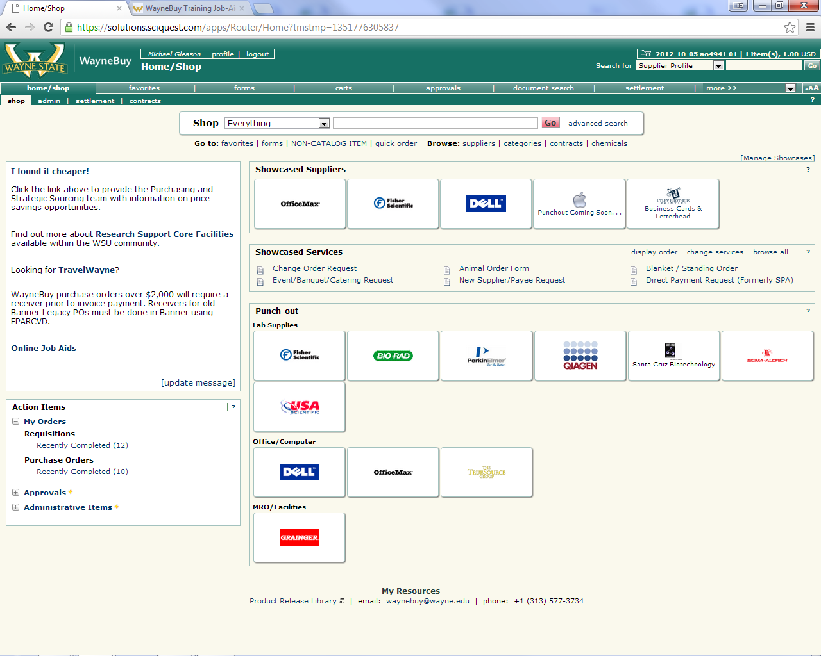

1. Click **Proceed to Checkout**.

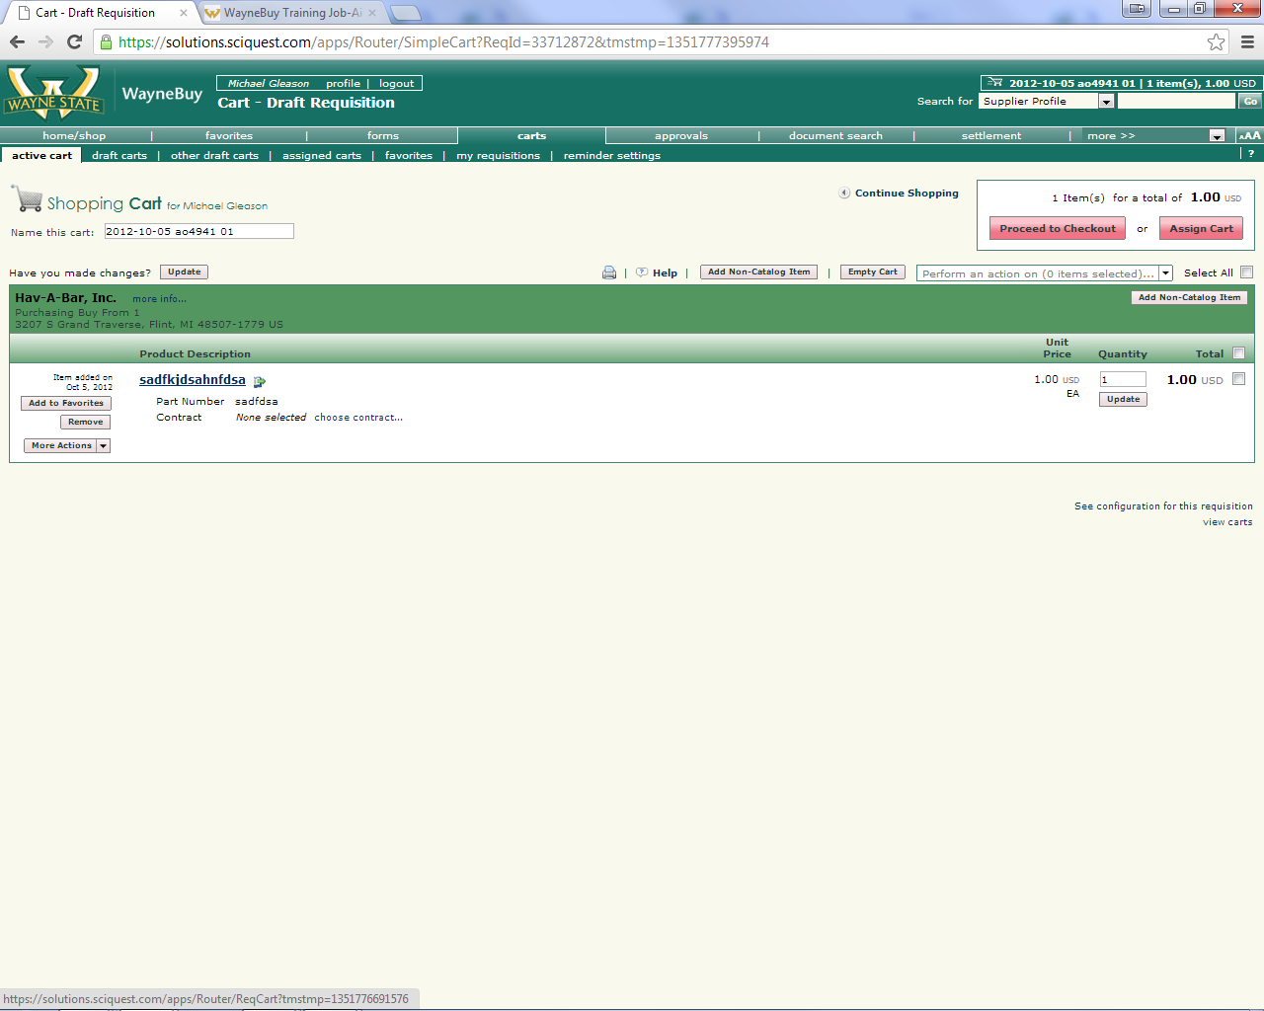

1. Use the Navigation error to complete the necessary **Shipping** & **Accounting** fields.

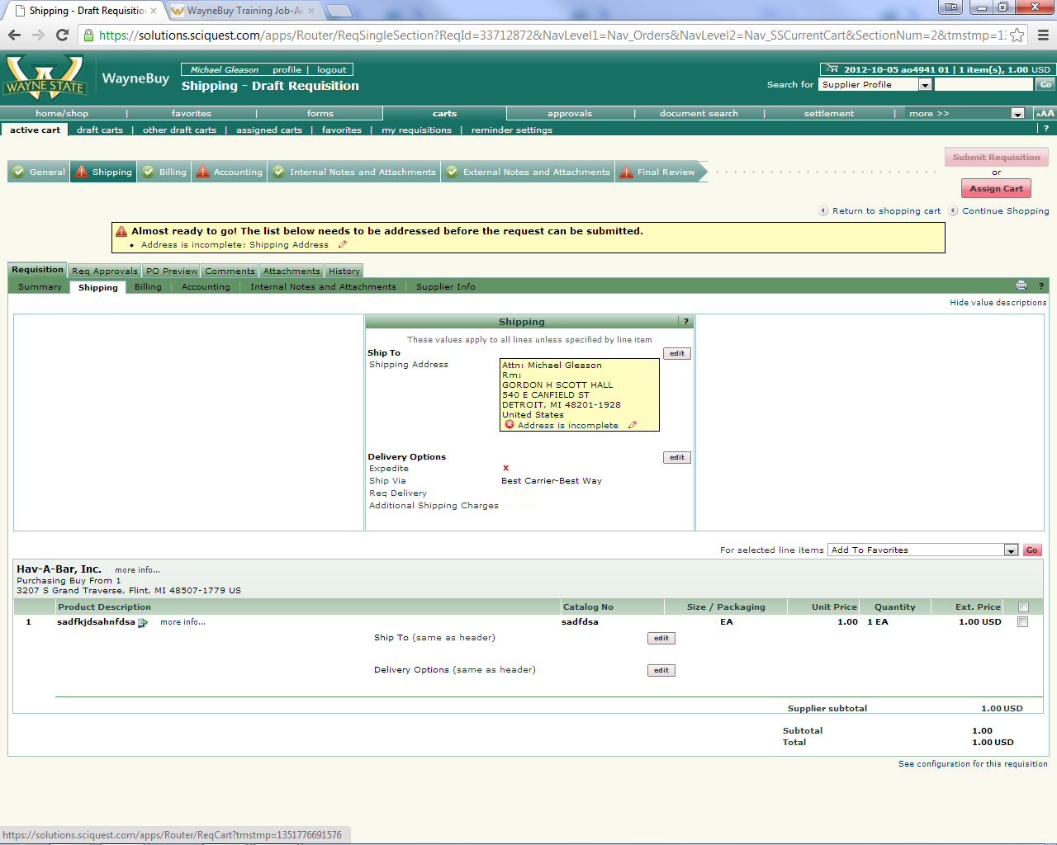

1. For **Shipping**, click the **Required Field** Notification and follow the prompts to locate your Campus location...

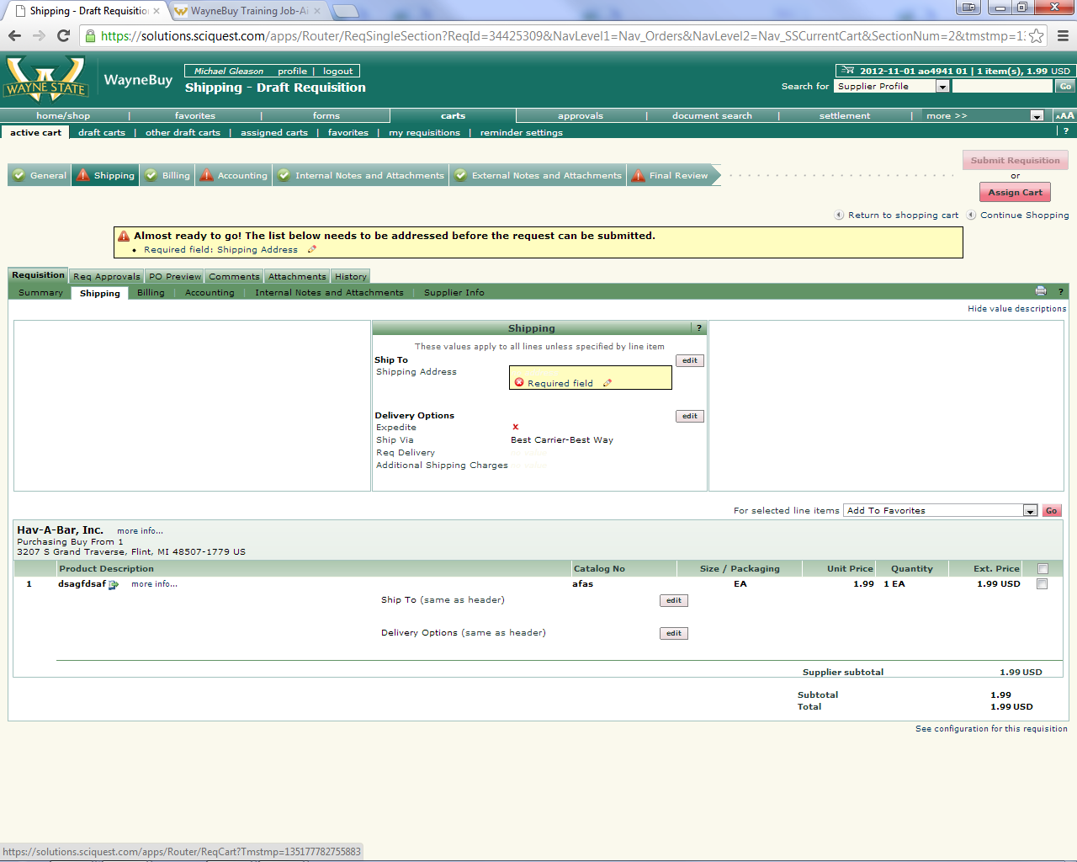

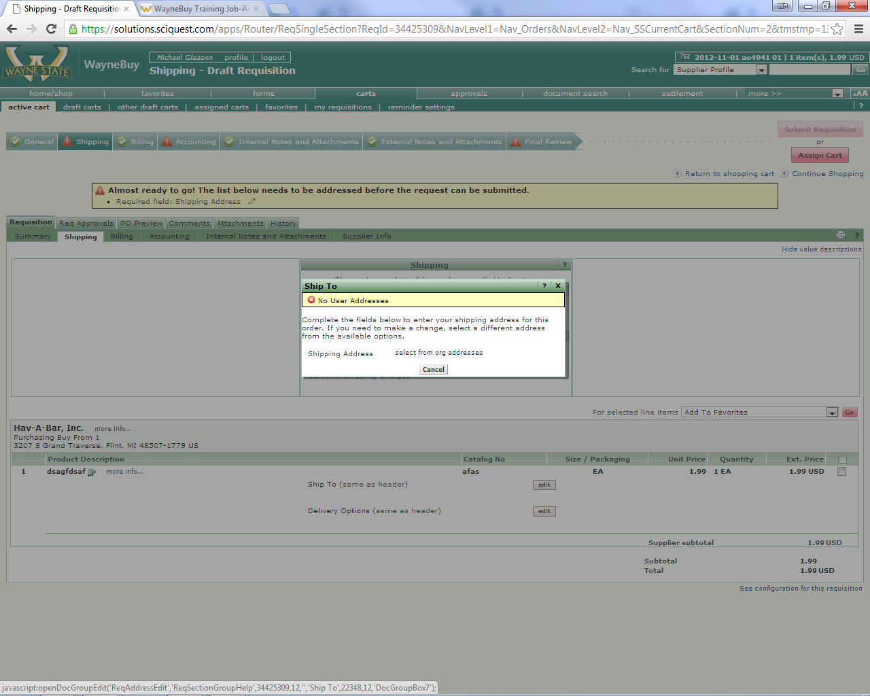

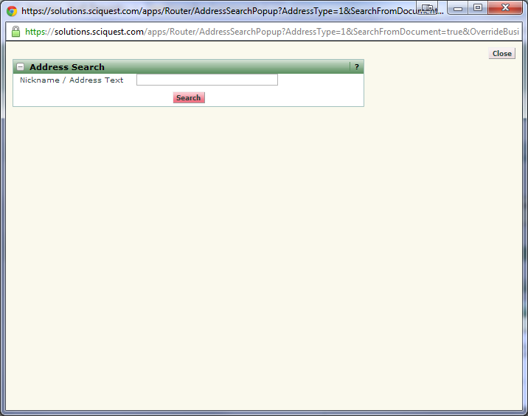

*(Search by Street Number or Street name. All known Univeristy address are available.)*

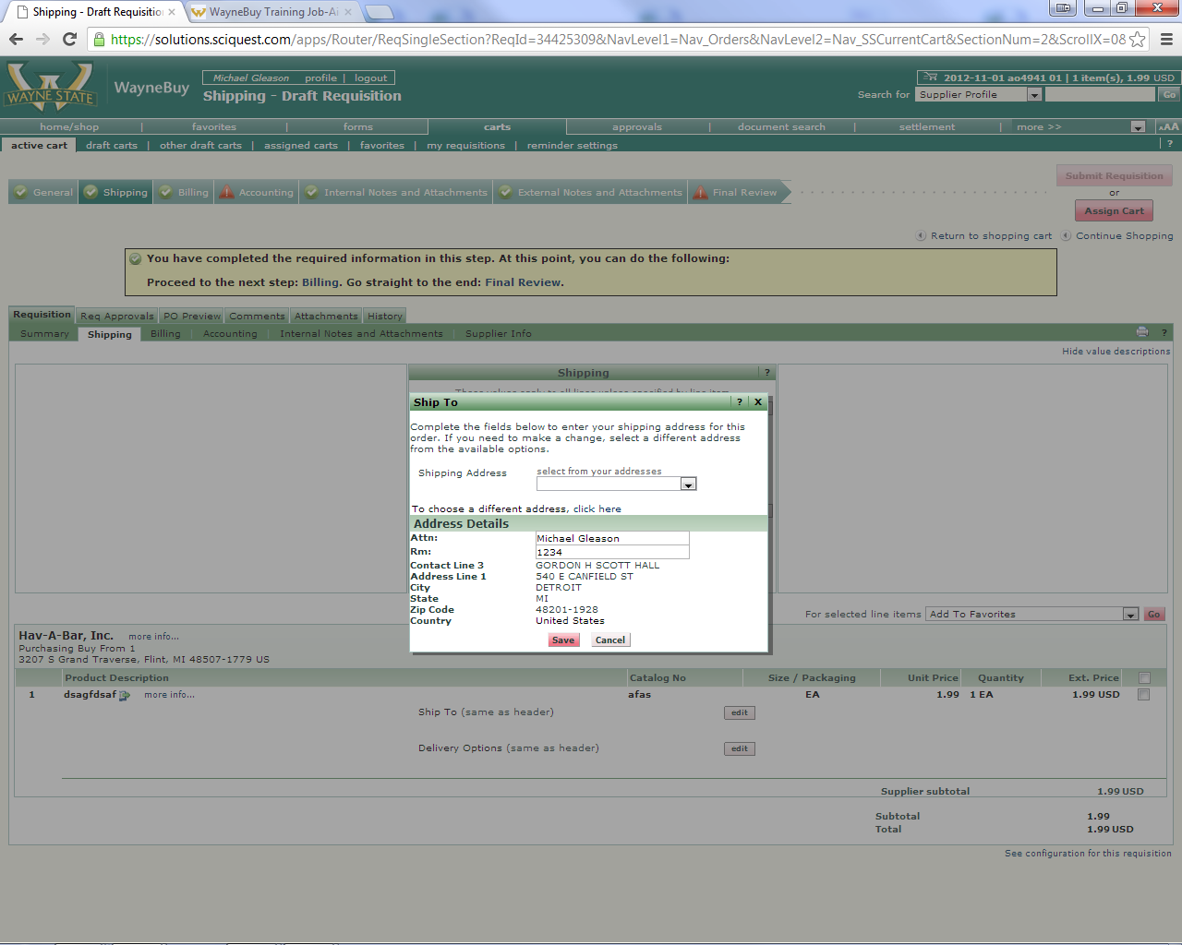

*(Room Number is Required)*

*\*Please Note: You can save the address for future use AND save it as a default to bypass this step on future requisitions.\**

1. For **Accounting**, click **Required Field** anywhere and it will prompt you to enter the **Index** and **Account Code**. (Please note the Fund, Org, Prg will all automatically populate by clicking Save)

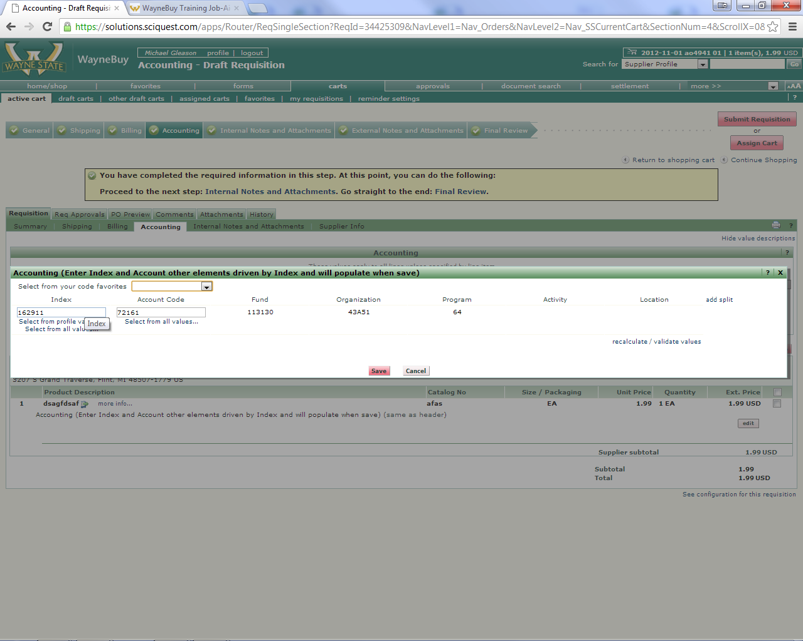

(*You can also accomplish Line Level Accounting Distribution by clicking the edit button for each corresponding line, and have the opportunity to accomplish split level Accounting.*)

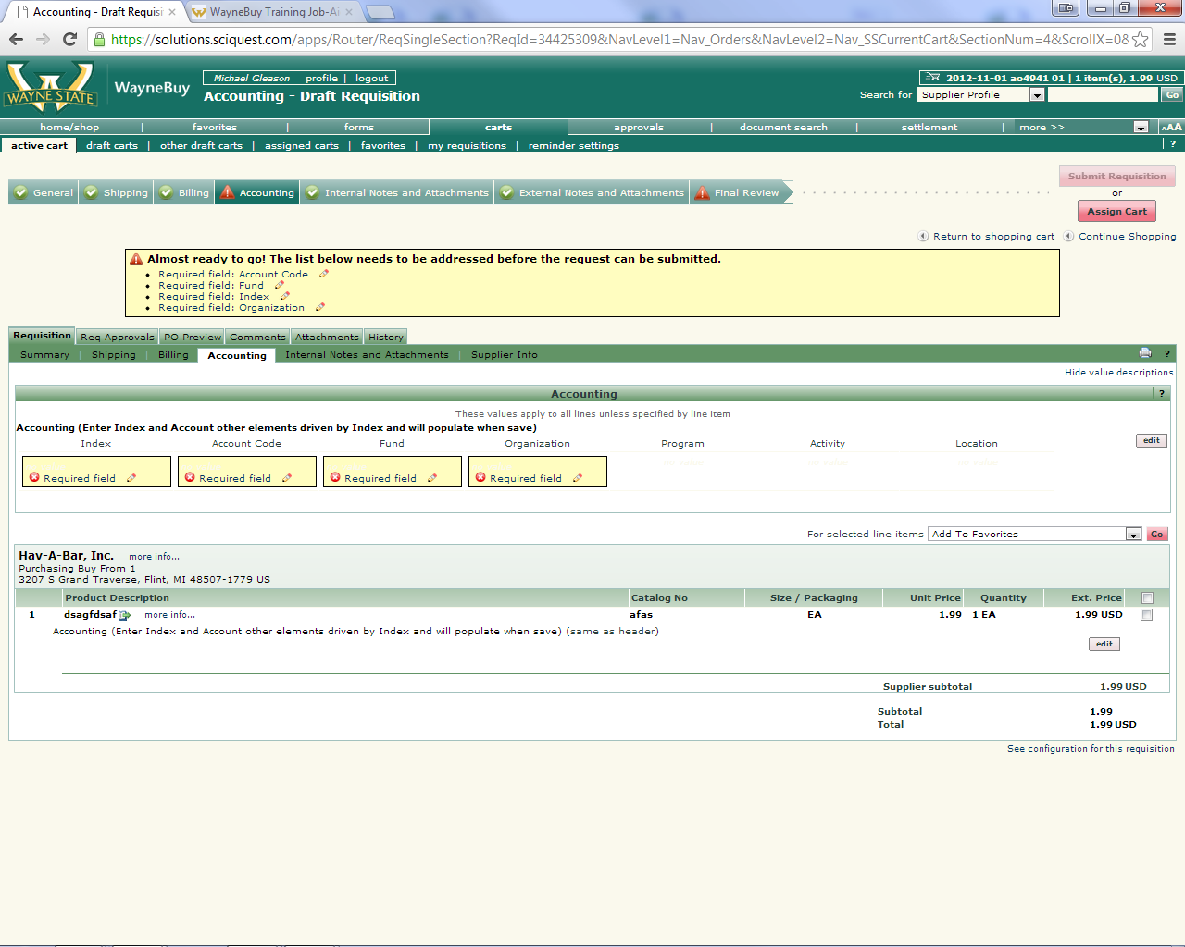

1. **Internal Notes and Attachments** or **External Notes and Attachments** sections are not required, but allow for attachments to be associated with the requisition (quote, memo, etc.)

(Please note: The only difference between Internal and External Notes and Attachments is regarding the handling of the notes and attachments at the time of PO issuance. External notes and attachments will flow with the PO delivery to the vendor, Internal Attachments will

not. Reviewers/Approvers at Wayne State will have view-access to either.

1. Click **Submit Requisition** to complete the checkout Process. You should receive notification of a successfully submitted requisition and reference number.

