**In This Guide**

|  |  |
| --- | --- |
| * Initiate a receipt for goods or services | * View past receipts |
| * Determining an order receiving status |  |

**Procedure**

1. Navigate to the purchase order requiring receipt of goods or services. *Reference the* ***Performing a Document Search*** *job aide for detailed instructions on how to search for a purchase order.*
2. From the **Available Actions** drop down box, select the **Create Quantity Receipt** option, and click on the  icon.
3. The receiving screen is displayed. A name for the receipt is automatically defaulted in the **Receipt Name** field. If desired, provide a more meaningful description of the receipt transaction.
4. If your department’s business process requires packing slip information be captured at the time of receipt, enter the information in the **Packing Slip No.** field.
5. If desired, provide information for the remaining optional fields on the receipt header such as **Carrier** or **Tracking Number**.
6. Once your updates are complete, you can record your progress by selecting the  icon.  
     
   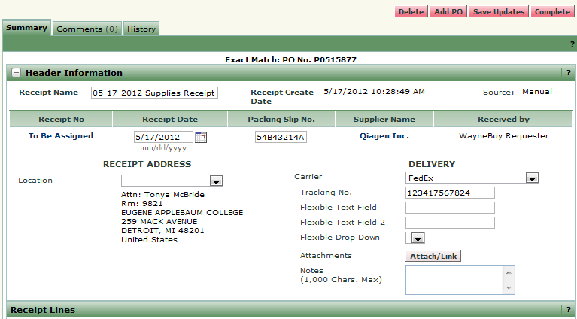
7. From the **Receipt Lines** section of the screen, indicate the quantity of goods or services received for each of the purchase order line items. Select the  icon.  
     
   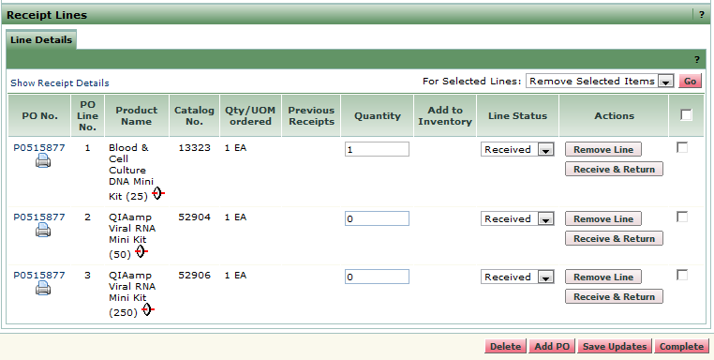

***WayneBuy will automatically display the quantity of goods or services available for receiving. For example, if you ordered 10 items and this is the first receipt, 10 will be defaulted in the Quantity field. If you ordered 10 and had previously received 3 items, 7 would be defaulted in the Quantity field.***



***If you received a partial shipment or fulfillment of the goods/services associated with the purchase order, you can either indicate the receipt of “0” on the applicable lines or select the Remove Line icon.***



*You have successfully completed a receipt.*