**In This Guide**

|  |  |
| --- | --- |
| * Forwarding a requisition to another approver | * Review/add comments |
|  |  |

**Procedure** *(Note: Steps 1-5 are identical to Approving a requisition job-aid)*

1. From the home screen, there are two ways to view documents in need of review. You 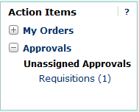can either select the **Requisitions** link within the **Approvals** section of the **Action Items** window (shown to the right), or select the **Requisition** tab under the **Approvals** window.
2. The **Requisition** tab under the **Approvals** window displays all documents awaiting your review/approval. As an approver, your approval queues are based on the organization specified on the transaction as shown in the following example:  
     
   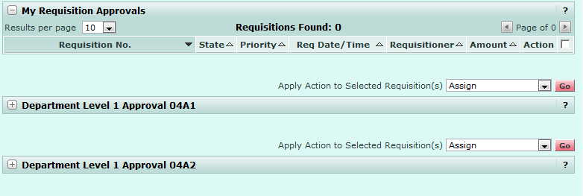

***When requisitions are routed to a queue for approval, they are in an “unassigned” state, as multiple approvers can be assigned to a single queue.***



1. To move a transaction to the “My Requisition Approvals” queue, where you are the only approver who can edit/approve the transaction, select the  link from one of your approval queues.  
     
   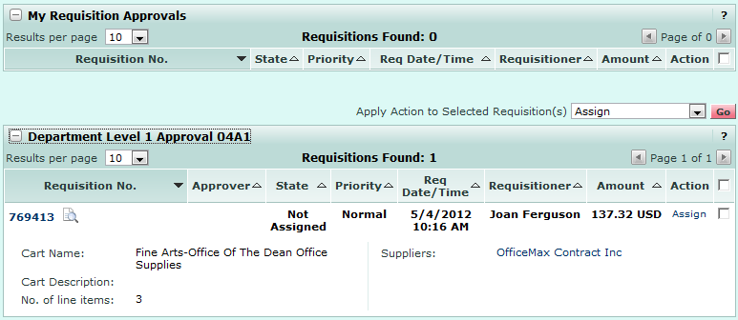
2. The transaction is moved to the “My Requisition Approvals” queue, preventing other approvers in the same queue from either approving the transaction or assigning it to their personal approval queue. Note, the transaction is still shown in the original queue, as well as “My Requisition Approvals”; however, the transaction is assigned to you and can not be edited by others on the approval queue.  
     
   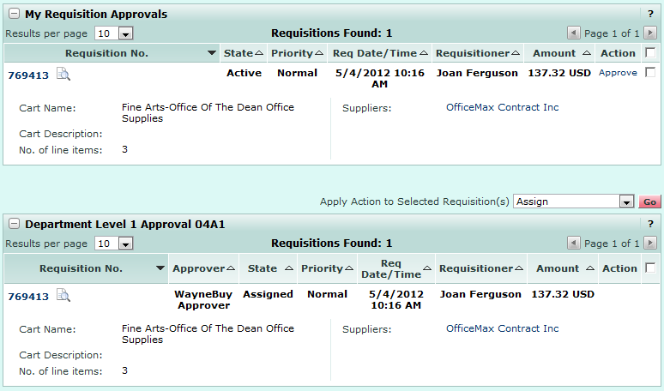
3. To view transaction details, select the **Transaction ID** link.  
     
   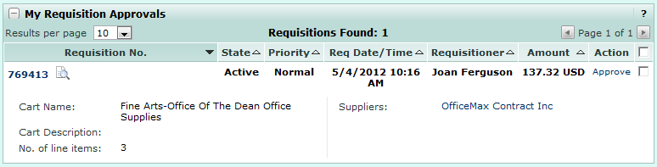
4. From within the transaction, you can review, and if necessary, edit, the transaction. Once you have determined the requisition needs to be forwarded to another approver for additional review, select the  option from the **Available Options** section and click .

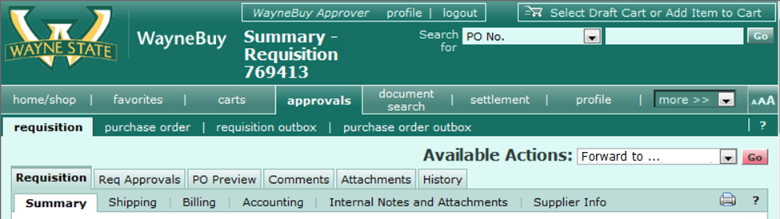

1. A dialog box will appear allowing you to search for the approver to receive the forwarded requisition. Fill out one (or more) of the fields (Last Name, First Name, User Name – access id, or email) and click .

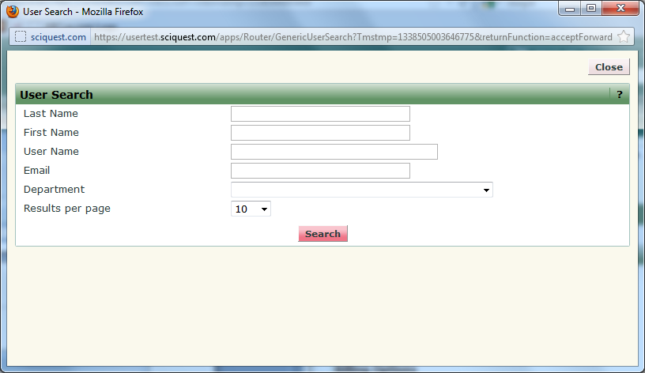

1. Once the results have generated, select the intended recipient of the forwarded requisition by clicking under the Action column  
     
   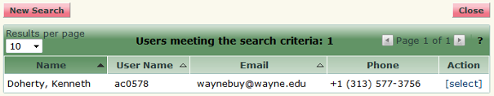
2. A final dialogue box will appear which allows you to type a message to the recipient detailing any instructions or information you would like them to be aware of regarding this requisition. Click the  to complete the forward request.

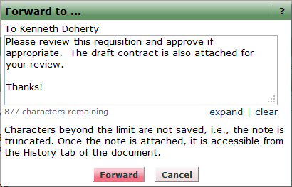



***A forwarded requisition’s comments will be historically archived with the requisition under the “Comments” tab. Also, a time-date stamp and action type will be recorded within the “History” tab for audit purposes.***

*You have successfully forwarded a requisition.*