**In This Guide**

|  |  |
| --- | --- |
| * Initiate a Blanket Order Request | * Understand Blanket Order Processing Flow |
|  |  |

**Procedure**

1. From the **Home/Shop** screen, select the **Blanket / Standing Order** link from the **Showcased Services** section of the screen.  
     
   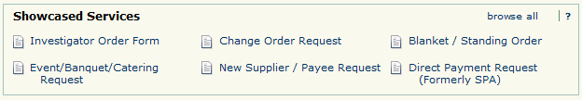
2. 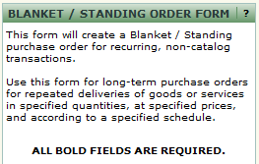The Blanket / Standing Order Request form appears in a new window. Review the **policy information** at the top of the screen for detailed information regarding the order request process.
3. From the **Supplier Information** section of the form, search for the name of the supplier who will receive the blanket / standing order.  
   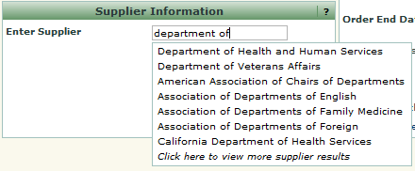
4. 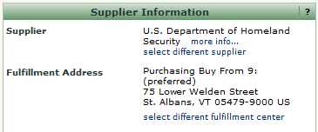 Selecting a value will automatically populate the related supplier information.
5. In the **PO Information** section of the form field, enter the **Product Information** for the requested goods/services. Be as descriptive as possible so that your request can be effectively fulfilled.



***WayneBuy makes it easy to quickly and efficiently order goods from key Wayne State suppliers using standard purchase orders. Procurement and Strategic Sourcing (PASS) will review blanket / standing order requests to determine if the request would be better served via a standard purchase order.***

1. Select a **Commodity Code** from the drop down box.
2. Enter a **Quantity** for the blanket / standing order.



***The quantity field controls the total dollar value of the blanket / standing order. For example, if you need to establish a $500 standing order, enter 500 in the quantity field.***

1. Enter the start and end date of the blanket / standing order in the respective **Order Start Date** and **Order End Date** fields.
2. Add any internal notes for the PASS team in the **Internal Notes** section of the form. Please note that any text entered in this section will not be included on any purchase order(s) sent to the supplier.
3. Provide any supporting documentation by selecting the icon and attaching the appropriate documents.
4. In the **Available Actions** dropdown box and then click the  icon. The request has been added to your shopping cart.

***WayneBuy includes a contract management system that provides the Wayne State community with greater visibility of the funds remaining on blanket / standing orders. The PASS team will configure the contract management application to automatically send you an email when invoices totaling 90% of the total have been processed against your blanket / standing order.***



1. For information related to selecting **accounting** and **shipping** information, please visit the [WayneBuy Training Job-Aids](http://purchasing.wayne.edu/waynebuy/training.php) section of the PASS [website](http://purchasing.wayne.edu/waynebuy/training.php). Once this information has been populated, submit the requisition for approval(s).