**In This Guide**

|  |  |
| --- | --- |
| * Initiate a Change Order Request (COR) | * Understand COR Processing Flow |
|  |  |

**Procedure**

1. 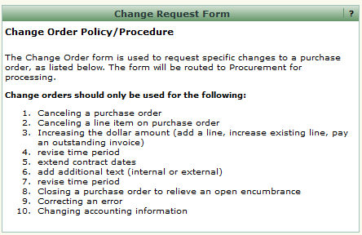From the **Home/Shop** screen, select the **Change Order Request** link from the **Showcased Services** section of the screen.  
     
   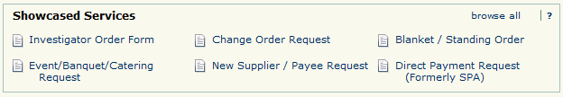

***WayneBuy is the single system used to capture requests for changes to all Wayne State purchase orders, regardless if the purchase order was generated in Banner or WayneBuy. Use the Change Order Request form for all modification requests.***



1. The Change Order Request form appears in a new window. Review the **Change Order Policy/Procedure** information at the top of the screen for detailed information regarding the request process.
2. From the **Purchase Order Information** section of the form, search for the name of the supplier associated with the purchase order you wish to modify.
3. 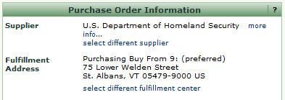Selecting a value will automatically populate the related supplier information.   
   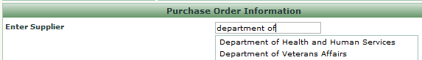
4. Enter the purchase order number associated with the requested change in the **PO Number** field.
5. Categorize the requested change in the **Type of Change** field by selecting the appropriate action from the drop down box.  
   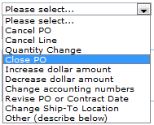
6. Indicate if you would like Procurement and Strategic Sourcing (PASS) to send the revised purchase order to the supplier by selecting the appropriate value from the **Send PO to Supplier** drop down box.
7. Provide PASS with additional details regarding the request in the text box located on the form. Be as descriptive as possible regarding the changes, especially if your purchase order has multiple lines or has been frequently revised.

***Provide as much detail as possible regarding the requested changes, including specifying PO line numbers and amounts (e.g., “increase line #1 amount by $35 to account for additional capacity”, or “cancel remaining encumbrance on line #2”).***



1. Provide any supporting documentation by selecting the icon and attaching the appropriate documents.
2. Select the **Add and go to Cart** option from the **Available Actions** dropdown box and then click the  icon. The request has been added to your shopping cart.



***Even though a COR does not entail the request for goods or services, it is submitted via a requisition which requires both accounting and shipping information. Please note that the values selected do no impact the routing of your request.***

1. Initiate the checkout process by selecting the  icon. Populate required fields such as shipping and accounting information as well as any other supporting fields. Once completed, submit your requisition for processing. For information related to selecting **accounting** and **shipping information**, please visit the [WayneBuy Training Job-Aids](http://purchasing.wayne.edu/waynebuy/training.php) section of the PASS [website](http://purchasing.wayne.edu/waynebuy/training.php).



***The PASS Amendment Processing Team will receive your requested changes and update the request to reflect the appropriate funding source(s). The request will then be routed for approval based on the total dollar amount of the revised purchase order. For example, if the request increases the PO from $100 to $125, the request will be routed for approval based on the new $125 value. Once the request is approved, the Amendment Processing Team will update the Banner and WayneBuy purchase order accordingly.***