**In This Guide**

|  |  |
| --- | --- |
| * Initiate a Direct Payment request | * Understand documentation requirements |
|  |  |

**Procedure**

1. 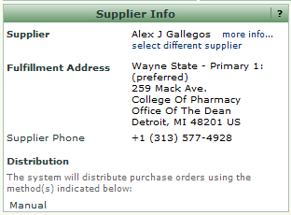From the **Home/Shop** screen, select the **Direct Payment Request** link from the **Showcased Services** section of the screen. 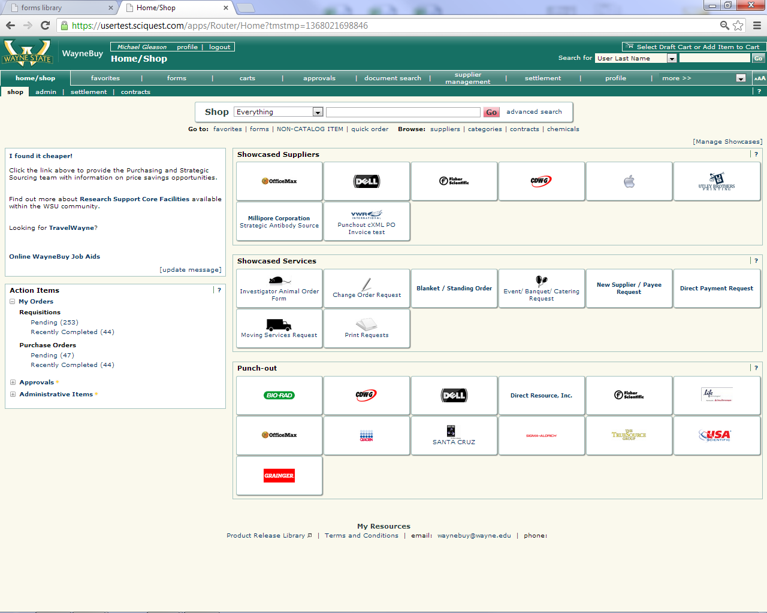
2. The Direct Payment Request form appears in a new window. Select the name of the supplier/individual receiving the direct payment from the **Supplier Info** section of the form.

***If you are creating a payment request for a student, the access id will be displayed and should be used to validate you selected the correct payee. For employee reimbursements, the work address (or W1 record) should   
be used to validate your selection.***



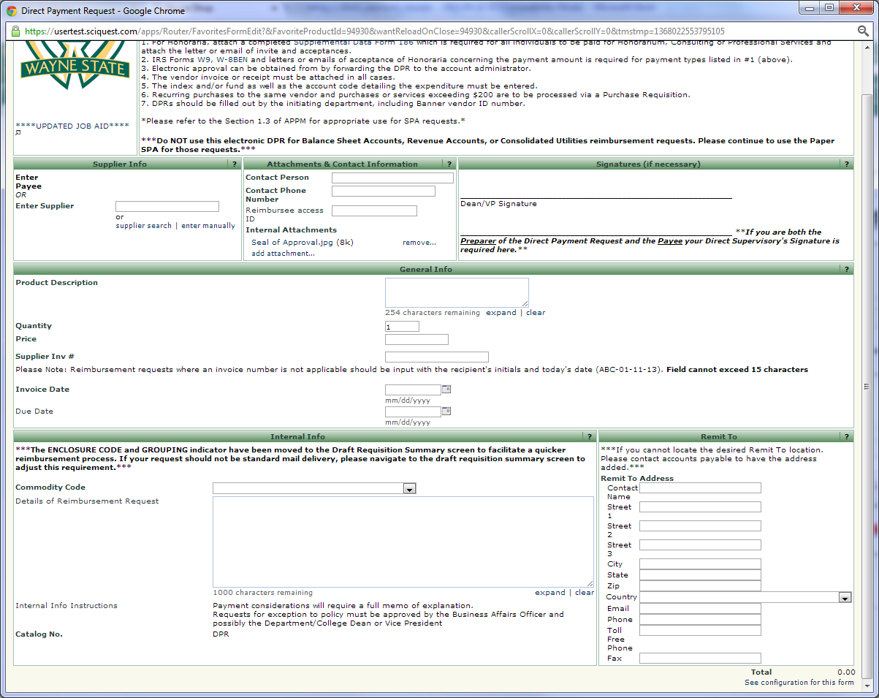

1. Once you’ve selected the Supplier/Payee, the lower right portion of the DPR will populate with the default **Remit To** address. You now have the ability to select an alternate address, if necessary.
2. 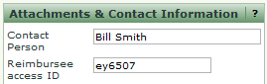Enter the appropriate **Contact Person** for the direct payment request in the **Attachments & Contact Information** section of the form. Include the access id of the reimbursee, if applicable.

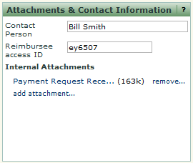

1. Add the required supporting documentation to the request by selecting the **Add Attachment** link, clicking on the **Browse** icon and attaching the appropriate document(s). A hyperlink is displayed when the document(s) have been successfully attached to the request.

***Supporting documentation is required for all Direct   
Payment Requests. You will not be able to submit the request until you have attached one or more documents.***



1. Enter a brief description of the payment request in the **Product Description** field. Enter the requested payment amount for the reimbursement in the **Quantity and Unit Price** field.Enter in a **Supplier Inv #,** **Supplier Invoice Date**, and **Due Date**. *(Note: Due Date is not required, but will override default payment terms if filled out)*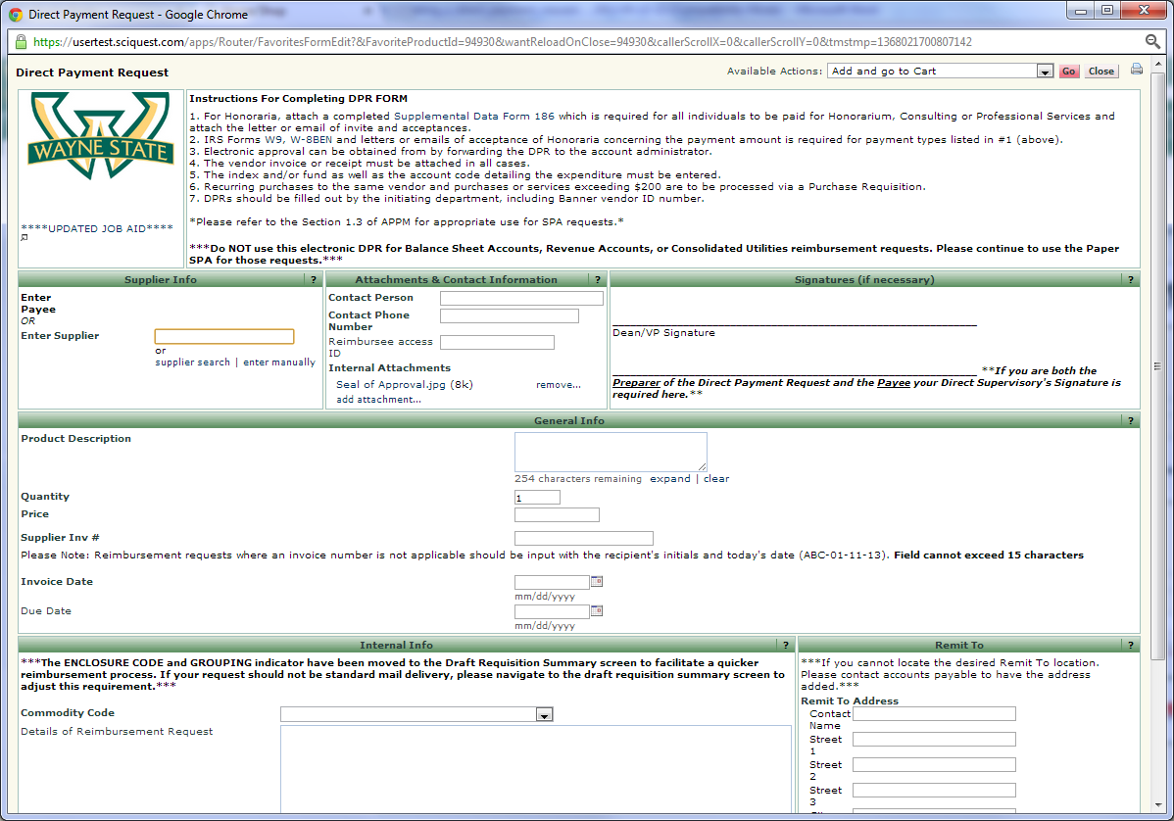
2. Enter a detailed description in the **Details of Reimbursement Request** field. *Note, payment requests require a full memo of explanation and will be reviewed by the appropriate Business Affairs Officer within your organization.*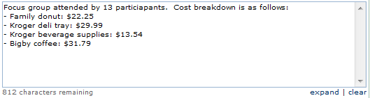
3. Select the **Add and go to Cart** option from the **Available Actions** dropdown box and then click the  icon. The request has been added to your shopping cart.
4. Select the  icon to view the contents of your cart. The reimbursement request is displayed.  
     
   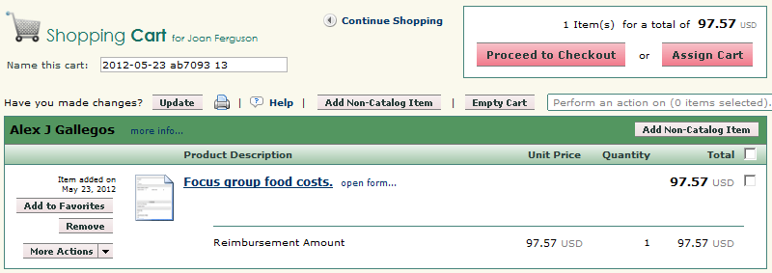
5. Select the  icon. The **Requisition Summary** screen is displayed.

***You can also click  and route the draft Direct Payment Request to a Manager or Supervisor for additional review at this point OR after the Accounting information has been keyed. This will allow you to electronically acquire any department approvals. The recipient of the Assigned Cart can then “Submit the Requistion” which will automatically route the request to the appropriate Business Affairs Officer for approval.***



1. Select the 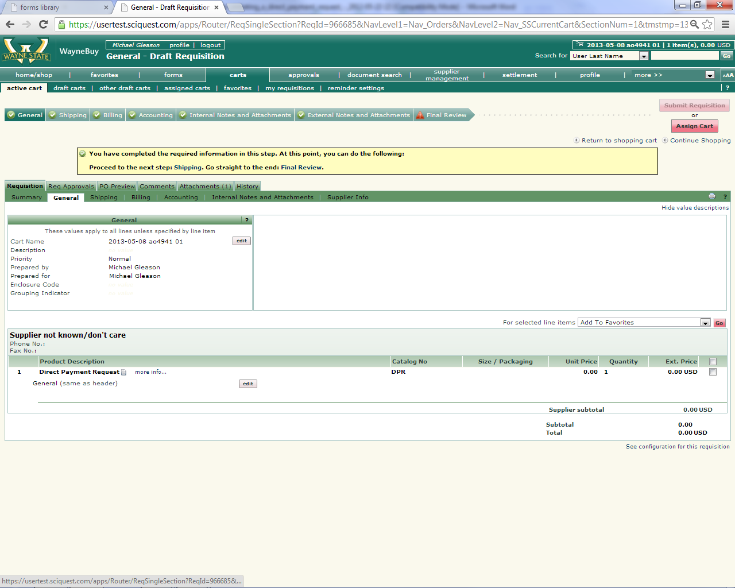 process step if you have an **Enclosure Code** or **Grouping Indicator** requirement for the checking handling process. The fields are found under the General section. *(Leaving these fields blank will result in standard check mail out)*

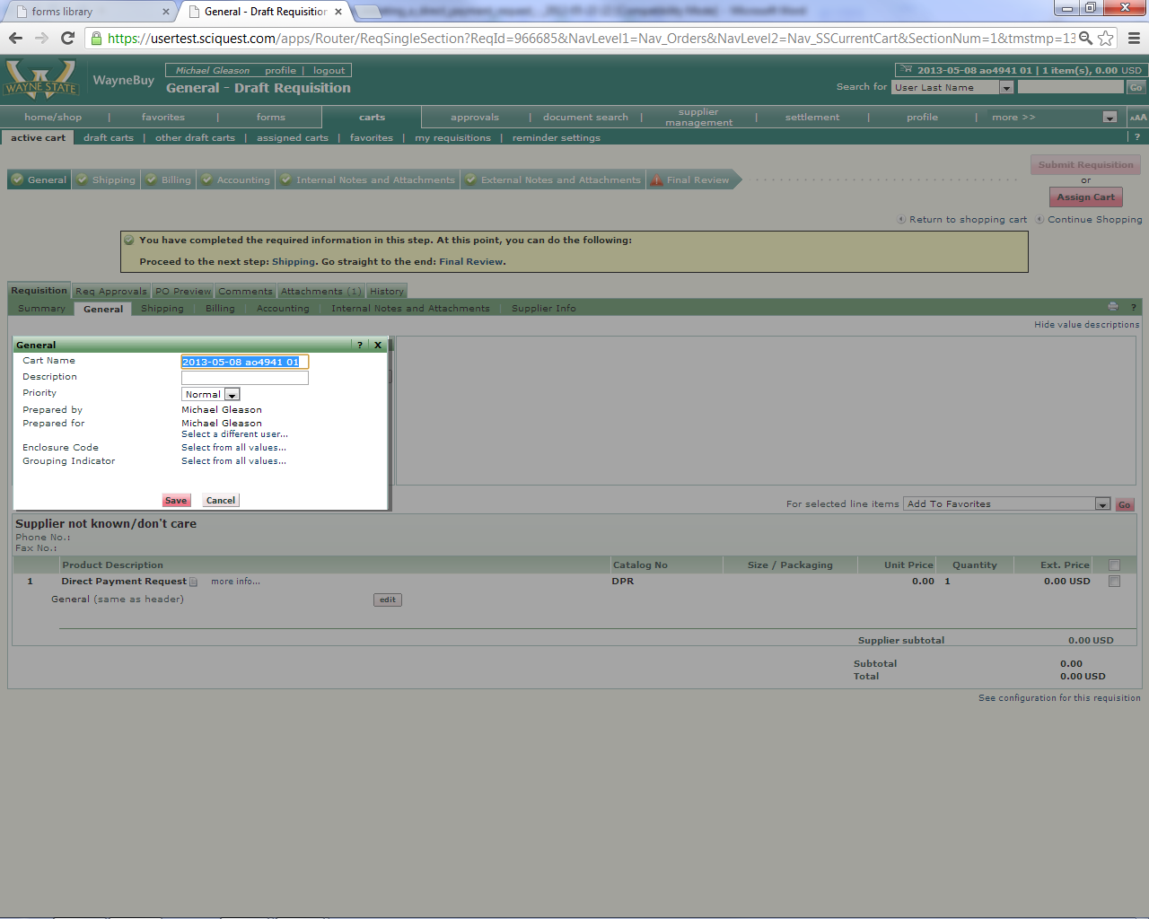

1. Select the  process step or click the **Accounting** tab under the Requisition window (shown below).   
     
   
2. Select the  icon for line item containing the reimbursement request. A pop-up window will appear with the existing accounting information for the requisition line (or entire requisition if so selected). Select the link for the **Index** field OR enter your 6 digit **Index** (in known already) and skip to step 15.  
     
   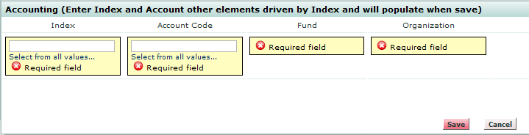

A search box is displayed. Enter search criteria in either the **Value** or **Description** fields and select the  icon.  
  
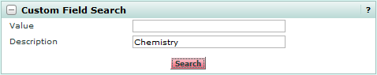

1. A list of search results is returned. Select the link next to the appropriate index value.  
     
   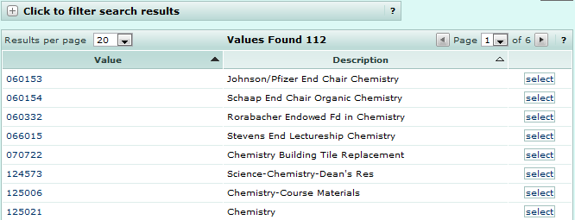
2. The Accounting pop-up box is updated with the selected index value.  
     
   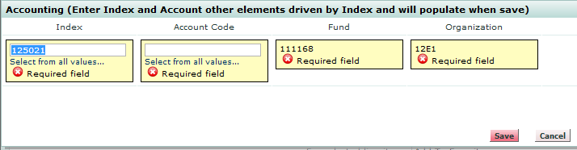  
     
     
   Select the link for the **Account Code** field OR enter your alpha numeric **Account Code** (in known already) and skip to step 17.  
     
   



***Selecting an Index value will automatically populate the Fund, Organization, Program, Activity, and Location fields. Index and Account Code are the only two fields users are required to populate on a requisition.***

1. Repeat steps 12-14 to select an **Account Code**. Select the  icon when finished.
2. Select the  process step and review the information contained on the requisition/direct payment request. Make any required changes.
3. Click the 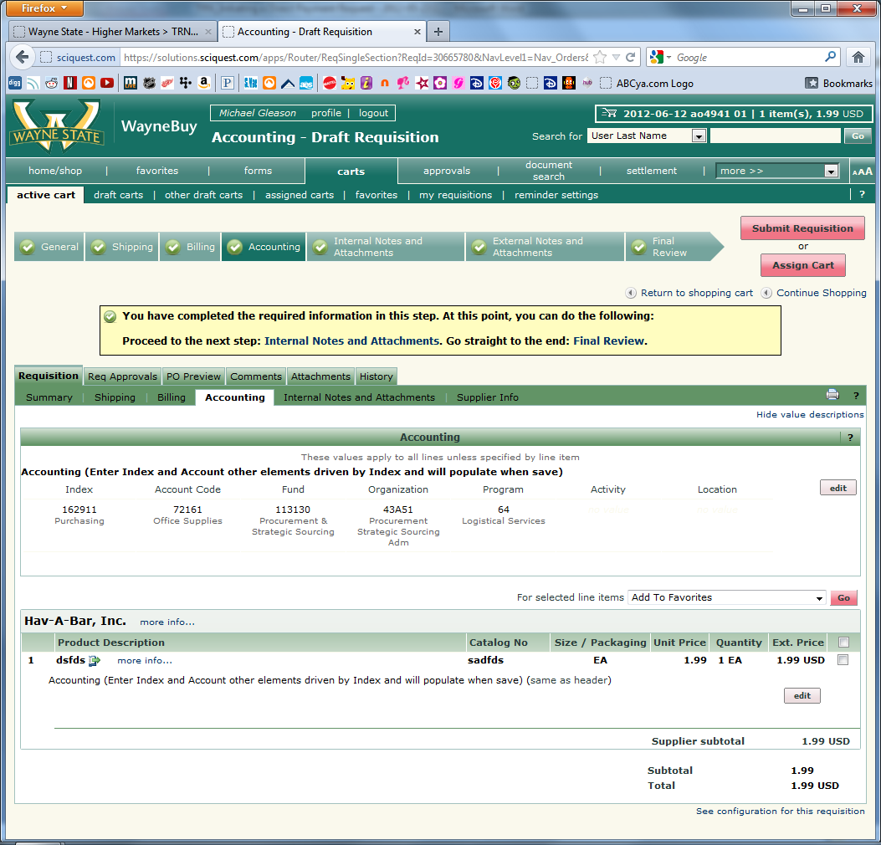 icon. The request is submitted into the workflow and a confirmation message is displayed containing the unique identifier of the direct payment request.



***The reimbursement request will be routed for approval to the Wayne State Business Affairs Officer responsible for the org code specified on the transaction. If additional Dean/VP level approvals are required, it is your responsibility to print the Direct Payment Request form, obtain signatures from the appropriate parties on the printed form, and attach the form to the online request as an attachment.***