**In This Guide**

|  |  |
| --- | --- |
| * Selecting a supplier * Specifying the details of a non-catalog item | * Submitting a non-catalog item |

This guide provides the steps required to purchase a non-catalog item(s) through the WayneBuy solution.

**Procedure**

1. Click on the **NON-CATALOG ITEM** link under the Shop section (shown below).   
     
   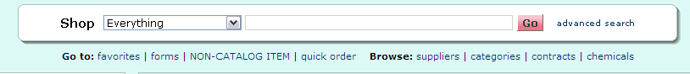

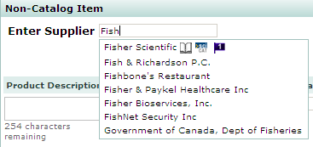

1. Search for your supplier by keying in the supplier name. The search functionality will display available suppliers as you continue to key in the supplier name.
2. Select the appropriate supplier for your non-catalog purchase.



***If the supplier has multiple fulfillment centers (locations that orders are shipped from) – review the address and if it is not appropriate, click on the different fulfillment center link and select the appropriate fulfillment center.***

1. Enter your non-catalog item information (product description, catalog no., quantity, and price). For packaging, if the default of EA-Each is not appropriate, click on the pull down arrow to find the appropriate packaging.

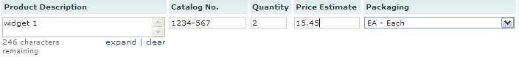

1. Click on the pull down arrow for **Commodity Code** and select the appropriate commodity code for the item you are purchasing.  
     
   
2. Review the item attributes and click on the attributes that apply to the item being purchased. These attributes may impact workflow and enhance reporting for the university.  
     
   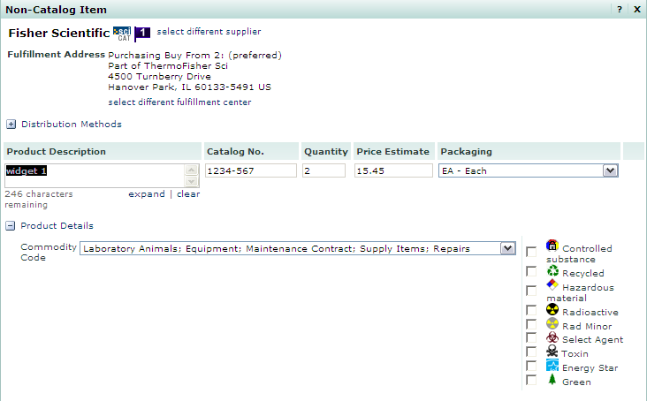
3. Once you are complete with your non-catalog item entries, select  if this is your only item. Or you can select button if you have more than one item to purchase. You will be returned to the **Home/Shop** page when you are complete.

*You have successfully entered a non-catalog item.*