**In This Guide**

|  |  |
| --- | --- |
| * Differentiate between returning/rejecting | * Return a requisition |
| * Reject a requisition | * Add comments |
|  |  |
| * Forward a requisition an approver |  |

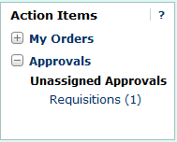**Procedure**

1. From the home screen, there are two ways to view documents in need of review. You can either select the **Requisitions** link within the **Approvals** section of the **Action Items** window (shown to the right), or select the **Requisition** tab under the **Approvals** window.
2. The **Requisition** tab under the **Approvals** window displays all documents awaiting your review/approval. As an approver, your approval queues are based on the organization specified on the transaction as shown in the following example:  
     
   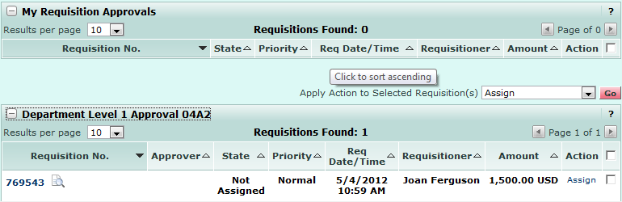

***When requisitions are routed to a queue for approval, they are in an “unassigned” state, as multiple approvers can be assigned to a single queue.***



1. To move a transaction to the “My Requisition Approvals” queue, where you are the only approver who can edit/approve the transaction, select the  link from one of your approval queues.  
     
   
2. The transaction is moved to the “My Requisition Approvals” queue, preventing other approvers in the same queue from either approving the transaction or assigning it to their personal approval queue.   
     
   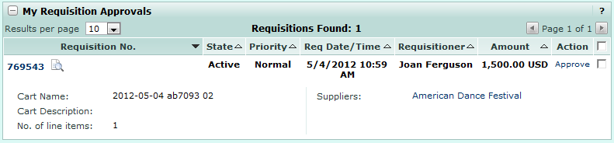
3. To view transaction details, select the **Transaction ID** link.  
     
   
4. From within the transaction, you can review the transaction. If the transaction needs to be either sent back to the requestor or forwarded on to another approver, select from one of the following actions:  
     
   **Forward:** Send the document to another approver for review. This action allows the approver to select another authorized approver, enter a note and forward the document for approval.   
   **Return to Shared Folder:** Place the selected document(s) back into the current shared folder associated with the workflow step. This action removes the assignment to the current approver and the document is available to any other approver with access to the shared folder. **Place Req on Hold:** Change the status of the document to "On Hold" in order to review the document at a later time. The status is displayed to other approvers to indicate that the document is awaiting additional investigation or will be reviewed later. The approver can enter a reason for the action that is stored in the document's history.  
   **Return to Requisitioner**: Select this action to return the requisition to the requisitioner for modifications to the requisition. This action will cause the requisition to go back to a draft cart and when submitted will restart to the first step of workflow.  
   **Reject Requisition:**This action will reject all line-items on the document at once and complete the workflow process. Once a document has been rejected, it cannot be un-rejected, reopened or resubmitted.

***If a requisition is returned to the requestor, they have the option to copy the contents of the requisition to a new cart and resubmit for approval. If a requisition is rejected, the requestor would have to reinitiate the cart from scratch in order to resubmit for approval.***



1. Select the  option from the **Available Actions** menu.  
     
   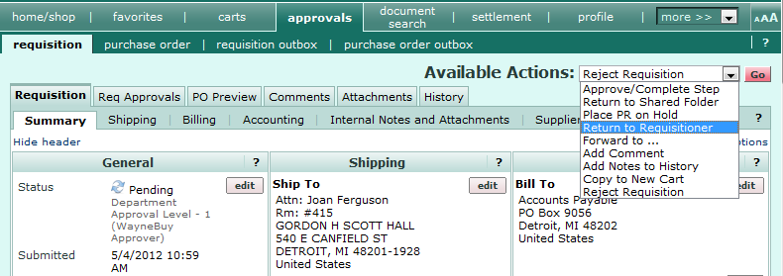
2. 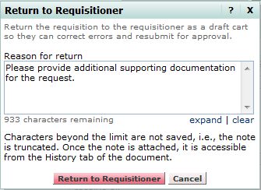A comments box is displayed requesting you provide the requisitioner a basis for the return. Enter comments and select the  icon. *Note, this same box is displayed if you select the* **Reject Requisition** *option.*
3. The transaction is returned to the requestor. The requisition is updated to reflect your action.  
     
   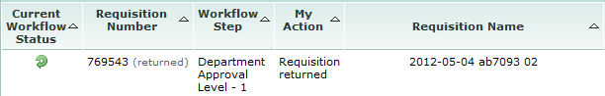  
     
   *You have successfully returned a requisition.*