**In This Guide**

|  |  |
| --- | --- |
| * Searching for desired item | * Creating, renaming, and saving a cart |
| * Selecting a contracted item |  |

This guide demonstrates shopping from hosted catalogs. Hosted catalog vendors provide Wayne State University contract products and pricing via an electronic catalog hosted within the **WayneBuy**.

The shopping experience with hosted catalogs has a consistent look and feel regardless of the vendor. The search criteria are the same, carts look the same, and overall functionality is the same across vendors.



***It is recommended to order items via hosted catalogs or punch-out vendors whenever possible to ensure you are receiving the WSU contracted rate.***

**Procedure**

1. From the **Shop** section of the WayneBuy home page, search for the item by entering keyword(s), and click the  button.



1. Search results will be displayed to start your selection process.

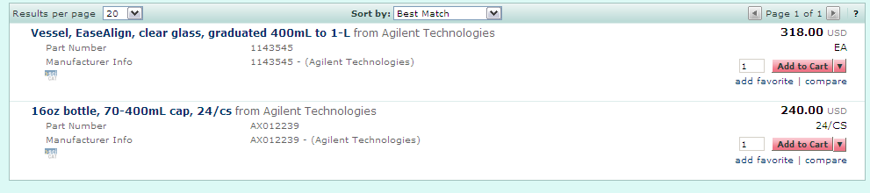

1. 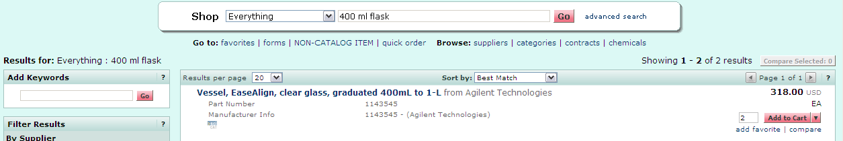Locate the appropriate product/item and enter the **Quantity**.
2. Click the  button.
3. If you need additional items, you can continue shopping and adding items to the current cart.
4. Click the **cart link**, located in the upper right-hand corner of the page.

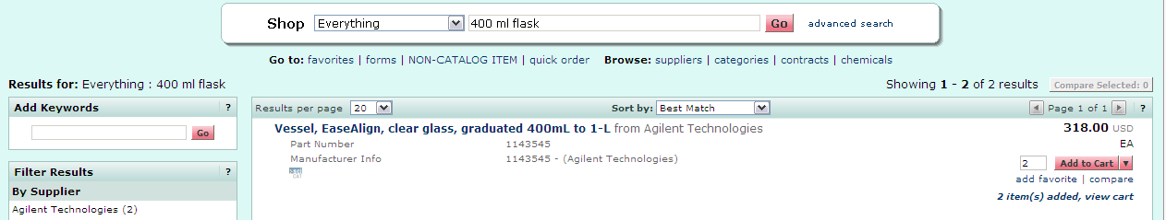Or you can access your cart by clicking the **View Cart** link, located below the **Add to Cart** button. Each will display your active cart.

1. 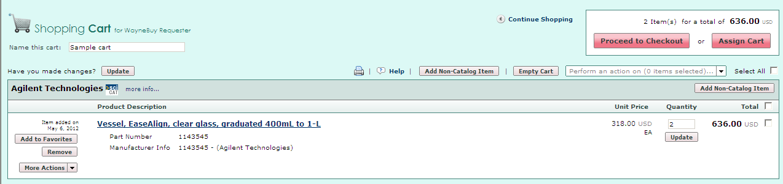Enter a unique cart **Name** (optional) and click the  button.

**Cart Name**: A default cart name, consisting of the following data, is automatically assigned: **Create Date** + **User Name** + **Sequential Number.**

For example: 2012-05-05 wsu_requestor 03

You can accept the default name or enter a unique name that can be used later to easily identify or search for your cart.

*You have successfully added a hosted catalog item to your cart.*