**In This Guide**

|  |  |
| --- | --- |
| * Selecting a punch-out vendor | * Searching a punch-out catalog |
| * Selecting contracted items | * Cancelling a punch-out session |

This guide demonstrates shopping from punch-out catalogs. Punch-out catalogs provide WSU contract products and pricing via a vendor’s eCommerce website, accessed from within **WayneBuy**. Selected products are then brought into your **WayneBuy** cart for processing.

The shopping experience with punch-out catalogs is different from vendor to vendor. Punch-out catalogs are created and maintained by each vendor, so the exact steps of how to search, shop, and add items to your cart will vary.



***It is recommended to order items via hosted catalogs or punch-out catalogs whenever possible to ensure that you are receiving the WSU contracted rates.***

**Procedure**

1. From the **Punch-Out** section of the **WayneBuy** home page, select a vendor by clicking on the vendor’s logo or name (this guide illustrates OfficeMax’s punch-out catalog).

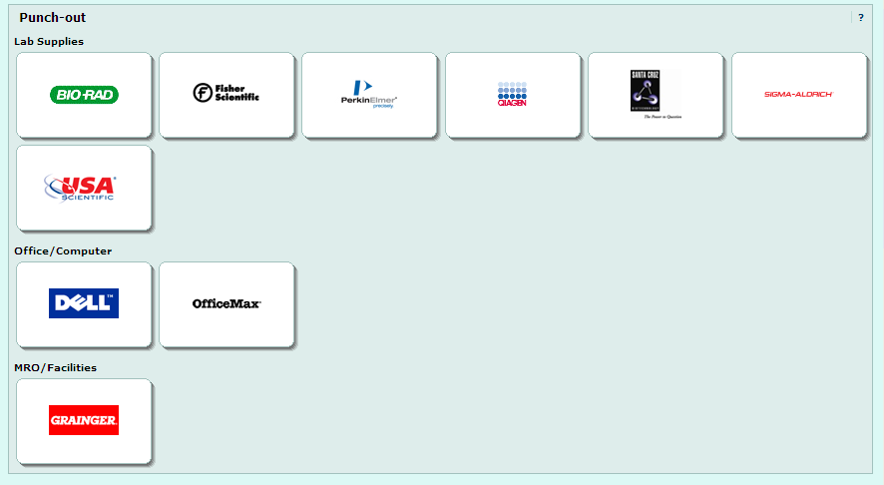

1. 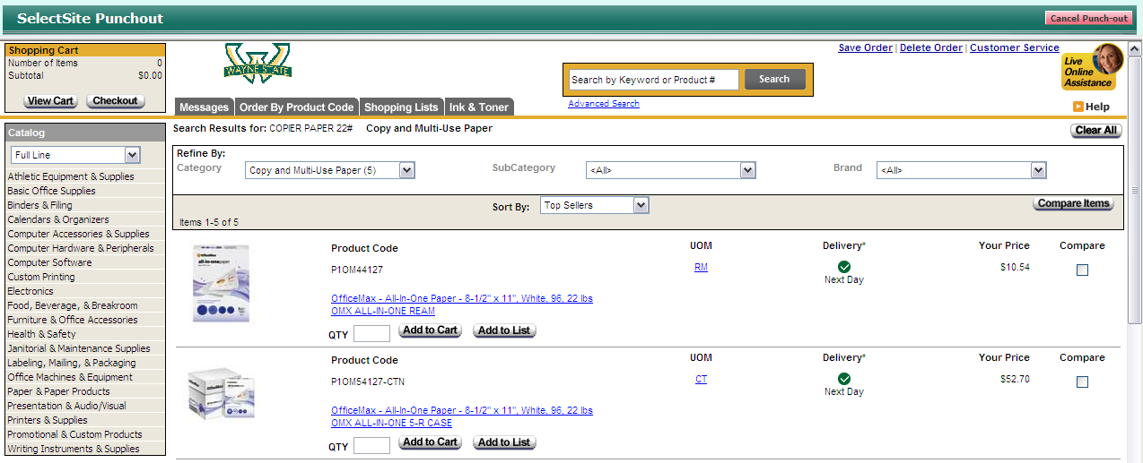Search for the desired item using the punch-out catalog’s functionality. On the OfficeMax Punch-Out site, click the link for “**Create New Office Product Order”** to be taken to the Search screen.

(The example on to the right shows a search for the term “copier paper 22#”.)

1. Locate the appropriate item, enter the desired **Quantity**, and add it to your cart.
2. If at any time you wish to exit the punch-out session without adding any items to your cart, you can click the  link in the upper right-hand corner of the screen.
3. Continue to shop and add items to your cart, as needed.
4. When you are finished shopping and ready to check out, go to your cart.
5. Review your order and proceed to checkout.



***Note: Each punch-out website is different in how it guides you through the checkout.***

1. Confirm your order. Clicking **Checkout** will return your browser will return to **WayneBuy**.
2. Once back in **WayneBuy**, Punch-out items can be edited by clicking the **Modify Items** link. This link returns you back to the checkout screen in the supplier’s catalog.
3. Enter a unique cart **Name** (optional) and click the  button to save the name.

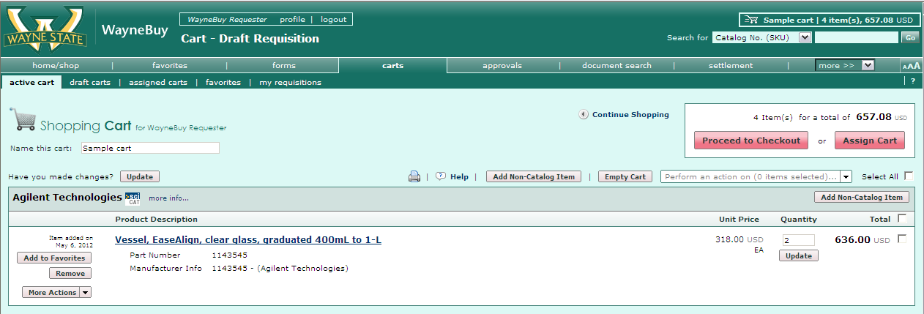**Cart Name**: A default cart name, consisting of the following data is automatically assigned: **Create Date** + **User Name** + **Sequential Number.**

For example: 2012-05-05 wsu_requestor 01

You can accept the default name or enter a unique name that can be used later to easily identify or search for your cart.

*You have successfully added a punch-out item to your cart.*