**In This Guide**

|  |  |
| --- | --- |
| * Assign multiple funding sources to a requisition | * Split funding by percentage or amount |

This guide provides the steps required to assign multiple funding sources to a requisition line item. It also details how to split funding sources by percentage or amount.

**Procedure**

1. Once you have populated your shopping cart and initiated the checkout process, select the  process step or by or clicking on the **Accounting** tab under the Requisition window (shown below).   
     
   



***It is recommended to set accounting defaults to make the checkout process more efficient. See the Manage User Profiles job aide for information related to setting default accounting information.***

***Note****:* Depending on the settings in your user profile, you may or may not have default values present for the source of funding. For the purposes of this job aide, default values have been populated based on the user profile.

1. Select the  icon for the line you wish to allocate to multiple funding sources. If you wish to apply the same split funding for all lines on the requisition, select the icon in the **Accounting** section of the screen.
2. 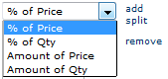A pop-up window will appear with the existing accounting information for the requisition line (or entire requisition if so selected). Select the icon to insert a second accounting distribution line to the requisition.  
     
   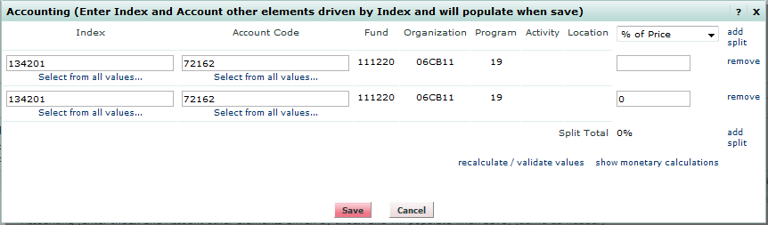
3. Select the method for splitting funding sources. You have for options: percent of price, percent of quantity, amount of price, or amount of quantity.



***If splitting at the requisition header level, only three   
options are available: percent of price, percent of quantity, and amount of price.***

1. Once a split option is selected, add a percentage or amount depending on the option chosen and select the icon. If splitting by price, an error message will be displayed if the total does not equal to the line total. If splitting by percentage, an error message will be displayed if the total does not equal 100%  
     
   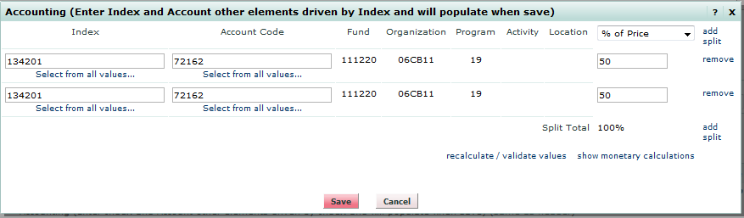
2. Add additional split lines if required by selecting the icon.  
     
   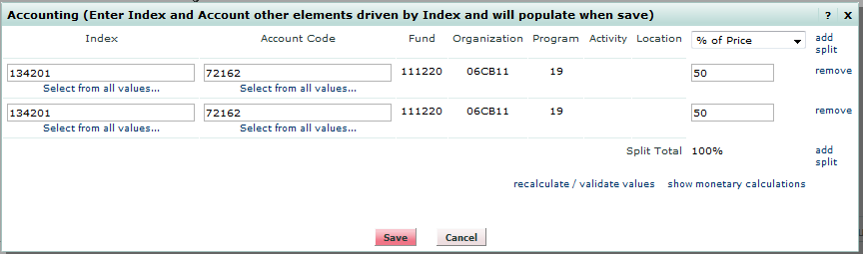
3. Once all split lines have been added and any calculation errors have been resolved, select the icon. You will be returned to the **Accounting** section of the screen where the split funding information is displayed.  
     
   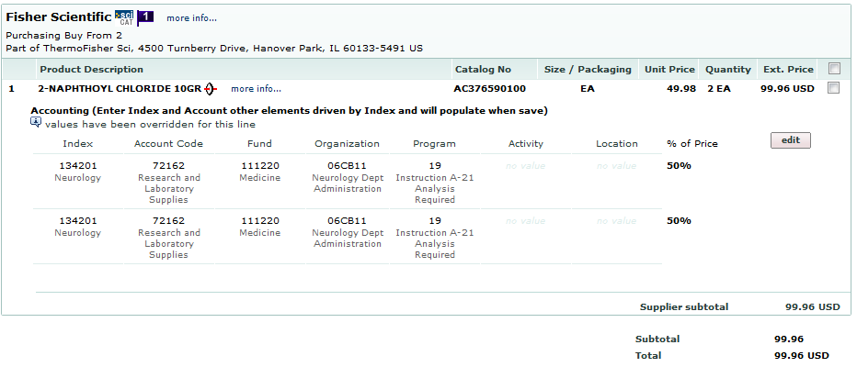

*You have successfully split funded a requisition.*